Predrag Djordjevic

atlasologist

HumanUP
Atlas tune up

Health without treatment
Healthy and long life

Recommendations

Renaissance of the art of healing

If medicine is the art of healing, and it is, and if we need new methodology in medicine, and we do, then this book is the renaissance of the art of healing. The facts presented in this book contradict different authorities, hypotheses and theories and as such reinforce the foundations of science as applied logic. Supported by detailed and thorough analyses, which have already been proven in the area of conventional medicine, these facts have been theoretically and practically verified as evidenced by the testimonies of thousands of satisfied clients. I am glad to be one of them.
Traditional medicine teaches us to deal with the cause of the problem and look at it through the prism of both medical and non-medical methods in order to find, understand and solve the cause of the problem. In a simple and easy manner, Predrag Djordjevic, the author of this book, deals with the cause and consequences of the misalignment of the atlas. We have to acknowledge and respect that kind of courage and responsibility by the author, who has selflessly tried to share with us his knowledge and experience.
I believe that this book will make a strong impression on every single reader, and to those who implement its author’s knowledge, it will offer a successful road to healing.
Dr. Nat. Dragan Oljača

A precursor to general healing

Predrag Djordjevic is, judging by this book and the job he does, a noble visionary, a brave and unrelenting enthusiast, one who opens an iron door and slowly but surely enters a whole new dimension. His originality and his knowledge of the subject matter are astonishing. He teaches us that by realigning the first vertebra, the energy of healing, vitality and positive vibrations is released and this is the way to avoid pills and scalpels.
Dr. Biljana Jevtić

Let’s support a great idea

Who does the author of this unusual book address?
He addresses the common man – offering health in an accessible and affordable way. He addresses medical specialists from different areas of expertise – to give, through medical methodology and research, scientific verification to this method of bringing bodies into natural harmony, and that is HEALTH.
The efficiency and effectiveness of Predrag Djordjevic's method is confirmed daily, but that alone is not enough for this method to gain mass popularity and at the same time to protect it from being misused by charlatans and imitators who would ruin it.
Unfortunately, many great ideas have failed in this country, to the detriment of our people. Do not let that happen in this case, so let us support this man and his idea.
Dr. Duško Ristivojević
Miracles are possible

It is clear, man is a miracle…
We have been suffering pain for years, for years we have been easing the suffering of our loved ones and for years we have been neglecting ourselves.
When in pain or ill we are of no use either to ourselves or to others. To those we love, it is best to show through personal example that there is hope and that miracles are possible.
This book is a product of Predrag Djordjevic's valuable experience, but it was also written by all of us who have solved our problems with his help and decided that we should help others.
A happier and healthier future is within your reach, one where you will be able to say proudly that you have done the best for yourself because you have reached for a solution – you have realigned your atlas and received your miracle!
Master of Biology Bojana Čopik Contribution to joie de vivre

Life is a miracle, for everything that is important to man is invisible, inaudible and incomprehensible. HumanUP atlas tune up broadens our understanding, contributes to our health and gives us back harmony and joie de vivre.
Therefore, TO YOUR HEALTH with the, HumanUP atlas tune up, dear ones!
Dr.Časlav Miladinović

This book is dedicated to
my sons Vladislav, Filip and Matija,
to my grandson Ognjen, my granddaughter Janja and
to my future grandchildren.

My children,
may you raise your children in happiness
for they will live in a better future.

FOREWORD

I begin with the very bold claim that within this book I present a discovery that will give you the opportunity to live a better and more healthy life. This discovery is ground-breaking, and this book might very well be the most useful thing you will read. If you are looking for a way to heal, you will find it here. You have most likely read many things related to matters of your health, but you still haven’t found a solution for your pain and illness.

What I am presenting here is not completely new information. There have been several scientific studies conducted on various aspects and there are also bits of information across the internet. This book is putting together the pieces and filling in the blanks. Through my work, I was made to question the existing knowledge about the human body and in this book, I am sharing what I have discovered through my professional experience.

Information has always been crucial to our success. The right piece of information at the right time is of the greatest value. We live in the age of information which gives us an illusion that we know everything. With the internet and many other available resources, we can search and find information about pretty much anything. This is both a blessing and a curse. We are often forced to sift through and figure out what is true from that which is simply false or what’s worse, has been manipulated by those who are making money from varying sides of an argument. It is important for us to understand that just because we have access to information does not equate to us knowing.

Similarly, just because we don’t know something, doesn’t mean it doesn’t exist. It is simply our knowledge that is new. For example, the greatest health problem for humankind has existed for tens of thousands of years, but we still haven’t figured it out – let alone its solution. It is not the first time and it certainly won’t be the last that new discoveries change existing information. Many people were afraid when electricity first appeared yet today we all gladly use it. The same thing will happen with the HumanUP atlas tune up.

We are talking about a completely different approach. I will explain how illnesses occur. Once you understand this, it will be easy to understand how illnesses can disappear without medical treatment simply by eliminating the cause. So even if you consider yourself completely healthy, this is a book for you, as it is focused on natural prevention.

Some things might seem superfluous, as if they have nothing to do with health but, everything around us is connected and influences our lives. Changes that have been happening since the beginning of humanity still affect us today. For tens of thousands of years, we have struggled with pain, illness and life-shortening disease but finally, the end is in sight.

Based on the natural law of cause and effect, the things within and around us are always changing. Sometimes things must change for the worse before getting better. As unfortunate as it is, this has been happening to humankind for tens of thousands of years but there is finally a solution that can eliminate the root causes of illnesses as well as their consequences. It will not be easy. The solution will essentially need to be applied for as long as the problem persists.

Until now, the role of the misalignment of the first vertebra in illness and disease has been unknown. I present my discoveries to educate the public as well as those who wish to pursue this humane work. My intention is to present the HumanUP Atlas Tune-up in such a way that everyone can understand it because I strongly believe that everyone is entitled to better health. I will try to be succinct so that you can find the solution to your health problems as soon as possible but also so that the size of the book does not discourage you from reading it altogether. My motive in presenting the HumanUP Atlas Tune-Up is to enable everyone to have a healthier and therefore, happier and more successful life.

THE SEARCH

For thousands of years, people have been searching for the cause of illness and disease. A lot of times this is a personal search - trying to figure out why ourselves or a family member has fallen ill. My search lasted for thirty years. When I was a child, I was ill more often than other children and I was admitted to the hospital multiple times. Between the ages of twenty and fifty years old, I was searching for what was making me sick. I realized that it wasn’t coming from my environment but rather something was happening inside my body that was keeping me sick. This began my journey into discovering why diseases come about and how they occur.

At first, I didn’t even try to treat myself because I was no medical professional and I left my treatment to the experts. By the age of thirty, however, I realised that modern medicine wasn’t working for me, so I tried traditional medicine. I found that I was wasting my time and money. It was not helping. At that point, modern and traditional medicine were no better than a sham to me. I was finding though, that it wasn’t intentional, but it was rather coming from ignorance. People really didn’t know. Despite all this, I made up my mind that I would not be a victim of my illness!

At the age of forty, I stopped taking treatments. I wasn’t getting any better and what’s more, I was experiencing several side-effects. I was in pain, but I was on a mission to find an answer to my simple question - what is causing these illnesses to occur inside my body? I spoke to doctors, including my children’s paediatrician whom I befriended over the years, and I read many books and magazines to try and gain some perspective. There was a lot of inconsistency and incorrect information. It wasn’t giving me any information on the causes of illnesses. The paediatrician mentioned some possibilities, but he wasn’t really sure. From there, I took a different approach, attempting to be more aware and attentive to my body, hoping that I would somehow be able to recognize from within, where and why my illnesses were coming about.

I was certain that the key to my healing was in discovering where diseases occurred. The reason being, I decided, it is better to eliminate the cause than to try to treat the consequences. I kept trying and trying but after three decades and still not being able to find out why I was ill, I began losing hope and I started to prepare myself to just accept the cruelty of old age. I began looking for a place that had a warmer climate, somewhere I could grow old without dealing with the unbearable pain of rheumatism. I would likely still have to deal with my other diseases but at least my twelve years of worsening pain would be alleviated. I settled on Cuba.

I didn’t want to spend my old age away from my family, but the pain left me no other option. They say we often find solutions where we least expect them and that’s what happened to me. When I was trying to do my research on Cuba, I was looking for a magazine called ‘Atlas’ and I happened across a health magazine with a headline on the cover that stood out to me. It had an article called ‘Realign The Atlas - Prolong Your Life’. I had no intention of trying to prolong my painful life and I had no clue how an atlas was connected to our life-span, but I was intrigued. I looked closer, reading the subheading: “The Misalignment of The First Vertebra is The Cause of Diseases”.

These two lines completely changed my life. I learned that atlas was the technical name for the first cervical vertebra. I had never considered an atlas as a potential cause of disease and despite all the research I had been doing, I had never seen this mentioned before. I immediately read the entire article, which was part of an advertisement, and quickly realized that this was the answer I had been long searching for. The cause of illness falls heavily on the first cervical vertebra, our bodies atlas. Though I was sceptical as I had been deceived so many times before, and this was even stranger because it claimed that it wasn’t just a treatment but rather completely eliminating the cause of your disease, I decided to try it for myself and see if it could really be the truth. I scheduled an appointment.

When I last spoke to my children’s paediatrician, asking about the causes of my illness, he told me that I was born with a flaw. He wasn’t sure what exactly it was, but it turns out that he was right. Two minutes after the treatment, I felt I could breathe more easily; five minutes after, I had the best gulp of water that I’ve had in my entire life; ten minutes, I felt an irresistible desire to eat. Health started returning to my body. When you are healthy, it can be hard to truly appreciate these little things, but I was incredibly pleased and relieved. I was only hoping for a third of my illnesses to disappear but within the first couple months of treatment, I had gotten rid of almost all the illnesses that had been previously torturing me for fifty years of my life.

Apparently, despite about two hundred people having read the article, I was the first person living in my town to go and have my atlas tuned up. I had a public job, so many people were aware of my health issues and they were similarly aware when they began disappearing. After seeing my personal experience with this treatment, two hundred people went and had their atlas realigned. It was enough for them to see how it had impacted me and people were quickly joining me in not just healing but eliminating the cause of their various pains and diseases. After seeing and experiencing this amazing improvement, I decided that I too wanted to be able to tune up the atlas. Now I am doing this noble job and I am extremely happy to be able to help ill people in such a simple yet transformational way.

I am finally healthy at the age of fifty-one and I assure you, it’s never too late. I spent thirty years searching for what causes diseases and it was always within my reach. For tens of thousands of years, people have massaged around the neck for relieving pain and tension, but we hadn’t realised that the misalignment of the atlas is the cause of almost all diseases. The circumstances of my life have made it possible for me to make an epochal discovery about realigning the first vertebra. It helped that due to my technical education as a cinematographer, I view the body as a machine and I perfected the power of observation. However, what helped me the most was my search for the cause of my disease.

THE STATE OF BEING & MISCONCEPTIONS

Who are we, where are we and why do we exist? These are questions we’ve been asking since the beginning of consciousness. Thankfully, as time goes by, it seems we are getting closer to finding our answers. Maybe we’ll never have it all figured out but surely it is worth trying. It is in our human nature to want to understand the things around us. We exist due to the existence of the universe and we are a small part of everything within it. The same rules apply to the whole universe that apply to even the smallest particles within our body. But for an individual’s life it is not important whether the cosmos is infinite. It is important however, that we are not harmed, and our life is not manipulated. Unfortunately, these things occur all the time as we fall victim to the many misconceptions that have been imposed upon us by different industrial groups whose aim is to make a profit.

Modern magazines, radio, television and the internet are all working for and supporting different industries that harm us. Most of the media outlets are owned by industries that utilize this to create illusions and convince us that whatever they are selling is good for us and something we should seek to attain. Misinformation has always existed, and it has favoured one group. We live in a time of rapid communication which gives us access to loads of information, but the problem is, we live in a time full of misinformation. We see commercials for new medications all the time, promoting a variety of treatments but it is known that many painkillers for headaches only provoke more severe headaches and the same is true for many other treatment options. These treatments seem successful because they remove symptoms, but the reality is they are not getting rid of the actual illness. A lot of times modern medicine treats symptoms and is very successful at doing so but it only creates an illusion that we are healed. Beneath the surface, we are still sick and because we think we are better we aren’t doing anything, thereby allowing it to grow until we become more ill. The problem is not spending money on wrong treatments but the fact that the disease gets worse because of the waste of time and in the end, we are still not cured.

Since the beginning of our species we have longed for an easier and more comfortable life but when we have too much comfort we are often sacrificing something essential to our good health. A chair for example, is generally a useful invention but now we have more health issues due to sitting too much and not moving enough. With children doing more and more sitting, parents are encouraging them to go out and do sports. They are under the impression that all sports are created equally and fail to realize that the wrong sports can potentially have long term negative effects on a young, growing child.

Another example of a common misconception that is projected with the aim to make money despite the negative impact they may cause is the case of women feeling like it’s good to wear high heels. High heels do make women look attractive but at the same time, they are deforming their bodies and spines. So, a woman will seduce a man, but she will develop health issues and not be able to enjoy the marriage. Several centuries ago, men were the first to wear heels because heels make a normal curve in the lower part of the spine of a man and that is why they were healthier than women in those days. In the twentieth century women’s wish for equality changed fashion because women wanted to be as tall as men. There is no need for this type of equality. Ultimately, the female principle is predominant because women are the ones that bear children.

It is a misconception that having a variety of foods in a single meal is good for your metabolism. For tens of thousands of years, however, we used to eat only one grocery per meal and therefore our digestive system is not capable of digesting different types of food. It is also wrong to think that dieting is a solution for obesity and it is much better to give up different tastes in a single meal. There are certain food products there is much debate about such as gluten or milk. Milk is white and therefore it seems clean and useful for your health but that is not the case. It has been known for decades that milk is harmful, but it is still often promoted as a healthy part of our day. The human digestive system is not equipped to digest milk and dairy products. Milk feeds parasites and bacteria in our body and their secretions increase the acidity of the body leading to illness. It is said that calcium found in milk is good for our bones, but it is quite the opposite and the more bacteria and parasites there are in our body the less calcium there is in our bones. The milk industry obviously doesn’t care, and they continue to promote us to drink a daily cup because it makes them a lot of money.

On the other side of the coin, for thousands of years people have used hemp, a material that is lightweight but stronger than steel. Hemp can be used in the construction industry, for furniture and in the car industry. In some countries it is still used for food, medicine and for producing cloth. There are as many as two hundred and twelve types of hemp but because of cannabis, all of them have been made illegal. Hemp is inexpensive and that’s exactly the problem for different industries - their profit would be small. Instead, we are encouraged to use synthetic materials such as plastic which is more expensive and damages our wellbeing. Not only are we ignoring our own health, we are being extremely aggressive towards nature. By cutting down forests we are putting our survival at risk and the use of pesticides is permanently polluting soil. Our ancestors used to worship Mother Nature and we treat her like a wicked stepmother. In the past two hundred years, humanity has been cutting the branch it sits on. The Amazon rainforest is systematically destroyed, not only because of the arable land but also, the Amazon plants are among the healthiest and it is not in the pharmaceutical industry’s interest that the rainforest exists.

There is a misconception that the modern way of life has made our lives much better. Some aspects are better, but most are not. One of the greatest misconceptions is that we are perfect, and that the creation of man is finished. We are however, neither finished or perfect. Changes are occurring all the time from people losing their teeth and hair for example to more noteworthy things such as the latest scientific research having shown that the human head has been shrinking over the past twenty thousand years. Our life is seriously affected by illness. Not knowing what causes diseases has created a misconception that it is normal to live with diseases and to die of them. Homo sapiens are the sickest species. Diseases occur due to external infections as well as internal influences. External infections trigger diseases from the outside, but many more diseases occur from within the body. You will find out how it happens in this book, HumanUP Atlas Tune-up, which will eliminate many misconceptions about how diseases occur.

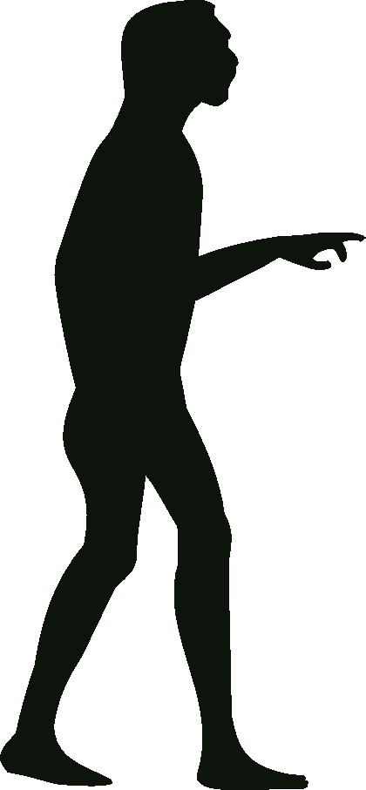

THE PAST
The past and future don’t exist now because there is always only the present. Where are we in this eternal game of time?

Bad consequences of the past exist in our body and that is what makes us ill. There is finally a solution to how to live healthily in the present and in the future.

This book describes the past, present and future of our species from the point of view of the greatest discovery connected to human health.

THE ORIGINS

Our findings are not final, but they are pretty accurate. My discoveries about the origin of everything, including Homo sapiens, are based on these findings so ultimately, if they turn out to be wrong then my discoveries are wrong as well. Thanks to the discovery of atlas realignment, what is most certainly correct in my discoveries, is the development of Homo sapiens in the past tens of thousands of years. The proof of my theory exists in each of us and it is a small anatomical error. Although the error is small, it is detrimental to our health and it has always been the greatest problem of humankind.

It is impossible to turn back time and be certain how everything originated, which is why there are different beliefs and opinions about the origin of the world. Everyone is entitled to their own opinion and you shouldn’t influence others with your opinions. In this section, I am sharing my opinion on how things got started and my intention is not to belittle other beliefs or to change them but rather to share the point of view from which I’m coming. Differences of opinion are valuable because it leads to truth that everyone can benefit from.

There are several theories about the origin of the world. One of them says that in the beginning there was nothing except a little singularity which exploded, and everything developed out of it. Scientist came to this conclusion because they noticed that everything is moving away from everything else in the universe. This explosion has lasted for thirteen billion, seven hundred million years and it will last until the last atom disintegrates. In the end there will be nothingness.

The latest theory supposes that there is an infinite number of universes that are different. These other universes are impossible to observe because they contain completely different dimensions and operate on a separate set of physics. Mutual activities of these universes create an infinite number of combinations in the endless multiverse which exists in eternity with no beginning and no end. This is all difficult to imagine but it becomes easier to understand if you compare it to soap bubbles floating. Sometimes these bubbles collide and when that happens, each time the consequences are different. It is possible that they merge into a bigger bubble but there is just as much of a possibility that one bursts, or both burst, and their remains are absorbed by other neighbouring bubbles. Something similar happens during fireworks as well.

Because it will allow us to live more easily and with peace of mind knowing where we are and what we are made of, let’s return our discussion to the reality of this universe. Like fireworks, after an explosion there is smoke and dust in vortices. The explosion is a cause and everything else that happens are effects. Our galaxy was created six billion years ago out of a huge vortex of dust. A similar pattern of events transfers into the galaxy and smaller vortices of dust create stars and their followers. Four and a half billion years ago, the Sun was created and shortly thereafter was the creation of the Earth.

There are many theories about the origin of life on this planet. It is possible that due to mutual actions of chemicals along with physical and electric reactions, a spark of life was created. A discovery made in 2002 however, overshadowed all other theories when the Stardust mission proved that life originated outside this planet. The spacecraft brought back a bit of dust from a comet’s tail and it was found to contain organic matter. Three billion years ago, organic matter and amino acids fell to the cooled Earth. Comets also brought water, without which life couldn’t have been created. Special conditions are needed for life to be created, and in order for it to survive and develop a lot of time is required.

Planet Earth is the ideal cradle for life to develop because it is situated at a suitable distance from the Sun, so it is neither too hot nor too cold. The Earth’s magnetic field protects us from solar radiation and our planet’s chemical composition offers conditions for numerous chemical reactions. The Moon stabilises the Earth’s axis of rotation and that enables us to have favourable climatic conditions. When the necessary conditions were fulfilled, the adventure of the living world was able to begin. Ribonucleic acid was formed from amino acids and deoxyribonucleic acid was formed from ribonucleic acid. The very name represents the grandeur of what is the largest natural molecule which can be found in every single human cell.

THE DEVELOPMENT

To prolong its survival, DNA forms a membrane around itself, filled with water molecules and that is how the first cell was created. For billions of years, single cell organisms existed in water. Life could be created in water because it has provided protection from solar radiation which was an extreme threat to survival. The effect of the Moon on the development of life was extraordinary. At that time, the Moon was closer to the Earth and circled it much faster, so tidal ocean waves were several dozen meters high. Their ebb and flow was very violent, causing single cell organisms to attach to the rocks.

There was no oxygen in the Earth’s atmosphere and photosynthesis occurred spontaneously in these single cell organisms when they were exposed to sunlight. It was through the process of photosynthesis that oxygen was created and over the next three billion years, oxygen slowly filled the atmosphere. At first, this oxygenation caused the environment to become toxic and only organisms that were already exposed to oxygen in their creation, managed to survive. Due to the Earth’s unstable orbit around the Sun, all water froze several times causing the planet to appear as a big white ball. When life first appeared, it wasn’t guaranteed that it would survive but it was during this early time that the theory, ‘what doesn’t kill you make you stronger’ was tested and confirmed. In fact, as the living world developed, this theory would be tested several more times. The frozen planet posed a threat to life, which was still sensitive at the time, but that is exactly what made it possible for multicellular organisms to form.

Ice up to ten meters thick formed around the coastal regions of the Equator, not allowing enough light through. To absorb as much of the little bit of light that there was, single cell organisms merged into multicellular and became green. That is how chlorophyll and all later plants were created. For the common good, groups of cells organised and specialised for certain functions to sustain the body. The organism which made it possible for animals to develop out of plants still exists today. We call it a sponge. Whereas plants are static, animals were able to develop much more quickly due to the mobility. Segmentation of their bodies enabled them to move more, allowing them to not only search for food but also to perform different tasks in the interest of their larger community.

A very similar pattern of organisation led to cells merging into organs, which enabled better adaptability and survival. Soft tissue species formed first, followed by organisms with shells which could protect the soft tissue. When vertebrate developed spines, it enabled the body to stay whole from the inside. That led to limbs being formed which enabled even better mobility, giving them an advantage in the fight for survival. All of this happened in water. Plants were the first to reach land and for hundreds of millions of years, they released oxygen into the atmosphere. Lungfish left the water and over the course of time, animals that breathe air were formed. Leaving water was a spontaneous occurrence. The Moon made that possible through ebb and flow. Different organisms stayed on land for several hours and they gradually started breathing the oxygenated air.

Genes transmit information to the next generation. In each generation, all living things go through a cycle from birth to death. Our genetics are the only things that last on, as they continuously clone themselves ever since the first genes were formed. Not only have they survived, they have also become more complex as they have had to adapt to the conditions of their environment, which in the beginning were often much less than ideal. The first genes had a simple structure but to prolong survival, they altered themselves from within. The structure of genes became ever more complex due to the growing number of DNA in them, which made it possible for new plants and animals to be formed. Scientists know of several million plant and animal species and there are many more that have yet to be discovered. The development of the gene has made this unbelievable variety possible and Homo sapiens have the most complex gene structure of all.

Genes are in the centre of every cell of every single life form. We, as humans, are the only ones aware of this but we tend to have a mixed up understanding of how it works, thinking that we possess genes whereas in reality they technically possess us. In this incredible relationship of mutual interest, the guest thinks he is the host but that is not the case. Each gene is the basis of life. Even today, after much changing and development of genetics, there are differences in the structure of genes in different life forms, but the differences are minimal. The difference between a human gene for an example is not much different from the genes of a pig or even a potato. Genes created organisms to give them protection and to be transferred through generations. Cloning from parents to descendants, only genes have had a single generation since the beginning of life to the moment when life ceases to exist.

SURVIVAL

The cycle of creation and extinction of new species is a continuous process. It exists now and will continue forever. The only unusual thing in that process is that we, human beings, are responsible for the extinction of many species despite genes having survived several seemingly much greater disasters. This is the first time since the beginning of life that it is possible for one species to not only destroy itself but also thousands of other species. Regardless of what damage we do however, genes will still survive.

Due to our lack of understanding of cosmic phenomena in the past, comets were seen as harbingers of death. Comets brought water and particles of life to the Earth, but they have likewise been the reason for extinction and it is possible for that to reoccur. Sixty-five million years ago a celestial body, ten kilometres across, fell to the Earth. A large majority of plant and animal species were destroyed in that catastrophic event. Even dinosaurs, who had ruled the planet up to that point, were destroyed. Before that event mammals had been small and less developed but with the extinction of the dinosaurs, they developed further. Mammals are a small genus in comparison to other species, having around five thousand, five hundred mammal genera today whereas there are incomparably more amphibians, reptiles, fish, insects and other species. However, mammals are still considered dominant because they adapt better. Some types of mammals have returned to water and some have developed the ability to fly and are now present on land, in water and the air. With all the changes that have occurred, the survival of life is that much more incredible, and it has been exactly those changes that have made it possible for life to adapt, perfect and last.

THE ERRORS

Billions of events from the past have made it possible for us to exist as we do today. Conflicts, struggling, adapting, suffering, torture, coincidence, selection, experience, error, and everything else that has happened on the journey until now is embedded within us and it has enabled us to enjoy life. When we aren’t happy or satisfied we should remember the difficult path of development that our ancestors took and allow being conscious of their sacrifices to make our life better.

Animals were initially unisexual and later they became bisexual. Females bear offspring and males serve for mutation errors. When after several generations it turns out that an error is good, that is when females adopt it and transfer to new generations. Males have led to ever better solutions and females have chosen. That principle of choice has survived for hundreds of millions of years and it is present in our species as well. What you have read so far is a reminder of one of the best known theories of the origin and development of life. Everyone is entitled to their own opinion on the past, but this is the most accurate sequence of events. It is true that future research of the past can somewhat change our current information but ultimately, the essence will remain mostly the same.

In the process of transferring information from one gene to another, sometimes errors occur. Among many mutations, one such error occurs which is useful for future generations and that enables genes to survive and develop further. These errors are not planned but rather spontaneous and unintentional. In the first primitive multicellular organisms there was one nerve cell which controlled the function of all other cells. Due to an unintentional mutation error two nerve cells were created which proved to be very useful. As a result of this error, primitive brains were created, which led to the creation of complex brain of Homo sapiens. This is an example of just one of many errors which little by little led to ever more successful species.

Although sometimes the errors that occur turn out to be helpful or even crucial for furthering the development of various life forms, they can likewise sometimes be fatal for a species, leading to their degradation or extinction. Unfortunately, this has been happening to the human species for tens of thousands of years. Every single person has a small anatomical error that can easily be felt between our earlobes and our jaw. That error is the misalignment of the first vertebra.
This has been the introduction into the story and my findings are changing the existing knowledge of the development of human species.

THE PRESSURE

Gravity existed long before Isaac Newton, but he was the first to understand and define it. Three hundred years later Albert Einstein redefined the concept of gravity with his theory of relativity – celestial bodies, with their mass, curve space which becomes thickened as a result. One of the basic concepts is space, which is present everywhere in the universe. Most space exists where there is nothing and we find the least space in black holes, the most massive celestial objects.

The more we know, the clearer it becomes how little we know and now we don’t know what most of the universe is made of. What is unknown and invisible to modern instruments we call dark energy. Science develops rapidly and once when it discovers what makes that energy, it will be named properly. In my opinion, it is the pressure of the explosion that has lasted for thirteen billion seven hundred million years. Connecting these findings, I have discovered how the pressure of the universe influences our upright position and how it is due to this pressure that we become ill.

The concept of gravity means that a larger object attracts a smaller one, but it is quite the opposite. Depending on the amount of matter that a body has, space becomes thick and that creates a vacuum in relation to the pressure in the cosmos. To us it seems that the Earth’s gravity is pulling us from the ground but that isn’t so because the universe is actually pressing us from above. Dark energy isn’t something that is somewhere far away, but it is rather present everywhere in the universe and it spreads through us influencing our existence and health. One million, five hundred years ago somebody dared to rise and stand up to the pressure of the mightiest force in the universe. We named that hero Home Erectus.

THE RISE

Homo erectus did not rise easily. The rise could only happen because of the order and circumstance of the above mentioned events. Of course, I haven’t witnessed any of these events, but I have made new discoveries which change the existing information regarding our species development. One hundred million years ago, tectonic activities started splitting the original continent into a number of continents. For mammals, it was particularly important what happened to the continent of Africa, which was where they lived. Africa used to be situated further south, where the climate was moderate with luscious vegetation and different animal species and these favourable conditions made it possible for mammals to develop further and create new species.
Monkeys lived on the ground, walking on four feet. Running away from predators, they started to climb trees, where they found sweet fruit, which gave them more energy for climbing trees and for jumping from one tree to another. While they climbed, jumped and picked fruit, they used to stretch their bodies and that corrected their joints in both, their front and hind limbs. That is how the upright body position was made possible but at that time standing was still painful. Even though monkeys couldn’t stand for a long time then, they could sit upright. There is a saying that labour created man, but I would rather say that laziness and resting created man. While sitting, the spine got used to a vertical position and had to support more weight. It was that position that led to a different arrangement of internal organs.
No one can say for sure why Homo Erectus straightened and walked on two feet. When jungles moved further west due to climatic changes, certain species of monkeys stayed in bushes so perhaps they straightened to orient themselves better and because it was easier to walk through bushes and grass in that way. It is possible that they started walking upright because they were walking through swamps and if that is so, then water helped again in our development because it made their bodies lighter and their joints suffered less pressure. My favourite theory is that mothers held children using upper limbs while breastfeeding and protected children from predators. That close relationship and love of offspring made it possible for them to rise.
Homo erectus was the first to stand and to oppose the pressure of the universe. Rising from a horizontal to a vertical position probably happened fast because it is very difficult to walk bent over. Over the course of time, several species of humanoids were created from Homo Erectus, but natural and climatic changes caused several of them to become extinct. One of those humanoids was the Australopithecus, which then slowly developed into Homo sapiens. The upright body position gave us the possibility to rule the ground, but this came with the price of us having to suffer through diseases. Back then, it was easier to stand when leaning sideways rather than forwards because their elongated chest would weigh them down. Over the course of time, our chest became thinner and that is why we are the only mammal species with a flattened chest.
The upright body position and thinner chest influenced a different arrangement of organs. At that time, the organs were equally distributed between the left and right side according to their weight and because of this, when Homo sapiens became omnivorous, it created our present health problems. A diverse diet contributed to our survival but because of it, our liver became larger and heavier. Every change leads to improvement of one thing but at the same time it leads to deterioration of something else. The curiosity of Homo Sapiens is what led them to diversify their foods but that caused their liver to enlarge. When the liver got larger, it upset the balance between the left and right side of the body. In a way, this situation is portrayed in the Old Testament. The forbidden fruit from the tree of knowledge gives more energy not only for physical activities but for thinking as well.

With their hands free, Homo sapiens were able to explore their surroundings and figure out how to start using tools, which led to the process of thinking. This exploration and making use of their brain, caused their brain and skull to become larger. In order to spend energy more efficiently, the process of thinking helps perform tasks more easily and that can be called laziness. There has been a tendency to live more easily ever since Homo sapiens appeared. Back then, laziness made further development possible but now we are becoming too lazy and thereby triggering rapid deterioration.

The explosion of a supervolcano which happened seventy-two thousand years ago could have led to the extinction of humankind but fortunately, around two thousand of our ancestors survived so all people in the world are their descendants. Since then, humans have spread around the world and dominated all the continents. Ice ages lowered the sea levels, so humans moved over to Australia. From there, during the last ice age, they moved across the ice to America. When the ice age ended people stayed isolated on the continents which led to different races being formed. Even though they were isolated, people had already brought with them the greatest problem of humankind. The misalignment of the first vertebra and subsequent problems that come with it affect people of all races and from all over the world.

THE FALL

Based on the current information, it would seem that the fall and the degradation of Homo Sapiens should not happen. In reality it has been happening for tens of thousands of years and in the preceding decades we have degraded faster due to the liver rapidly increasing in size. Despite our predecessors living shorter lives, they used to be much healthier than we are now. Over the course of time, our lifespan increased because of how successful our species was and it could have continued even longer, had it not been shortened by infections from our surroundings. We were killed by microorganisms as well as larger predators. Organising into tribes helped Homo sapiens defend against predators but they were still threatened by invisible viruses, bacteria and parasites. The immune system fought against external infections and it became stronger over time.

Conflicts within their tribes also shortened the life span. At first, they were individual but as they moved forward in conquering lands, the conflicts became collective and that is still the case today. Other animals also fight within their own species, but these conflicts end in wounding their opponents. War is a fatal creation of Homo Sapiens and it turns out we are not as civilised as we might think.

I hope that we will finally become civilised soon but there is still the problem of a conflict of interests which through deceptions favour a certain group. An example that most of us aren’t aware of is that during the twentieth century, our species grew ten centimetres taller and the reason for this rapid change was our diet. A lot of hormones are used in agriculture and livestock breeding, which make plants and animals grow faster. When we eat these plants and animals, we are affected by those hormones, causing us to become taller as well. Due to our height and the fact that the first vertebra is misaligned, our body and spine curve even faster, causing us to be even more ill.

The blame is not on the food industry alone, chemical substances from medications weaken our immunity which has developed for millions of years. By realigning the first vertebra we are offered an amazing possibility to stop the degradation and fall of humankind.
CIVILISATIONS

Modern civilisation has inherited from the many civilisations that existed in the past. The discovery of land and underwater architectural structures testifies to the success of civilisations that came leading up to and after the last ice age. The precision of cutting and transferring huge rock blocks is unattainable to us using modern technology. It is strange that these structures were built on different continents because there was no means of communication back then which implies a possibility that aliens influenced the development of our species. We can’t confirm that for sure except maybe if they themselves confirm it one day.

When the ice age ended, different civilisations appeared and influenced each other. Within each civilisation, there were the centres and the outskirts. Different knowledge mixed on the outskirts and new and better civilisations were created. Sometimes knowledge would get lost, leading to certain civilisations disappearing. The discovery and development of script made the transfer of knowledge between existing civilisations faster. The existence of Atlantis was ancient history even for Homer, but he was the first one to write about it.

Greek civilisation was created on the outskirts of these civilisations and philosophers appeared. Socrates, Plato, Aristotle and other philosophers are the fathers of the present. There had been wise men before them and there have been plenty since, but they made a crucial impact on the modern way of life. The Chinese civilisation is the oldest but even modern China uses the achievements of the Greek civilisation. Hippocrates is the father of medicine. The Roman civilisation inherited and improved the achievements of the Greek civilisation and the same thing happened to medicine.

The Middle Ages slowed the development of humankind, but the Renaissance accelerated it and is still ongoing today. Unfortunately, speed is sometimes fatal for our species. Because of rapid development and our desire to live more easily, we made too many mistakes in the twentieth century. Blinded by technology, we have created an illusion that our life is better, but it is quite the opposite. That is the case with modern medicine as well, which is constantly moving further away from Hippocrates’s ideas and centuries-old natural treatments were declared outdated.

Our comfortable life is turning us into a civilisation that just sits and eats. We are sitting when we are working or having fun. In the past two hundred thousand years, the human body has adjusted to the upright or lying position and that is why too much sitting is a huge mistake. For millions of years, spontaneous errors occurred but they also lead to or produced better solutions. In the present day people make intentional errors because they bring them a huge profit. Because of the minority’s profit, the majority has health problems. Natural immunity weakens, humankind degrades, and generation after generation we are becoming more ill.

Since its beginning, the living world has almost become extinct several times, but it has always managed to be reborn and to improve. Discovering the HumanUP method will allow our and future generations to become free of both natural and intentional mistakes. It has taken some of you twenty minutes and some of you half an hour to read the chapter on the past. During that time, I have reminded you of different events that have lasted for millions of years and made it possible for us to exist. Our ancestors lived primitive lives but unlike us they respected their ancestors and were thankful to their families. In each of us, the consequences of the past are present, and it is up to us to respect them more. Let us be very grateful to all our ancestors – to have a better life and to deal with the present more easily.

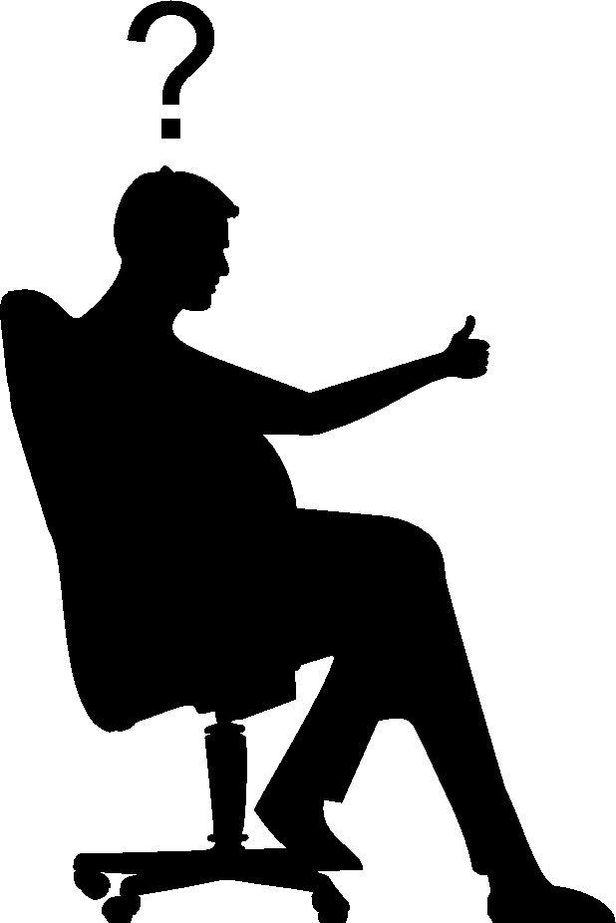

THE PRESENT

Health problems occurred in the past because the first vertebra was misaligned. That error is inherited from our ancestors and now we suffer consequences in the present.

Thousands of generations have tried to correct the error but so far there hasn’t been a true solution to the problem.

The way to improve health of present and future generations has finally been found.

THE ATLAS

What is the atlas? It is not easy to answer this question because this word is used for more than one concept. We learn about it in history, geography and biology lessons. We’ve learned about it, but we forgot because the neural network in our brain has a limited capacity. We receive new information everyday which pushes away old information that is no longer relevant. When you read this book, you will realise that knowing about the atlas is one of the most valuable things in your life. Depending on personal or professional interests, certain individuals will know the different concepts referring to the word atlas, but most people simply have a vague idea about it, so I will explain these concepts.

Greek mythology tells us about a Titan whose name was Atlas. He was one of the brothers, the Titans, who fought against the Olympian Gods. When they lost their battle, Atlas was punished, and his punishment was that he would have to hold the Earth on his shoulders forever. Because it is relevant to this book, I would add that Atlas holds the Earth on his nape and because of it his head is bent. We should be mindful that every myth has a lot of truth in it. In my opinion, Homo Erectus is a greater hero than Atlas because, as mentioned in the previous section, Homo Erectus was the first one to stand against the pressure of the universe.

An atlas is a collection of geographical maps. It is also the name of a mountain range as well as a mountain in the west of Africa. An atlas is a collection of anatomical maps of human or animal bodies. The main topic of this book is the first vertebra in humans, which is positioned under the head. Translated from old Greek ‘atlas’ means ‘a supporter’ and it was given this name by the Greeks because it supports the head. Despite all scientific knowledge, up until this book, there has been no real knowledge of the importance of the first vertebra, so it is going to be my honour if this book becomes the basis for a new science which could be called ATLASOLOGY.

In every anatomical atlas of the human body you can find a drawing or photograph of the first vertebra.

THE FIRST VERTEBRA – THE ATLAS

back view

above view

The atlas bone supports not only the head but essentially the entire body, which creates the effect of being hung from it. At the beginning of the twenty-first century, science proved that the universe has been pressing us down.

THE PRESSURE OF THE UNIVERSE MISALIGNS THE ATLAS AND BECAUSE OF IT OUR SPINE AND BODY CURVE, AND NERVE SIGNALS AND MATTER FLOW DECREASE SO DISEASES OCCUR DUE TO BAD REGENERATION AND SLOWER BODY FUNCTIONS.

For thousands of years, the original incorrect or incomplete medical knowledge was inherited and changed through copying, translating and adding new information, some of which was correct and some not. The discovery of the microscope was a turning point and the beginning of modern medicine. Amazed by this discovery, doctors started looking for the causes of illnesses in microorganisms, which led to the situation where you can’t see the forest for the trees. Rapid technological development has led modern medicine astray because seeing the details better has overshadowed the whole. It is not possible to see the entire first vertebra under the microscope for example, but just a tiny part. However, even when you look at the entire atlas, it appears to be perfectly normal. The point is that the atlas is not the cause of illnesses but rather its misalignment from its anatomical position.

Due to paying too much attention to the details at the micro and molecular level, things are left out. In this book, we are discussing a thing that has been left out but surprisingly, when made aware of it, everyone can feel it - between the base of the skull and jaw on both the right and left side. What you can feel there are the lateral sides of the first vertebra. It is quite easy to feel the different positions of the atlas on the left and right side in relation to the base of the skull and lower jaw.

The atlas has the key position in the body, so it is incomprehensible that medical experts don’t pay any special attention to it. How is it possible that they haven’t noticed a small misalignment of the atlas in every human being? They were able to recognize major misalignments in people who had suffered physical trauma and that injury was named ‘whiplash’ but there was no solution of how to push the atlas back into a better position. In the human body everything is a bit misaligned from its correct anatomical position and that is likely why they didn’t pay any attention to the atlas. Everyone can see that the human body is asymmetric, and medicine notices it as well. It is unbelievable that experts didn’t realise why the asymmetry exists and what is even stranger is that they declared it normal just because most people have it.

There is symmetry in other mammals between the left and right side of their bodies because of the horizontal position. In our species the body is curved because of the upright position but nobody realised where exactly the curvature occurs. The mythical Titan, Atlas, has his head bent so people can’t see his painful facial expression from holding the Earth. That symbolic hiding of his head, nape and suffering explains how it is possible that the greatest problem of humanity has remained hidden for so long.

Our fear for the back of the neck is also a reason to keep the problem hidden. We all have an innate fear of this area. Those working in medicine have an even greater fear because of their acquired knowledge of vital body parts in the area. When somebody complains about their neck, the doctor will send them to different specialists but there’s nothing they can do about it. They go through different scanning processes, trying to figure out an appropriate diagnosis but it usually turns out incorrect.

The atlas is difficult to x-ray because it is under the skull. Atlas misalignment can be x-rayed through the open mouth and from above through the skull but even these positions don’t allow us to see all types of misalignment. The fact is that radiologists are not taught how to x-ray the atlas or how to observe its position. With the development of MRI, it is possible to see different types of misalignment a bit better but only at the beginning of the twenty-first century with the development of the 3D scan has it become possible to see the atlas misalignment. With the help of the so-called 5D scan we can film parts of a foetus in the uterus so it is possible to see if there is any misalignment of the atlas in a foetus, but only towards the end of pregnancy.

Surgery is not an option for the atlas area, it is too sensitive, and it wouldn’t be possible to tune up the atlas this way either. For thousands of years, gifted people have been realigning peoples joints and their spine for them. ‘Chiropractic’ translates from old Greek and means ‘healing with hands’, and during the twentieth century it was adopted into modern medicine. It helped millions of people, but it didn’t manage to solve their problems permanently. The misconception of chiropractors is that they believe that if you realign the spine and pelvis, the rest of the body will become symmetric but that doesn’t happen because the pelvis and vertebrae become misaligned again for as long as the atlas is misaligned.

When you mention the first vertebra, there is usually some confusion. It is usually thought that the first vertebra is located at the bottom of the spine. Even medically educated people fall into this misconception because they forget its position in the body. It isn’t difficult to forget because they learn about a thousand phenomenon and the atlas is neglected. Orthopaedic surgeons and physiatrists know where it is, but they do not pay enough attention to it. One of the misconceptions is that due to gravity the body and spine curve from the feet up and that’s why it is thought that the atlas is located at the bottom of the spine.

What is up and what is down? The answer was provided by Einstein and he proved that everything is relative depending on your position.
At the beginning of the twenty-first century, Russian doctors discovered that diseases occur in the cervical area and over the course of time they travel down the body, but they didn’t realise where in the cervical area problems occurred. That research is correct because after realigning the atlas, diseases disappear from the neck downwards through the body. Fortunately, that process of healing is much faster than the process of becoming ill.

It is a misconception that the first vertebra is a part of the spine at all. The atlas is a vertebra, but it is not a part of the spine, because strong, short ligaments connect it to the skull and together they make a whole. There are four ligaments that connect the atlas to the skull. Two are in the back and two in front.

LIGAMENTS CONNECTING THE SKULL AND THE ATLAS
back / posterior
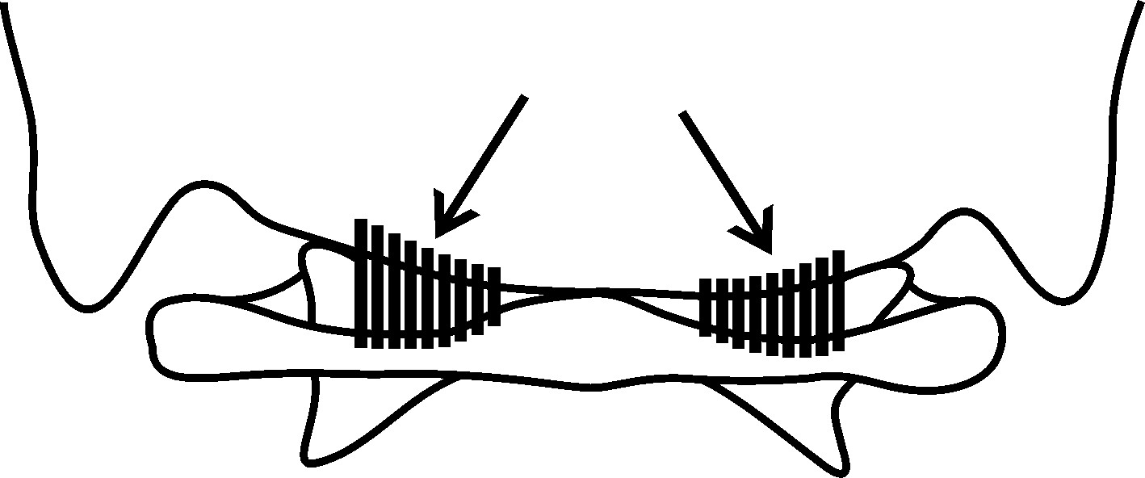

front / anterior
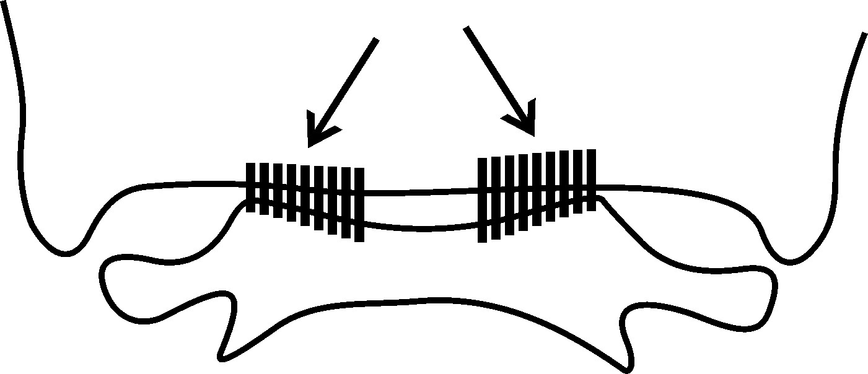
The basic task of the first vertebra is to connect the head to the body. In other mammals, the atlas is larger in relation to the skull and because of their horizontal body position, the atlas holds the head in front of the body so the connection between their skull and atlas is stronger. Compared to the body size, our species have a larger head than other mammals. Because of the speed at which our brain and skull grew larger, our atlas hasn’t had time to adjust to this change and didn’t become properly fixed in its position. Also, because of our upright position, our atlas is smaller and the connection between our skull and atlas is weaker. The connection between the atlas and the skull isn’t strong enough and a blow to the head or body can cause even greater atlas misalignment.
The latest research proves that our head has been getting smaller over the past twenty thousand years. Sometimes during development there is an error which is later corrected. Though it is correcting itself now, it is too late for our generation and those that came before us, hence we suffer from many diseases. Through the discovery of atlas tune up, humankind can permanently improve the health of our present and future generations. When you know what triggers diseases, it is much easier to work your way from the root cause as opposed to simply trying to work through the consequences.

The first thing the universe exerts pressure on is the head, which together with the base of the skull, continuously presses down on the atlas. There is an opening at the bottom of the skull through which the spinal cord runs and next to the opening there are two bone growths covered with cartilage. These two growths rest on the atlas dents which are also covered with cartilage. The contact surface between the skull and the atlas on the left and right side should be the same but it is off balance, causing the greatest problem of humankind.

THE DIFFERENCE IN THE CONTACT SURFACE BETWEEN THE SKULL AND THE ATLAS

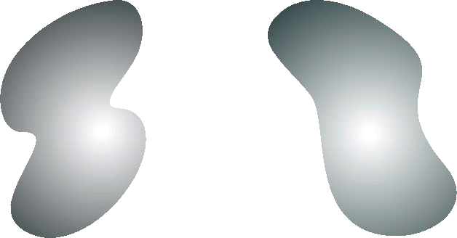

In the twentieth century, several scientific studies confirmed that the left and right contact surface between the skull and the atlas is asymmetric in everyone. If there is a place in the body where there should be complete symmetry, this would be it because the entire bodies arrangement and proportioning stem from this area. Studies showed that in most people, the contact surface is bigger on the right side. In every individual, the contact surface between the foot and ground is proportionate to the contact of the skull and the atlas. In most people the surface at the bottom of the skull is less rounded on the right side than on the left but up until now we didn’t know why.
Let’s return to the anatomical order of the bones in the path of the pressure from the universe: Under the skull there is the first vertebra, followed by the axis, which is Latin for ‘axle’. Only the atlas and the axis have names due to their specific roles and shapes, the other vertebrae have alpha-numerical markings. The axis got its name after a growth which looks like an axle. When we turn our head the first vertebra together with the skull, turns around the growth on the axis. Right there the atlas is in contact with the second vertebra and that contact surface is small but there are two other spots where the atlas is in contact with the second vertebra and these surfaces are larger because those are its resting place on the axis. These surfaces are covered with smooth cartilage and are lubricated with a special fluid so that the head can turn more easily. Around half way through their lives, most people can hear squeaking when they turn their head, and this is because the cartilage on the atlas and the axis gets thinner from the misalignment of the atlas. After atlas realignment the squeaking decreases because the cartilage is regenerated correctly for the first time.
The atlas and the axis are joined through the ligaments and short muscles which allow the head to turn. Between the skull, atlas and axis there are no discs, so the contact is made through cartilage. Discs exist between all the other vertebrae and their function is to connect the vertebrae. Due to their elasticity small movements between the vertebrae are possible so that the spine can easily bend and twist during moving. Because of the upright body position discs in our species have the additional role to carry the weight of the body and relieve the pressure on the vertebrae.
Not much attention is paid to the joint of the skull and the first vertebra in medicine because medicine treats the problem of the vertebrae, discs and disc herniations. Since there is no disc between the joint of the skull and the Atlas, there is nothing to treat. And yet that is where most diseases occur. I won’t bore you with anatomical details, but assuming you wish to know why you have a disease, I am offering the basics for you to understand where diseases occur. The joint of the head and the body is unique because it consists of three parts – the skull, atlas and axis. This joint is the most stressed in the body, because it moves around six hundred times in an hour on average.
The atlas is located in the middle of this joint and its task is to connect the head tightly to the axis, that is, the head to the body. The Greeks named it ‘holder’ but recent scientific discoveries have found that the atlas carries the body and that the universe pressures us from above, so this would mean that the old name is no longer appropriate. I don’t wish to nor do I have the ability to change the name of the first vertebra but I will imply that it is necessary to change it in order that people become aware of its real role. It is true that due to the pressure from the universe, the atlas does hold the smartest head in the known universe, but its main task is to connect the head to the body. With that in mind, I suggest calling the first vertebra the connector. A more accurate name would offer a clearer picture of its importance to human health.
Let me go back to the name of the atlanto-occipital joint. The name of this joint consists of two words. The first, atlanto, is from Greek and the second, occipital, is from Latin. This is a symbolic connection between Greek and Roman medicine. This joint connects two bones, the skull and the atlas but it is only a part of a larger joint that connects three bones – the skull, atlas and axis. This is the most important joint in our body and it would be better if it was given an appropriate name as well. Due to the direction of the universe pressure which is downward, we should change the order of the words. If we change the name, we should also substitute the word ‘atlant’ with ‘atlas’ and finish it with ‘axis’. My suggestion is to call it the occipito-atlaso-axial joint as this name describes the real positioning and role of the joint.
New and precise terminology is important because we are talking about new discoveries which are the key to health and a good life. We live in a fast, digital era where everything is being shortened. Latin for the neck is cervix so the cervical vertebrae bear the following markings: C3, C4, C5, C6 and C7. Sometimes they will write C1 for the atlas and C2 for the axis. The skull consists of several bones but when they write about the joint of the skull, atlas and axis, they mark the skull with C0 (zero). It is easier for me to also use this marking, C0-C1-C2, and so this is what I’ll mostly be calling it going forward.
C0-C1-C2 joint is unusual because it has three parts whereas the other joints in the body have two parts. The atlas is inserted into this joint and it seems out of place there or as if it is an extra. However, everything in our body comes down to the atlas and not only is it a core structure, its position is vitally important to whether we live healthy lives or not. To the atlas itself, the misalignment isn’t a problem, but any misalignment of the first vertebra causes maximal health issues throughout the rest of the body because of its critical location.
The atlas is located in the middle of the C0-C1-C2 joint. However, because of the strong connection between the atlas and the skull it seems that this joint connects two parts just like other joints. The atlas and the skull are tightly connected through short, strong ligaments. These ligaments are in a state of constant spasm from the moment they are formed in the uterus and continuously throughout our lives. Their main function is to connect the atlas with the skull but in order to do their job properly, it is required that the atlas be in its correct anatomical position.
In normal circumstances, the connection between the skull and the atlas is strong but because of the misalignment, the ligaments are not capable of holding the atlas in place even at the lightest blows to the head or body. The cartilage on the atlas and the base of the skull is smooth, which is why it is so easy to misalign the atlas. The atlas weighs only twenty-five grams and it holds the head which weighs around five to seven kilos. The difference in weight and size is considerable which is a cause that the ligaments can’t hold the atlas in place at the moment of impact. The atlas is the smallest vertebra and it is completely different from the other vertebrae, which are alike.
THE ATLAS THE LAST VERTEBRA – L5

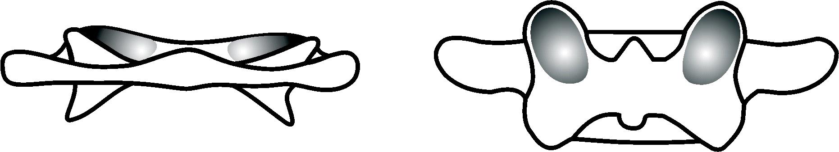

The first and the last vertebra are tilted in the opposite direction, but they are rotated in the same direction. The last vertebra is like the mirror image of the atlas. The wrong position of the atlas is the cause and the wrong position of the last vertebra is the consequence.

THE OPPOSITE TILT OF THE ATLAS AND L5 VERTEBRA

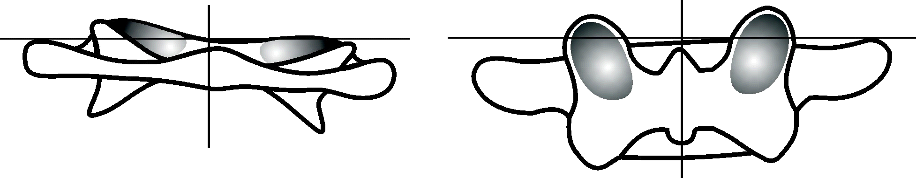

In chiropractic’s and medicine, the last vertebra is the most important because it carries the upper half of the body and suffers the greatest pressure. The last vertebra is treated the most but in vain because it can’t be permanently realigned unless the atlas is properly aligned. When the atlas is tuned up, the last vertebra slips back into its position on its own. Each person’s atlas is slightly misaligned while they are still in the uterus. Before birth, the atlas is only several tenths of a millimetre misaligned and the angles of tilt and rotation are several degrees. These deviations are small, but they are enough to cause a greater misalignment and many diseases during one’s life.

THE UTERUS

The foetus’s body is formed irregularly inside the uterus. To this day it has not been understood why this happens and what the consequences are when a child is born. It is not only the first vertebra that is formed in the wrong place. It would be best if babies’ first vertebra could be realigned before they start walking or at least that it be corrected before a child enters into puberty in order that their body is able to form properly, but it is never too late and regardless of age, once the atlas tune up takes place, you will feel a significant improvement in your health because everything in our body goes back into its natural position, and that is quite miraculous.
There are several theories as to why exactly these errors occur during the process of formation but it’s not something that can be proven scientifically and therefore, any conclusions are mere speculation. Inside the uterus the foetus is well protected, which has made me realise that it is not that the atlas becomes misaligned but rather that it is formed in the wrong place. The larger liver has initially started our health problems, upsetting the balance between the left and right sides of the body. During pregnancy the foetus mostly sleeps with its right side toward the ground and the uterus pushes its head into a bent and tilted position to the left side, and its right shoulder forwards. Everyone has heard of the importance of foetal position, but they have seemed to miss this aspect. Due to the increased size of the liver, the right side of the foetus is heavier and that is what causes it to sleep in that position.
Life was created in water and water is the basic ingredient of every living being. Inside the uterus there is amniotic fluid and the foetus itself is more than ninety percent water. This causes gravity to have diminished effect, but it still impacts the positioning of the foetus and its development. This theory could be scientifically proved by looking at the millions of photos from sonograms of the foetus within the uterus.
The uterus offers the best possible conditions for the development of the foetus in mammals, and it is the same for humankind. The uterus itself is not the reason why the foetus forms incorrectly but rather the unique elongated shape of our body, which happens because of our upright positioning. Unlike other mammals who have front and back limbs, we have upper and lower limbs. As opposed to their elongated chest, ours is flattened, which makes it so that we are the widest around the shoulder girdle. Their head is in front of their bodies and ours is positioned upward.
In the first months of development, the head of the foetus is larger than its body and by the end of pregnancy it makes up one third of the body. During pregnancy, the uterus pushes the foetus’s head into a bent position and when the foetus turns its right side downward while it’s sleeping, the uterus tilts its head to the left. Due to these two opposite pressures to the foetus’s head, the atlas is formed into two misaligned positions – backwards and tilted, downward on the right side and upward on the left. As if these two misaligned positions weren’t enough, there is something which causes a third. The uterus pushes the right shoulder forward and there is no pressure on the left one, causing the rotation of our shoulders, the right being forward and the left being backwards. Therefore, the atlas is rotated in the opposite direction with the right side being backward and the left being forward. The shoulder girdle is like a lever which is pushed by the uterus at one end and because of it a double body rotation occurs along the longitudinal axis. Looking from above, the head and the cervical area of the spine are rotated clockwise, and the rest of the spine and the body counter clockwise.

THE UTERUS EXERTING PRESSURE ON THE FOETUS

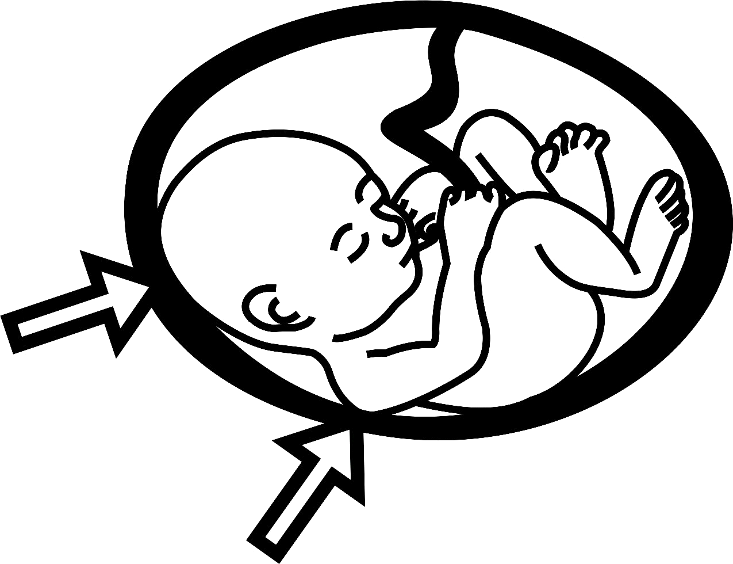

When there is more than one foetus in the uterus, their atlas forms in different positions because they can’t turn their right side downward toward the ground due to the limited space in the uterus. That is why even identical twins’ atlases are in different positions before birth. In one out of ten-thousand foetuses, an anomaly occurs where the organs are arranged in a perfect mirror image of what is considered normal. In Latin this is known as ‘situs inversus’. In those cases, even the heart can have a right-sided aortic arch and a reversed direction of beating. The atlas is also formed completely opposite to most foetuses and that exception will confirm the rule and my theory.
OPPOSITE ROTATIONS OF THE FOETUS’S BODY

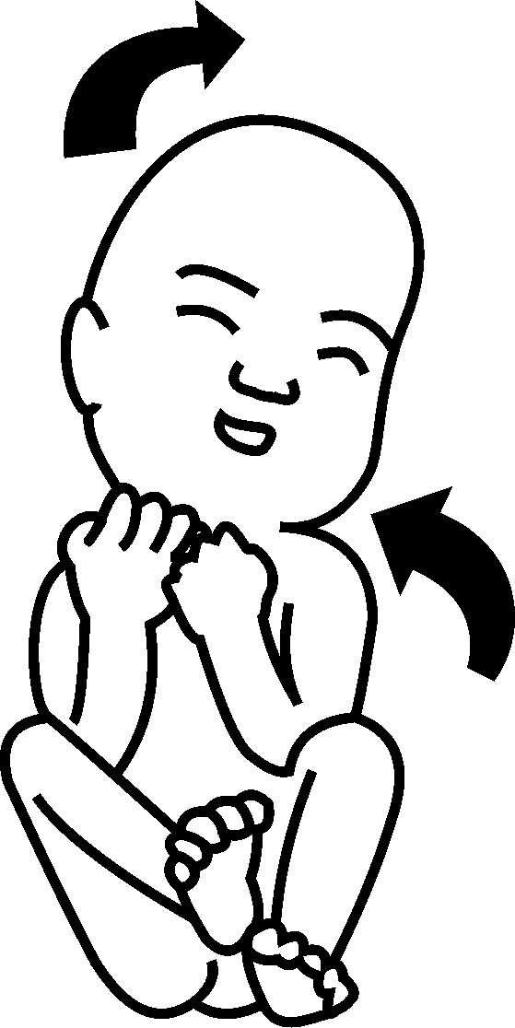

In most foetuses, the atlas has a combination of four misaligned positions:

TILTED to the right and downwards, to the left and upwards
RIGHT
ROTATED to the right and backwards, to the left and forwards
BACKWARDS

anatomical site ............... wrong place –––––––

TILTED AND RIGHT

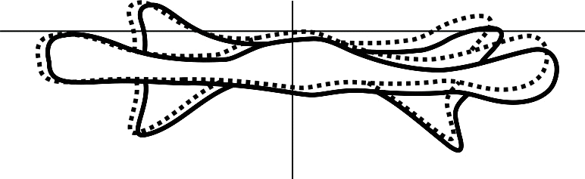

ROTATED AND BACKWARDS

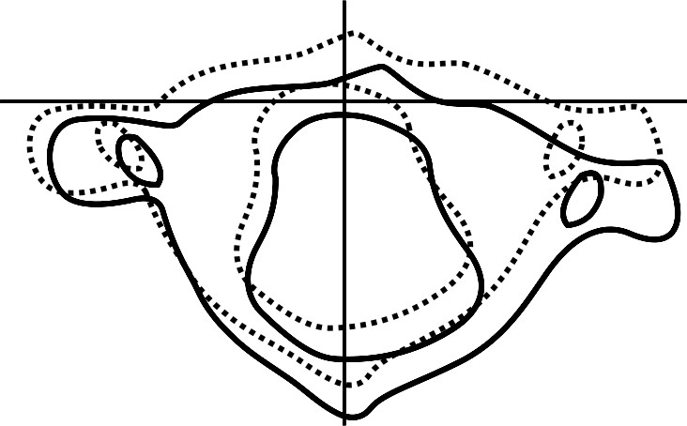

In most people, the initial misalignment of the atlas is present throughout their lives, causing people in general to have not only similar illnesses but also a similar pattern in which they occur. In some people, over the course of their lives the atlas is misaligned into a different position due to an injury of the head, neck or body, which then causes them to suffer from other diseases and deformities. Everything I have said about the atlas forming in the wrong place is my own discovery, completely new to humankind. I haven’t had the ability yet to conduct scientific research, but I have come to these conclusions through my thinking. Scientist will test these discoveries in the future and I will be happy to see the results because they will confirm my findings, which will serve for the benefit of all humankind.

On the following pages I will mention other events occurring inside the uterus that can affect the development of the foetus and the formation of the atlas. The incessant beating of the heart during the development of the foetus can affect its bones and cause the atlas to become misaligned as well. The heart is formed at the end of the first month and in the following eight months, it beats over forty million times. The heart of a foetus beats much faster than throughout the remainder of its life. Although the beats are weak, the foetus is so fragile that it is possible that the direction in which the heart is beating affects the development of bones and the alignment of the atlas. The heart beats from the right to the left side, causing the apex of the heart to pound with kinetic energy against the left side of the chest. Due to the position of the foetus during sleep there are already body rotations in the opposite direction and the beat of the heart against the chest happens exactly in the direction of the chest rotation, causing most foetuses to have a slight displacement to the left in the sternum.

The mammal heart beats an average of about two billion times during its life. To help you understand the kind of force within a heartbeat, I invite you to do a little experiment. First, you will need to sit on a chair. Make sure you are sitting straight without leaning. After ten seconds or so, you will feel your body moving left to right. The same thing happens to the foetus, but the impact is even greater because the foetus is in amniotic fluid where there is relative weightlessness. As the amount of amniotic fluid is different in each pregnancy, so is the effect on the positioning and development of the foetus.

The foetus is attached to the uterus through the umbilical cord. The force that the umbilical cord exerts on the foetus is small, but depending on the foetal position, it can be enough to affect its formation. One out of two babies are born having its umbilical cord wrapped around its neck. At least in most cases, it is not a problem at birth as it is quick to fix. The actual problem is that during pregnancy, the umbilical cord pulls the neck to one side, causing the head and the body to face opposite directions. It is possible that this also causes the atlas to be formed in the wrong place, linking this to health problems occurring before and after birth. Nerve impulses and blood flow decrease when the atlas is misaligned, and the umbilical cord presses the neck. Depending on how many times the cord is wrapped around the neck, the atlas is formed more or less misaligned. During pregnancy the cord is usually around the neck and is later removed but even when it is wrapped around the waist, leg or arm it can still misalign the first vertebra. The children whose cord was wrapped more times are generally more ill.

About ten days before labour, the foetus turns head down toward the pregnant woman’s pelvis, which in most pregnant women, is in the wrong position (tilted – to the right upwards, to the left downwards, and rotated – to the right – backwards, to the left forwards). The pelvis is minimally misaligned, but it is enough to deform the foetus’s body even more and to misalign the atlas even further in the direction of an already existing misaligned position. One of the theories about the atlas formation in the wrong place claims that this occurs genetically. It is hereditary, but it is not genetic, and I will explain my opinion in the following paragraph.

There have been several decades of research done on the human genome and there was finally a discovery in the year 2000. Among other things, hox genes were discovered. They oversee bone formation and the correct direction of the foetus’s body. Bones form in good positions and the mechanical force of the uterus pressure changes them and therefore the foetus’s skeleton is slightly deformed.
I have one more idea why this double rotation before birth occurs, but it is difficult to prove it at this stage of scientific development. Everything in the universe rotates including atoms. The foetus’s body is made of atoms and it is possible that this affects it as well. The body of a foetus and an adult person contains energy rotation points called chakras. From the feet up, there is a vortex through our body which changes direction and when it is above the head it is directed to the opposite. It seems incredible, but the foetus’s body is rotated in these exact directions.

It is not important to me that my theory be proved but it is important for humankind to know why the atlas is formed in the wrong place inside the uterus. With the proof, maybe someone will find a way to influence the development of the foetus allowing us to remove the cause, rather than having to try to reverse the consequences. It would most likely take a higher level of technological development than what we currently possess but thankfully technology seems to be always moving forward. It is possible now however, to realign the atlas in females. During puberty their pelvis will go back into its correct anatomical position, meaning that when they are pregnant their foetuses won’t develop in a misaligned pelvis. During pregnancy, three atlas misalignments occur, namely backwards, rotated and tilted. This combination of misalignment remains present throughout most people’s lives and gradually increases over the course of time, causing us to become even more ill.
FACTS

As I’m writing this book, I’ve been very careful to only include what I know to be true because I respect myself, you and this discovery. Science will be able to verify the discoveries discussed in this book. I want the research results to be published as soon as possible because that would hasten the process of atlas realignment. The fact is that the atlas forms in the wrong place and that throughout our lives this misalignment increases. The ligaments that connect the atlas to the skull are stretched and can’t hold the atlas tightly. When the atlas is more misaligned it causes the ligaments to stretch further and hold it even more loosely. This combination of events over the course of time allows it to misalign more easily and causes more difficulties and diseases to occur.

Unfortunately, the position in which most women give birth in is not natural. They deliver babies half lying down, because it makes it easier for the midwife to catch the baby. For thousands of years, women delivered babies in a squatting or kneeling position because in these positions gravity helps them deliver more easily. Labour is difficult for the woman giving birth, but it is even more difficult for the foetus. Not only does the uterus exert pressure on the foetus during contraction, the foetus is also pressed by the pelvis. This affects the foetus’s atlas, causing it to become even more misaligned during labour. The moment that the head comes out, the neck is in the tightest part of the pelvis and that is when a short break occurs while the midwife turns the baby’s head so that the shoulders can come out. Most of the time midwives turn the head in the direction of the atlas misalignment. The baby is widest around its shoulders, so once the shoulders are out the labour is basically over. Male foetuses are larger and that is why their atlases are more misaligned during labour.

During labour, the parietal bones of the foetus’s skull overlap, and the woman's pelvic bones widen. For tens of thousands of years, babies have died in labour because of the size of their head and because the small pelvic inlet. The research has shown that in the past twenty thousand years our head has been getting smaller and it is necessary to find out if the pelvis is likewise getting bigger. During the seventh month of pregnancy, the atlas of the foetus is less misaligned than in the ninth and the body is smaller as well. If a woman goes into labour and gives birth in the seventh month, the atlas is less misaligned.

It is best if labour is normal and natural. Unfortunately, sometimes a breech birth occurs, causing the first vertebra to be even more misaligned and if it becomes necessary to use forceps or a vacuum, this affects the atlas even worse. It is well known that these children have serious health issues in life, but it is not known that it happens because of a greater atlas misalignment during birth. Even when the foetus is developed normally but is then born using a vacuum, the child is often ill. Severe misalignment can even lead to suffering from cerebral palsy.

The duration of pregnancy is not the same among all mammals but regardless, the young are born unfinished and because of breastfeeding, they stay with their mothers for a while. We are born less complete than other mammals due to the large head of the foetus and the narrow pelvis of the mother. Most mammals’ young can stand on their feet after a short while because it is easier to stand on four feet compared to two. That is why babies crawl on all fours only after six months and they walk when they are about a year old. Some babies start walking on their own, but most babies start walking with their parents’ help. When they start walking, their parents are happy and applaud them and that joy of a thousand generations of humankind is a note of congratulations to the first Homo erectus who rose to the upright position.

Compared to other animals, our species has the longest period of raising their young. In mammals in general, it is usually a combination of instinct and imitation of the parents. In our species the learning process lasts until we reach the age of maturity. Parents help children grow up and then children return that love by helping their parents when they are old. That close connection between children and parents lasts their entire life. Our generation is really concerned and saddened to see their parents affected by so much pain and illness. It is not easy to raise children, but it is even more difficult to take care of ill parents.

Until the age of modern medicine, one out of three children used to die during the first year of their lives. Atlas misalignment used to weaken children’s immunity and they easily died of infections. Medicine keeps such children alive, but they are more ill than others throughout their lives. When these children grow up their genetic code is worse and when they have children of their own, it aids in the rapid degradation of humanity. During the past millennia, the average human lifespan was around forty. Life was shortened due to infections and wars but there were still people living to be eighty years old. Nowadays the average lifespan is around seventy-five. Lifespan has been prolonged with the help of modern medicine which found antibiotics to aid fighting infections, however their life is burdened with disease in old age. Unfortunately, most people die not of old age, but of illnesses.

Scientists, who estimate how long our lifespan could be say that we could live to be one-hundred and twenty and still be healthy. The misalignment of the atlas stands in the way and is the cause of most diseases and leads to a shorter life. The undeniable fact is that when the atlas is misaligned, more illnesses occur. The fact is that treatment has existed for thousands of years and that there are always new types of treatments, but people are still ill, and statistics show that we are becoming more ill. Even without statistics, we can notice this happening in our surroundings.

Modern medicine is constantly developing and yet people are increasingly more ill. It defies logical explanation. Atlas misalignment triggers illnesses, therefore people use medicine and pharmaceutics to prolong their life artificially, but their life is still riddled with sickness. Maybe not everyone wants longevity, but everyone wants to live healthily, they just don’t know how to achieve it. Medicine and pharmaceutics are not the only ones to blame but also our modern way of life. Our food and environment are ever more polluted. We take around four kilos of poison into our body through air, water and food in duration of one year.

THE ELIXIR

For thousands of years, rulers would send their emissaries around the world to find the elixir of life. Everyone loves life but rulers love power so much that it creates an illusion that they are more important than their subjects. Modern rulers also search for the elixir of life and they pay thousands of dollars to scientists but their search is still unsuccessful. Scientists know that we could live to be one hundred and twenty, but they just can’t seem to figure out how. They have mostly sought for the elixir outside the body but even those searching for it within the body can’t seem to figure out the exact location. Everyone has been searching for it in the wrong place. The elixir is not thousands of kilometres away but inside the body. Everyone, even before birth, has within their body a perfect and natural elixir, but the problem is that something prevents it from working as well as it could. Atlas misalignment is the brake that slows us down and stops us from having an optimal life.

The elixir of life is the realigned atlas. When the first vertebra is in its correct place, the flow of nerve signals and matter in the body becomes normal which enables us to regenerate more optimally and to have a longer, healthier life. Having the atlas tuned up will allow the young to live healthy, long lives and the older amongst us will feel as if they’ve been reborn. They may not live to be very old because their body has been suffering for decades, but it will allow whatever time they have left to be healthy and without pain. The essence of a quality life consists of giving and receiving love within your surroundings and the success of humankind depends on cooperation that dates back to tribal communities. Thanks to our numbers and faster communication, humankind has become one giant tribe that is only minimally different from the original tribe. We are all descendants of thousands of couples who survived the natural disaster seventy-two thousand years ago, so despite our differences we are all brothers and sisters, providing space for less hate and more love between us. When someone is ill however, they don’t love themselves or anyone else. For now, we need to go back and examine the place in the body where diseases occur.

THE CAUSE

In most people across the world atlas misalignment is the cause of just about every health problem. The atlas presses neural pathways, decreases matter flow and curves the body. Just one of these irregularities is enough to cause illnesses but unfortunately there is this combination of all three. How is it possible that one small bone can be the cause of almost all illnesses, enormous human suffering and a shortened life? The answer to this question is simple. The atlas is situated in the most important place in the body and that is why any misalignment from the anatomical position decreases nerve impulses and blood flow and over the course of time, curves the spine and the body.
A more important question is: how is it possible that medicine has never paid any special attention to the atlas when its position is so important. There is no answer to that one. Modern medicine researches DNA and tries to manipulate genes at the molecular level and change our genetic code. Surgeries are conducted with micron precision, but medical experts don’t see atlas misalignment which is, on average, nine centimetres wide. Medicine cures illnesses and the atlas is not ill. Out of all the bones in the body only the first and second vertebrae don’t lose their bone mass. They keep the shape and density until the end of life. This is an extremely important place in the body and that is why the atlas and the axis regenerate correctly throughout life.
The complexity of organisms is extraordinary even in microorganisms. However, the same principle applies as in the biggest animals – the tiniest part of the body is in the service of the entire body and likewise, the entire body is in the service of the tiniest part. When any part of the body malfunctions it causes problems to occur throughout the body. In our species, the key position is disturbed and that causes constant weakening of the body. In mechanical clocks, tens of wheel gears and hundreds of teeth set the hands of clocks in the position that shows the time. If one tooth is out of place, then the whole clock breaks down and shows the wrong time.
Where in the human body do we find that broken tooth? Unfortunately, it is in the worst possible place. The base of the skull has skipped the atlas and causing the entire body to break down and our lifespan to be shortened.
At the age of twenty we realise how short two decades are and we watch our grandparents suffer from illnesses from the age of fifty. We hope that we will be healthy in old age and that we will enjoy the fruits of our labour but usually that doesn’t happen because of illness and because most of our pension is spent on futile attempts to heal them. Even those who live to be one hundred, feel that they have been denied several years of life and that they have neither received nor given everything they would’ve liked to.

THE CURVATURE OF THE BODY
Before atlas misalignment was discovered, it was believed that the spine and the body curve from the feet up. Why does the body curve and how is it possible that the body curves from the head down? In babies the atlas is already misaligned and that is why their head is tilted and slightly rotated. When they reach the age of six months, babies start to sit, and their head is slightly tilted in relation to their body so that balance sensors are in a horizontal position. That becomes even more apparent when children start to walk and the body tilts so that the head can stay vertical. The centre of gravity allows us to stand upright without falling and the price we pay for the upright body position is different diseases that occur due to the curvature of the body and the spine.
Babies and children can feel that there is something bothering them in their neck region and when the atlas is too misaligned, that is when they keep their head down or tilted. Children, whose atlas is more misaligned sleep with their head in strange positions relative to the body because that eases the pain in that area. When children are nervous, they push or hit their head against a bed rest or wall and some children may put their thumbs in the mouth, which is misunderstood as the need for breastfeeding. These children feel that there is something wrong in the area in the rear of their neck, but they don’t know what exactly is going on. Parents take them to the doctor but doctors wind up giving incorrect diagnoses and treatments that worsen these children’s health because they don’t know what it is either.
THE CONTACT SURFACE BETWEEN THE SKULL AND THE ATLAS

symmetrical surfaces

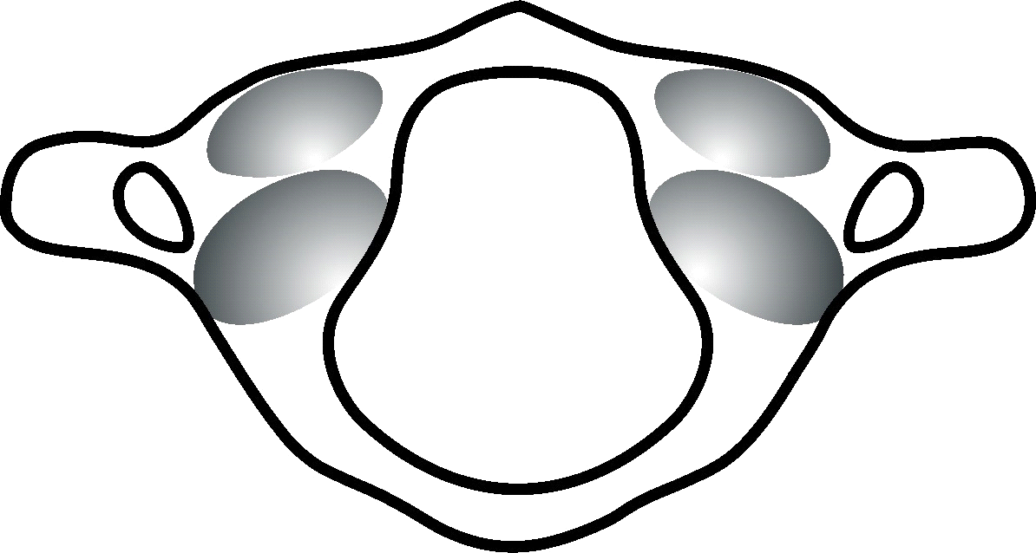

asymmetrical surfaces

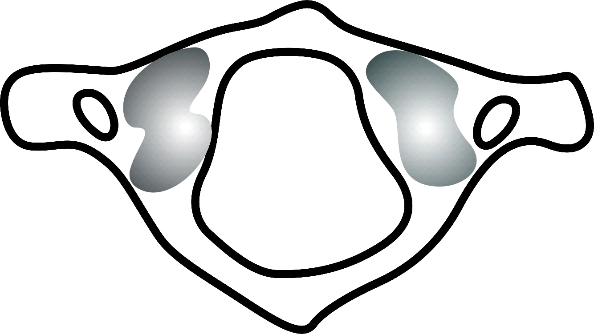

There are only a few scientific papers dealing with the cartilage at the base of the skull and on the atlas. These studies have confirmed that the contact surface on the right is larger than on the left in most people. This has been merely observed but no one has realised why such asymmetry exists. Research has been published comparing the relation between the contact surface of the skull and the first vertebra when the weight is on the right and on the left foot. It has been proven that there is a ratio between these surfaces and foot pressure and in most people, the pressure on the right side is greater. The research has confirmed that immediately after the atlas is tuned up, the pressure of the right and left foot is equalized due to better statics and the spine and the body start to straighten.

THE CONTACT SURFACES OF THE FEET

before realignment after tune up

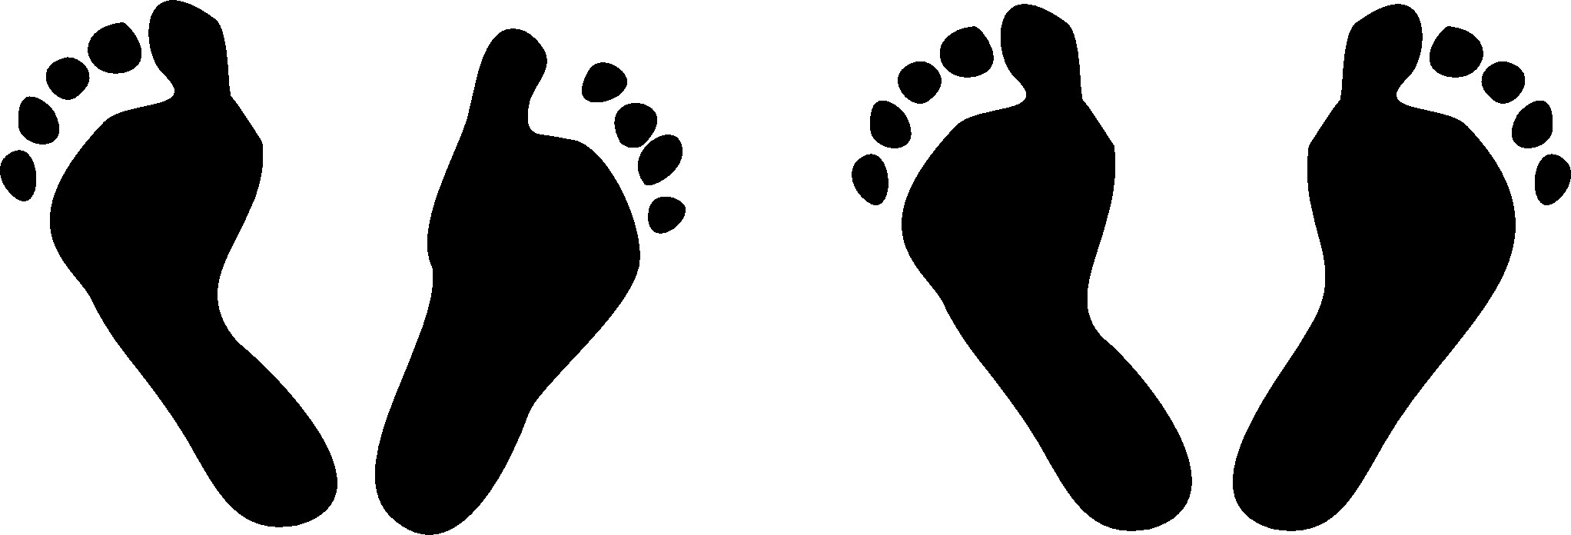

The thickness of the cartilage at the base of the skull and on the atlas should be the same throughout. Unfortunately, in most people that isn’t so, and the cartilage is thinner where the pressure is greater. It is only a couple of tenths of a millimetre thinner but that causes the greatest problem of humankind. This has stayed hidden and immeasurable for science, with only a few scientists dealing with it. But they too have failed to figure out why this happens. Up until now, the greatest problem of humankind has been hidden in the most secret of places - under the head.

THE THINNESS OF THE CARTILAGE

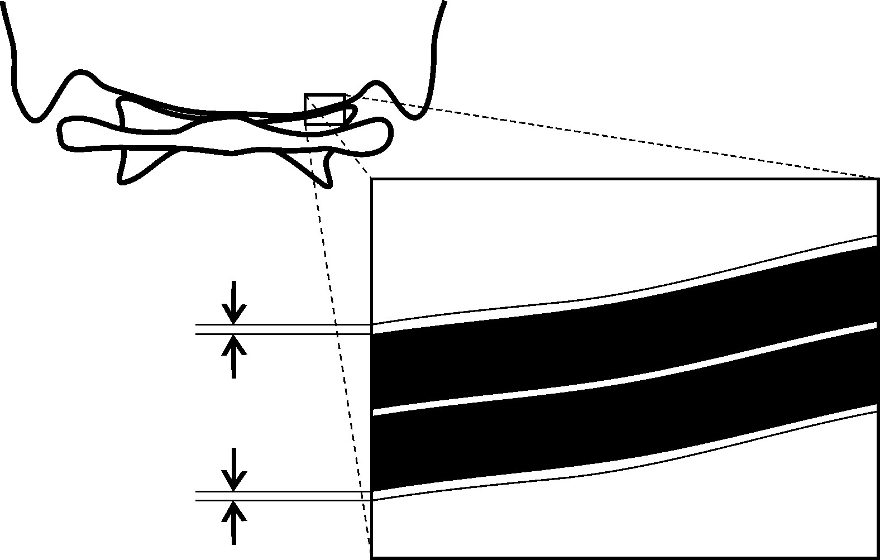
For the sake of truth and understanding it is important to emphasise that the atlas itself is not the cause nor is it responsible for human suffering. The misalignment of the atlas is just the consequence. The cause of all irregularities and problems is the head tilt and rotation relative to the body in almost every human. This claim seems unbelievable because it seems that everyone’s head is normal. It is true that in most people, their head is upright in relation to the ground, but its position is not normal in relation to the body. The foetus’s head inside the uterus is positioned in a slightly incorrect position in relation to the body and its position only worsens once the baby starts to sit or walk and it continues worsening throughout one’s life.
THE POSITION OF THE HEAD IN RELATION TO THE BODY
normal misaligned

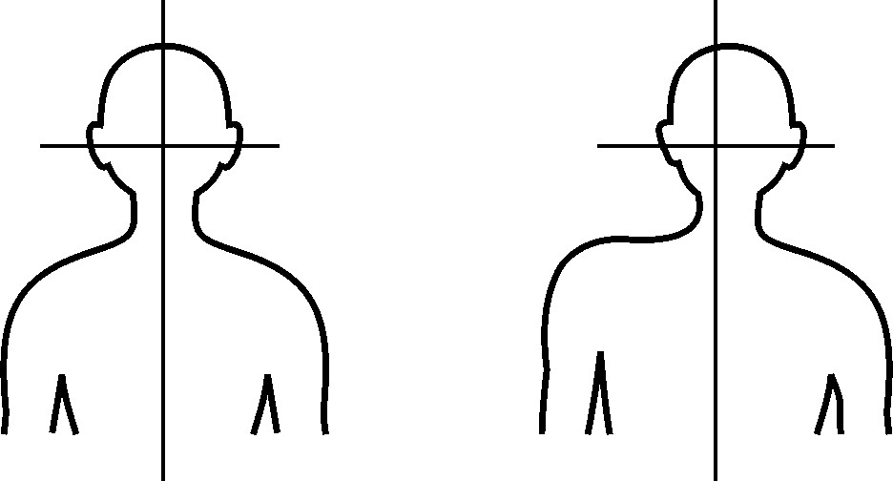
It is scientifically confirmed that Jeanne Louise Calment was the oldest person in the world. She lived to be 122 and towards the end of her life she sang and recorded records. She was among a dozen people in the world whose atlas was aligned throughout their lives. The head straightens when the atlas is misaligned to make sure that balance sensors are in a horizontal position, helping us to not fall. Unfortunately, this same thing also causes our body and spine curve.

The curvature of the body exerts pressure on the joints and that is what thins out the cartilage on them. Our muscles try to straighten the body and they become fatigued, causing pain to appear. Most people try to alleviate the pain using medications or massages, both of which provide temporary and insignificant relief. The upright body position has allowed us to be who we are, but atlas misalignment takes away our ability to be healthy. We can’t go back to walking on four feet, but we shouldn’t have to live with diseases either. After realigning the atlas, the pressure from the universe straightens the body and we get better.

THE DECREASE OF NERVE SIGNALS
At the base of the skull there is an opening through which the spinal cord runs but there is an opening in the middle of the atlas as well. Because the atlas is misaligned these two openings don’t match up and depending on how and where it is misaligned, the atlas constantly exerts pressure on nerves.

THE MISMATCH OF THE SKULL AND THE ATLAS OPENINGS
the skull opening the atlas opening

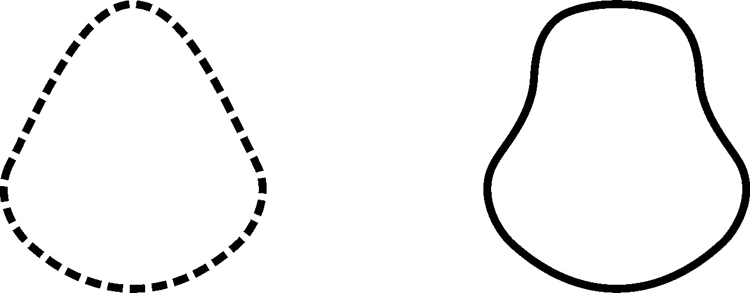
THE OPENING OF THE ATLAS
forwards backwards to the right
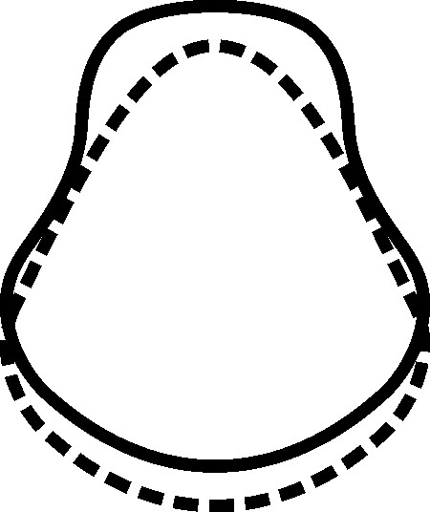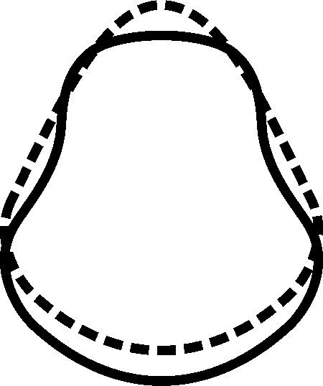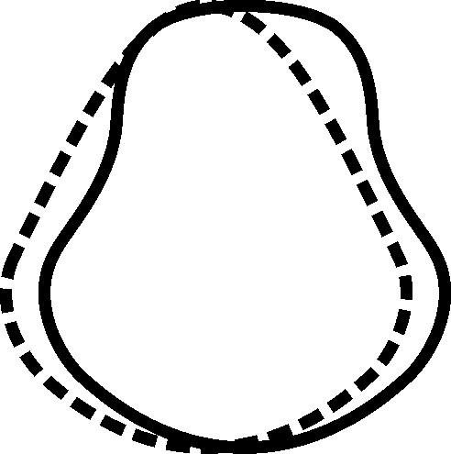

The atlas presses the spinal cord, which begins in the area of the atlas and through which almost all nerve signals travel, in the worst possible place. However, the worst thing is that this is the location of the oldest and smallest part of the brain which contains the centre of vital functions. It is usually thought that the brain is a single unit, but it is made up of multiple units which, independently, have specific functions. Roman doctors noticed a mass at the beginning of the cord and they named it the ‘medulla oblongata’, not knowing that it is a part of the brain.
The unwritten rule is that there are precise names which are different from scientific names and this is the case with the smallest brain. Different nations call it ‘the centre of life’, ‘the knot of life’, the tree of life’, ‘the trunk of life’ and ‘the crossroads of life’.
In medicine as well, there are more names – vegetative, autonomous, automatic and primary brain. There is no other part of the brain with so many names, which indicates how important this particular part is. Apart from being extremely important for the functioning of the body, this part of the brain still doesn’t get enough attention and it is not known that almost everyone’s atlas exerts constant pressure on it. For this part of the brain I will use the name ‘the first brain’, because that describes its role most precisely. That is where the commands for the beating of the heart, breathing, blood and lymph circulation, blood pressure, digestion and muscle activity come from. Apart from these basic tasks, the first brain is also responsible for – regulating body temperature, salivation, sneezing, coughing, vomiting, as well as falling asleep or waking up.
The commands for staying awake and sleeping may seem irrelevant but this is necessary and important to give attention to because our body heals and regenerates during sleep. We fall asleep when the first brain equalizes the frequencies of the right and left side of the cerebrum and we wake up when it separates them. Up until recently, it was thought that the body heals and regenerates around ninety percent during sleep, but the latest scientific findings suggest that the percentage is ninety-nine. It would be best if we woke up when the first brain decides and not by an alarm clock which interrupts the processes that are happening during sleep. The first brain uses twelve cranial nerves to communicate with the environment, it receives information from the body and reacts to all these signals. The first brain doesn’t only regulate our physical body but our psyche as well. The centres of motivation, feelings, concentration and orientation are located in the first brain. Psychiatrists and psychologists have neglected it and instead look for the causes of mental problems in the cerebrum.
Due to the horizontal position of the spine and body, other mammals’ first brain is in front of the first vertebra but since we are in an upright position and have an enlarged brain, the first brain of our species descended into the atlas area. This means that when the atlas is misaligned even minimally, it exerts constant pressure on the first brain. Due to the mismatch between the opening of the skull and the atlas, there’s pressure on the spinal cord causing a decrease in nerve signals. However, it is even worse when the first brain is pressed because then it can’t function at full capacity. Depending on what exactly is being pressed in the first brain, there could be problems with the heart or breathing, bad blood and lymph circulation, high or low blood pressure, indigestion, as well as mental problems. The stronger the pressure, the worse the impact is, and more problems occur.
I have mentioned that the first vertebra rotates around a growth on the axis. On three sides of the growth, there is the atlas bone and on the fourth side there is a strong ligament that is part of the atlas. That ligament exerts constant pressure on the first brain such that when the atlas is even a fraction of a millimetre misaligned, it causes problems in the body. Primitive organisms only had the first brain. As they developed over time new parts of the brain and additional neural pathways were formed. On the left and right side of the first vertebra there are the left and right vagus nerves. These nerves are also pressed when the atlas is misaligned due to being tilted and rotated. The left and the right part of the heart receive different signals from the vagus nerves and that causes arrhythmia and other heart problems. Something very similar happens to all other individual organs. It causes problems for paired organs as well such as if one vagus nerve is pressed, it causes one kidney to be ill or have a stone in it while the other kidney remains healthy.
Through urine and faeces, we eliminate the products of metabolism and in humankind there is also elimination through the skin by way of sweating. Sweating eliminates waste products, but it also regulates body temperature when we become too hot. Sometimes people sweat more or less than what would be considered average and these irregularities occur due to the atlas exerting pressure on the vagus nerves which give the signal for sweating. After realigning the atlas, sweating becomes regulated in most people. In addition to the first brain and the vagus nerves, misaligned atlas also presses one more neural pathway. On the left and right side, between the skull and the atlas, there are nerves that innervate the head. Depending on misalignment positions, it creates different types of pressure on these three neural pathways, leading to a variety of difficulties and diseases. Throughout life the pressure of the atlas continues to increase, making the overall condition of the body worsen and incites new diseases to occur.

DIFFERENT COMBINATIONS OF THE PRESSURE ON THE NERVES

1. the first brain 2. the vagus nerves 3. the head nerve
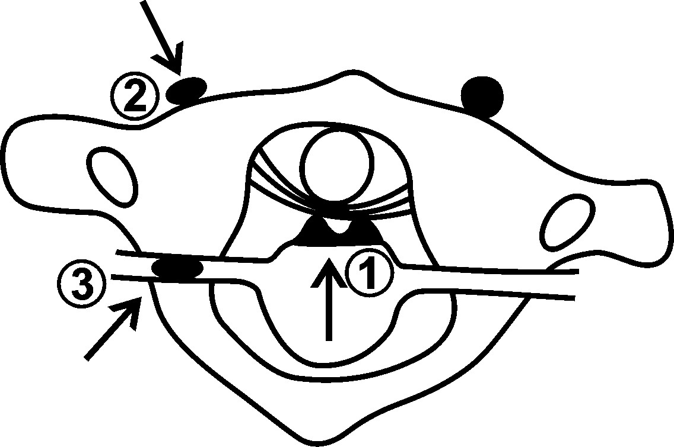
The spine curves because the atlas is misaligned and that is why the vertebrae are not in place. Nerves leading to organs are exiting the spinal cord and spreading next to the vertebrae. Next to the atlas, nerve signals are decreased, and the pressure of other vertebrae additionally decreases these signals. When we get old, our spine rapidly curves and that is why we have more health problems later in life. When nerves leave the spine, they pass next to the ribs, and they are additionally decreased because we sleep in bad positions. That becomes a major health problem because our organs work the hardest at night.
THE NARROWING OF BLOOD VESSELS
In other mammals the first vertebra is of similar width to the other cervical vertebrae, in human beings is wider due to our upright position and the size of our head. Through and around the atlas, there are blood pathways leading to the brain and they are pressed due to the misalignment and the width of the atlas. The atlas and the cervical vertebrae have small holes on their sides through which the vertebral arteries run. All blood vessels in the body are important but these arteries carry a special importance because they supply blood to the bottom parts of the brain, which oversee the bodily functions.
When the left and right vertebral arteries enter the skull, they join into the circle of Willis, which equalizes blood pressure before it enters the brain. Due to decreased blood flow on one side, a blood vortex is formed at the beginning of the circle of Willis which is why nitrogen atoms are released. Nitrogen destroys our brain cells and that is one of the causes of Alzheimer’s disease.

When we are young, baldness is an aesthetic problem and many older men lose their hair completely. Men suffer from baldness much more often than women, but it is unknown why. Because the atlas is misaligned, men’s heads are more bent than women’s, thus they don’t have enough blood under the skin of the head and it is blood that supplies the particles for hair growth. The last place to go bald is the back of the neck because there is sufficient blood in that area. To decrease the possibility for boys and young men to go bald, it is necessary that they have their atlas realigned.

THE PRESSURE ON THE RIGHT VERTEBRAL ARTERY

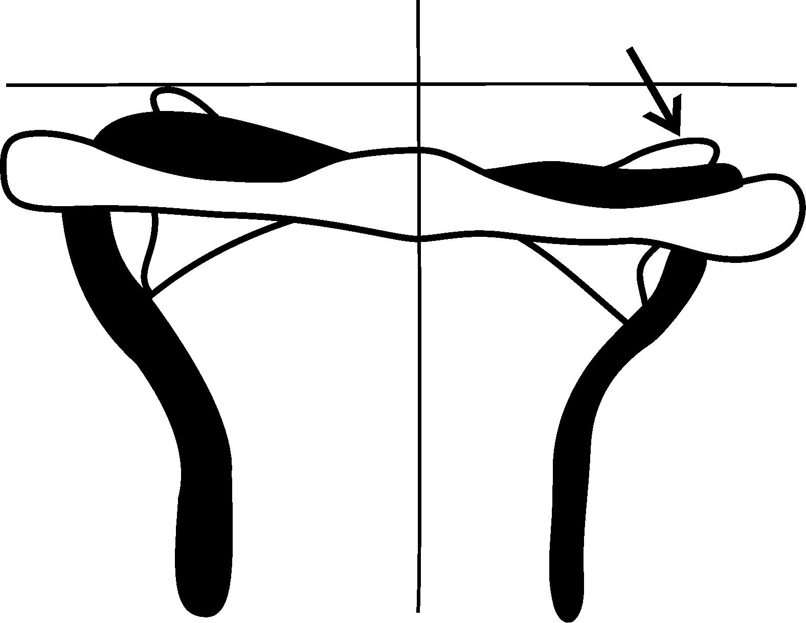

The carotid arteries run through the neck and pass next to the first vertebra. These arteries supply blood to the upper part of the brain. In most people, the atlas is lifted and rotated forwards on the left side. That exerts constant pressure on the left carotid artery and it is the reason why most people don’t have enough blood in the left side of the cerebrum, which is responsible for rational thinking. The atlas is misaligned even before our birth and as a result fifteen percent less blood flows through the left carotid artery than the right.
THE PRESSURE ON THE LEFT CAROTID ARTERY

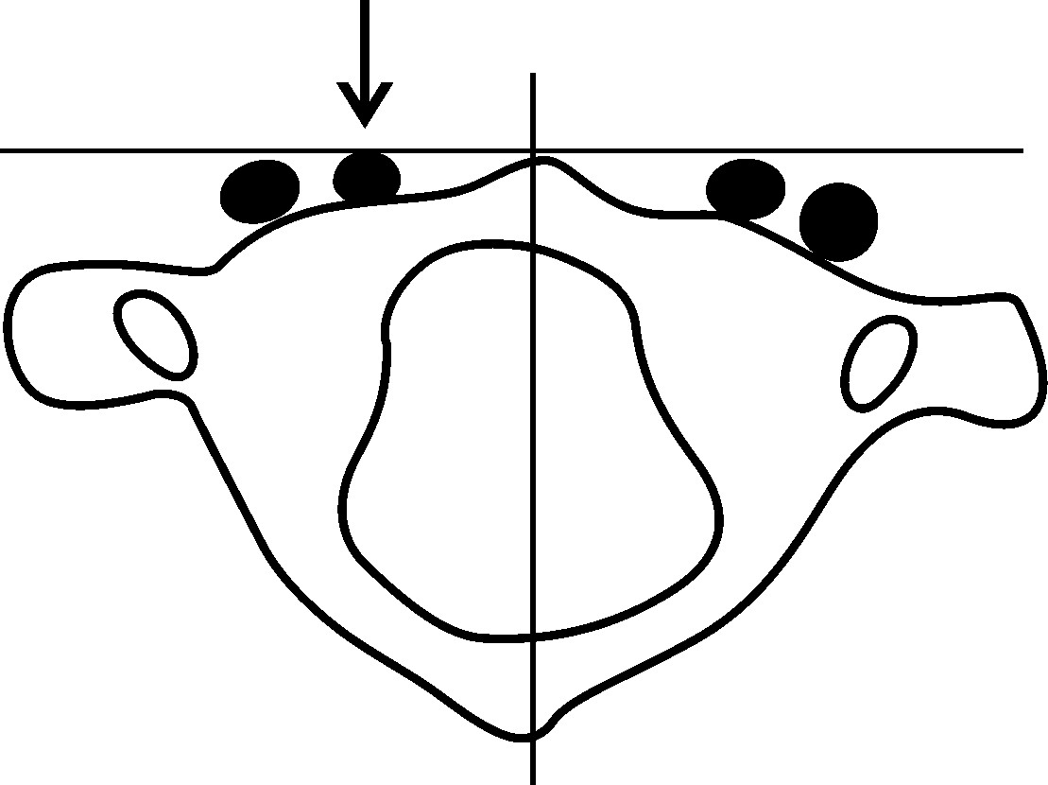
Due to similar misalignment positions of the atlas in most people, less blood flows into the right part of the lower brain as well as the left part of the upper brain. It is a very similar pattern when the blood is flowing out from the brain. Veins are also being pressed by the atlas causing blood flowing through the brain to slow down, leading to impurities being deposited into the blood vessels. The brain is the most protected organ and the only way through which impurities can reach it is through the blood. Neural signals are transferred through electrochemical reactions and when neural pathways are obstructed, the flow of neural signals is slower and as a result, the functioning of organs and systems in the body decreases. The blood deposits iron into the brain and the molecules from the iron create a short circuit and decrease neural signals. Such decreased signals leave the brain and are additionally diminished because neural pathways next to the atlas and other vertebrae are pressed.

THE CONSEQUENCES

In nature there is usually a single cause with a single consequence but with the misalignment of the atlas, there is one cause with many consequences. Using computer language – in the lower part of the brain there are programs for the proper functioning of the body. When the first vertebra is misaligned, not all signals reach the entire body and so the body is unable to function normally. It is similar with the flow of matter in the body because for cells, organs and systems to function normally, sufficient matter is necessary at the right time. Metabolism is the compatibility of different systems in the body, so a normal matter flow is extremely important. In order to live, cells use chemical compounds from intercellular spaces but when there aren’t enough compounds or when there are too many, the cells can’t function normally.
Cerebrospinal fluid is found around the brain and spinal cord and is there to protect them. When the atlas is misaligned, it does not upset the fluid around the brain, but it decreases its flow around the spinal cord, which decreases the level of protection. Salivary glands also don’t function well when the atlas is misaligned. If the composition of the saliva is off or there is simply not enough saliva, this can affect digestion. Not to mention, the modern way of life often makes us eat fast which means that saliva is already unable to play its role optimally. Lymph and the lymphatic system are our first line of defence against viruses, bacteria and other impurities. The lymphatic system exists in the entire body, but it is strongest in the upper third of the body because external causes of illnesses are usually introduced through breathing and food. When the atlas is misaligned, it disturbs lymph pathways and decreases the body’s natural protection from biological dangers.

There is a reason why blood is called ‘the river of life’. Its task is to supply nutrients and oxygen to every cell and to help purify the body. When the atlas exerts pressure on the centre of circulation, all body systems are endangered. We get the energy necessary for normal functioning through the process of burning food nutrients and we get the necessary material for cells regeneration from chemical compounds. Due to atlas misalignment metabolism deteriorates, causing a slowdown in regeneration. When health is impaired by the basic cause of a disease it weakens the body, allowing external factors to easily worsen our health. If there are any difficulties and diseases in the body, the body spends the energy of life on trying to heal, but it never heals completely because the atlas remains misaligned. The attempts at healing spend our energy and weaken our immunity and make it easier for viruses, bacteria and parasites to exhaust the body.
Health difficulties are the centres where diseases are slowly created. We are not aware of some of these centres and they can’t be discovered in medical examinations, so they are often not found until a disease has occurred. The difficulties may be aesthetic, mental or health nature. The aesthetic difficulties are things such as slouching, obesity, baldness, cellulite, squinting or something else that affects your physical appearance. Some mental difficulties that people experience are: depression, lack of concentration, fatigue, or a stammer. It is possible to live with any of these difficulties, but the quality of life is diminished. The health difficulties are the most numerous and they are poor hearing and sight, sinusitis and ear infections, nose and gum bleeds, breathing difficulties, poor circulation, hernia, allergies, suppuration processes, muscle pain or weakness, disc herniations, numbness in the hands or legs, excessive or insufficient sweating, joint swelling, headaches, limited movements, flat feet, acne, constipation and the list could go on. These difficulties are usually not life-threatening, but they certainly make life more complicated.
As the atlas becomes more misaligned, more difficulties are experienced, and they have a greater impact on the quality of one’s life. For example, obesity is a difficulty which causes the discs between the vertebrae to become thinner, decreasing the flow of the spinal cord signals. After that, the organs become ill and sciatica and disc herniations get worse. Atlas misalignment curves the body which is why the joints are not in their correct positions and obesity additionally makes the cartilage in the hips, knees and feet thinner.
It was thought that snoring was simply a difficulty but now we know it is a disease. The quality of sleep is extremely important for health and snoring stops our breathing and affects other life functions as well, interrupting our sleep. As a result, our organs and systems grow exhausted and become even weaker. Obstructed and decreased flow of signals and matter makes the correct body regeneration impossible and degenerative changes become serious chronic diseases which are life-threatening. Tumours, cysts and arthritis weaken the immunity, so the body is even more prone to infections and some people die of a common flu instead of a cancer. Difficulties and diseases shouldn’t exist and the key to removing them is in correcting the position of the first vertebra.

THE POSITION

By rising, Homo erectus gained a view, an advantage and dominance over those shorter than him. The position in space is of paramount importance for survival. The body is a complex mechanism where everything should be correctly positioned to function properly. Unfortunately, in the human species, displaced forming of anatomical positions occurs inside the uterus as well as during life. Because of the atlas misalignment, bones and joints move from their correct positions even more. Muscles and internal organs are attached to the skeleton and because bones are not in their positions, neither is the soft tissue. Internal organs press each other inside the body and that impacts their ability to function normally.

Our joints connect bones and allow us to move. Due to misalignment of the first vertebra the joints become slowly deformed and their mobility decreases. The only joint in the spine is that of the atlas and the second vertebra, which allows us to turn our head to the left and right. Due to atlas misalignment, the mobility of the head decreases and in old age it becomes a serious problem.

There is a difference between ‘misalignment’ and ‘dislocation’. Dislocation is a state in which a bone is completely out of its joint and requires physical manipulation to be repositioned whereas misalignment is a state of a partially incorrect position in a joint. Sometimes a minor misalignment occurs but the bone can go back into its correct position on its own. Though the first vertebra is misaligned as opposed to being dislocated, it can’t go back to its correct position on its own due to the ligaments holding it in the wrong place and thinned cartilage on the atlas and the skull. This becomes even worse when any serious physical trauma occurs, because the ligaments are unable to hold the atlas properly due to that original misalignment.

In particularly severe trauma misalignments can lead to quadriplegia or a coma. When major pressure is exerted on blood vessels a coma can occur and when the spinal cord is pressed, it results in quadriplegia. It would take a major physical injury to dislocate the first vertebra, which would mean that it came completely out of the joint connecting it with the skull and this would cause death, due to the extreme pressure exerted on the spinal cord and blood vessels. When one wheel of a car is not in its position, the entire car starts shaking and breakdowns occur. In that case, the best thing to do is to get the wheels aligned. Atlas misalignment doesn’t cause the body to shake but it does curve and damage it over the course of time. The best thing to do is to realign the atlas in babies or little children so that they are able to develop properly and stay healthy throughout their lives.

To convince you even further, I ask that you stand in front of a mirror and have a close look at yourself. We look at ourselves everyday but mostly we focus on our face and basically disregard the rest of our body. We get used to the way we look so we don’t notice anything unusual. I ask you to participate in this experience and to truly see yourself for the first time. To begin, you’ll need to stand in front of a mirror that is large enough to allow you to see your entire figure. Relax and look toward your pelvis. Look carefully and notice if it is tilted to either side? Now, look up at your shoulders. Which shoulder is lower? Does either shoulder seem to be displaced forward? In over eighty percent of people, the pelvis is tilted to the right and the right shoulder is lower, and it is displaced forward.

While you are looking at your body, you can see how your atlas is misaligned. You won’t be able to see the next position yourself, but it is the most important one. You’ll need to have someone look at you from the side and tell you if your head is displaced forwards. The head is forward in relation to the body in most people because the atlas is misaligned backwards. When you look at your body sideways, you’ll notice that your ears and hips are displaced forward and your shoulders and heels backward. You can do the same for them and you will notice the same thing. In little children you can’t notice the difference but in older people it is easy to see. The usual bends and curves of the body have occurred before birth, and in a minor percentage of people we can notice different positions because their atlas has been misaligned differently during life.

Stand in front of the mirror once again and look at how many centimetres one shoulder is lower than the other one. In most people, the right one is about two centimetres lower and that is because the right side of the atlas is two millimetres lower than the left. Notice which shoulder is displaced forwards and which one backwards. If the atlas is more rotated, then the shoulders are more rotated as well. In most people, the right side of the atlas is pushed backwards and that is why the right shoulder is pushed forwards and the right side of the pelvis backwards. The atlas can be tilted, rotated and misaligned backwards. The fourth type of misalignment is to the side and that type occurs in many people. It occurs due to side blows to the body or head. Look at your neck and if it is tilted to the right, your atlas is misaligned to the left and if your neck is tilted to the left, then your atlas is misaligned to the right.

There is a fifth type of misalignment that is very rare and occurs in the case of a breech birth where forceps or a vacuum was used. As a result their skull, including its base, is elongated. Over the course of time the shape of the skull becomes more regular but that is not enough, and the atlas remains in a position that is set low in relation to the skull. Because of that, the ligaments are more elongated, and they can’t hold the atlas firmly, so misalignments occur more easily, leading these people to become ill more frequently. Only a small number of people have just one or two types of misalignment. Most people have at least three types, all of which had already occurred by the time the child is born.

Over time, we get used to the decreased mobility of our head and don’t even notice that we turn our head less to one side. Have someone check which side it is for you. Turn your head maximally to one side and then to the other. The person watching will easily see which side it is. In most people, turning to the left is limited due to the similar atlas misalignment. Almost everyone can feel the wrong position of the atlas, if not on themselves than on someone else.

You will have to tilt your head backwards and just behind the base of your ears feel the base of the skull with your forefingers. What you are touching feels like a solid bump, so move your fingers down and you will feel the sides of the atlas. It is only possible to feel them at that spot. Between the base of the skull and the sides of the atlas there are small dents. Compare the dents on the right and left side and you will feel the difference. In most people, there is more space on the right side between the base of the skull and the side of the first vertebra. If you can feel that, it means the atlas is tilted downwards on the right side.

FEELING ATLAS MISALIGNMENT

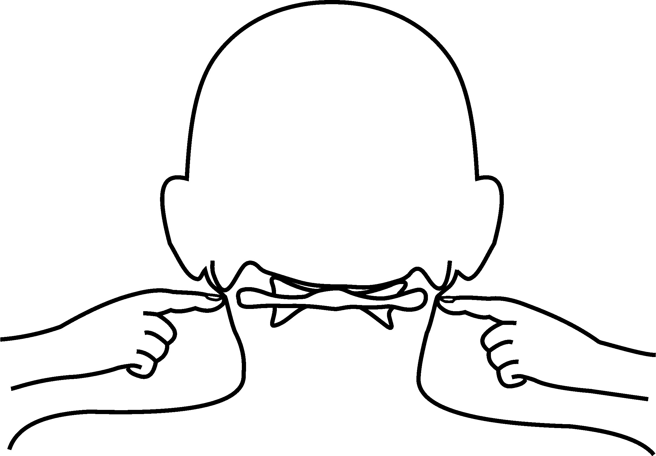

Due to the rotation of the first vertebra, the jaw is displaced to the right. On the left side the atlas pushes the lower part of the jaw joint forwards, and that is why our face is asymmetric. In women, the atlas is more rotated and therefore women’s faces are more asymmetric.

Painters, sculptors and morphologists have worked with this asymmetry, but they have never figured out how it occurs. Painters and sculptors, lacking an explanation, have tried to convince us that this asymmetry is interesting. It is not a question of aesthetics but of health. It causes irregular chewing of food and our teeth wear more on one side. The pain in the jaw disturbs chewing and unprepared food causes problems in the stomach.
THE MOST COMMON TYPES OF ATLAS MISALIGNMENT
backwards

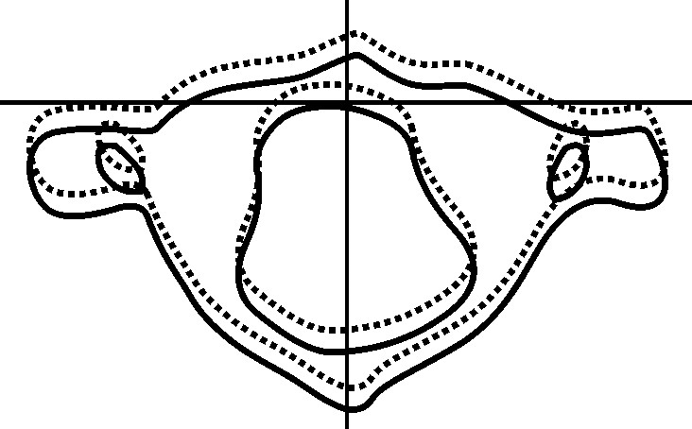

rotated

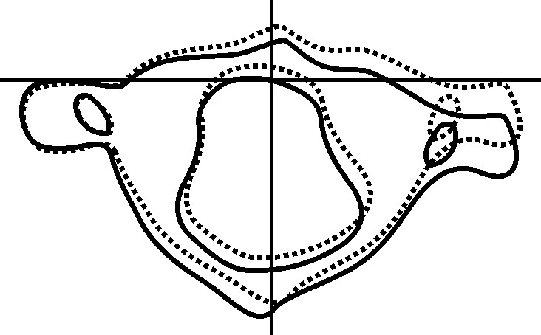

tilted
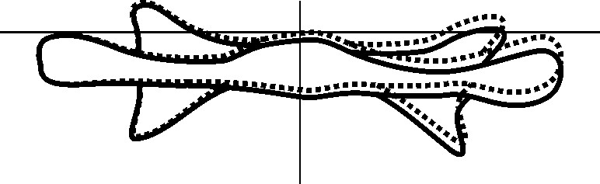

inclined

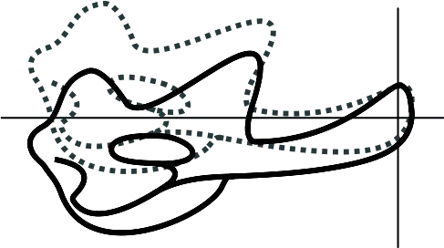

It takes a few seconds to tune up the atlas for babies and children and it takes a minute for adults. In that way, an error that occurred tens of thousands of years ago is corrected. When the atlas is realigned in babies, their bodies don’t become deformed, and after the atlas is realigned in adults, deformities gradually disappear.

THE DEFORMITIES

A deformity is a state of being misshapen. When an object is deformed it can be fixed but when a body is deformed, it can cause a serious health problem. The shape of the body as a whole as well as each individual parts depends on the degree and direction of atlas misalignment.
Space is a basic phenomenon in the universe, without which nothing else could exist. The pressure of space is the strongest force in the universe which is the cause of deformity in everything else, but at the same time space itself becomes deformed depending on the speed at which it moves and the mass of the object. The metre is the basic unit of length. Using it, we can define the size of space but space itself is flexible and that is why one metre is not the same everywhere in space. Depending on the state of space, a metre can be shorter or longer. Forces existing anywhere in the universe influence us as well.

DEFORMITIES ON THE ATLAS

- The back arch of the atlas is stretched to the right
- The right surface of the cartilage is larger than the left

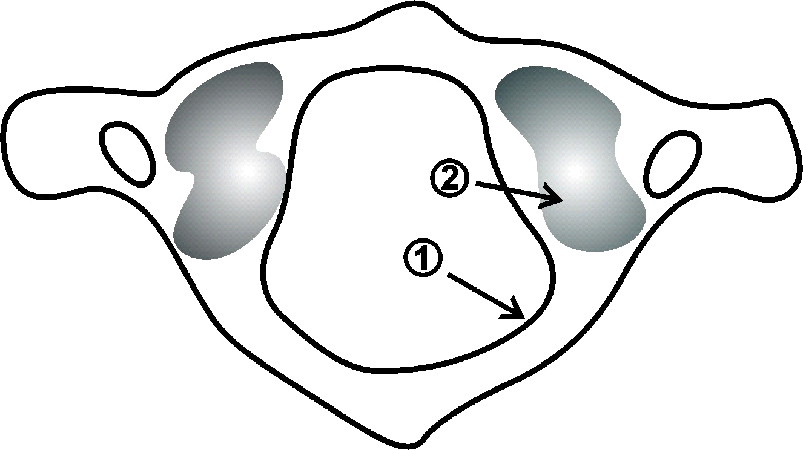
- The cartilage on the right side is thinned
- The right growth of the atlas is tilted

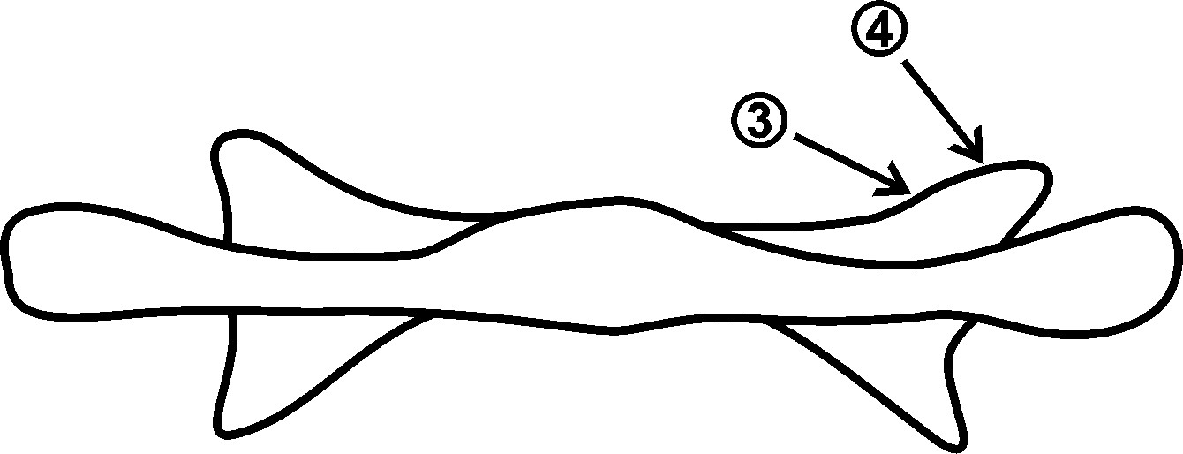
In the pictures you can see four places on the atlas which cause deformities of the entire body. These four are the most common and when the atlas is in a different position, different deformities occur. In most people body deformities are not easy to notice and only some people have pronounced deformities. They struggle to buy clothes, because clothes are made for the correct body shape. Those with pronounced body deformities need to get clothes specially made to fit their body shape and even then, it is hard to compensate for the difference in arm and leg length.

The pelvis is one of the larger bones in the body, but it is only minimally deformed because of the first vertebra, which belongs to a group of smaller bones. When sitting, most people put their right leg over the left one because in most people the pelvis is displaced to the right and elevated on the right side. When we put one leg like this, the pelvis is in a better position and it straightens the spine. The transfer of signals is better and there is a sense of relief in the back and in the right leg. Morphology is the study of the shape and structure of organisms but there is a phenomenon that not even the experts in the field are aware of. When the pelvis is displaced to the right, in old age, over the course of a decade, the left side also becomes displaced. Because it happens gradually, most people aren’t aware of it happening. When the pelvis is too displaced to the left, people start feeling pain and they begin carrying a walking stick in the right hand to ease the pain and to provide support. After several years, as things become worse, the walking stick is no longer enough and so they move up to using a walker. After some time, a surgery is performed on the right hip and left. But if the atlas is simply tuned up, the pelvis goes back to the middle and stays horizontal, so these people don’t have to carry a stick or have hip surgery.

Body deformities usually mean there is a curve, but completely flat feet are also a deformity. A small number of people have flat feet, and this happens because their atlas is tilted forwards. After realigning the first vertebra, normal arches appear on the feet. In children and the young, this process lasts for several months and in adults, several years. Very rarely, people’s lower teeth are in front of the upper teeth. In these cases, medical experts think that the lower jaw is deformed, and they suggest shortening it. It is not that the jaw is elongated but rather, it is displaced forwards because of the forward misalignment of the atlas, permanently pushing the jaw. When the atlas is tuned up, existing deformities become smaller or they disappear and there are no new deformities. Morphology believes that if the body of most people is similarly deformed it becomes normality.

How does the body slowly straighten, and these deformities decrease once the atlas is realigned? If these deformities are normal than how is it possible for it to change and reverse?

DIFFERENCES

There are many differences within the entire universe and at the same time there are aspirations to reduce these differences. This desire is the driving force that provides better solutions. Differences are also desirable because being the same is monotonous. Identical twins have a detail that makes them different and even when they are physically identical, their health is different. The reason is that their atlases are in different positions. This difference between the positions of the atlas occurs in the uterus and over the course of life, depending on different physical factors such as injuries or traumas, there may be additional differences between these positions.

Regardless of race, all people have a similar body shape. It is impossible to find two identical people. Diversity exists in other animals as well, but nothing compared to ours. When you look at a herd of animals, a flock of birds or a school of fish, you will notice similarities between their bodies. But there are huge differences in humankind. When the atlas is misaligned, it affects almost all our bones, which leads to differences in position, length and shape. In most people one leg appears to be shorter. The length of our leg is measured from the hip to the ground. The left leg is usually shorter when measured in a standing position but when the same person is compared lying down, the right leg is shorter. The true state is that the legs are almost the same length but because the pelvis is tilted, it seems that the right leg is shorter. The pelvis is tilted because of the tilt of the atlas pulling one leg up. In most people the atlas is lowered on the right side, thus the pelvis is elevated on the right side.

Most people have a different length and shape of their paired bones. That asymmetry occurs during the development of the foetus and continues throughout life. The right clavicle is shorter than the left and it has a more rounded shape. The chest bones are similar. There is a minimal difference between the leg bones but because most people put more weight on the right side of the body, the bones of the right leg are approximately one millimetre shorter. Only the bones of the arms are similar in size. Because we hold our arms alongside the body, the force that causes deformities within the body, doesn’t affect them. Except for the above mentioned difference between paired bones, individual bones on the right and left side are also asymmetrical.

The skull is similarly deformed in most people. The parietal bone is more protuberant on the left side than on the right and the opposite is true of the frontal bone. Nasal deviations are more or less present in everyone. In most people the nasal septum is displaced to the right, and the cartilage section stems from it, leading to difficulties breathing through the right nostril. The opening on the base of the skull is also slightly displaced to the right in most people and the atlas opening is displaced to the left, putting constant pressure on the spinal cord. The middle of the sternum is displaced slightly to the left, but it doesn’t impact the function of breathing or cause any major health problems. Very rarely, the base of the sternum is bent inwards towards the solar plexus and that causes nervousness and bad digestion.

The difference between the left and right side of certain vertebrae cause the differences between the function of the left and right side in paired organs: thyroid gland, lungs, kidneys, ovaries or testicles. Because our liver is genetically increased, the right kidney is lowered while the left one is in its anatomical position. Since the atlas is rotated, the left vagus nerve is pressed and that is why the left kidney receives fewer signals and doesn’t function as well as the right one. This is why the kidney stones usually form in the left kidney. When the differences between the functioning of the organs is reduced, the problems start to go away.

After the age of forty, most people feel the difference between the left and right side of the body. They have more problems on the right and it is because the right side has to carry more weight to balance out the misalignment of the tilted atlas. We live in a world of right-handed people. It is present even in animals and birds, but it is more conspicuous in humankind. Over ninety percent of people are right-handed and no one knows why. I have realised that it occurs during the development of the foetus as a result of atlas misalignment. Because the atlas is tilted and rotated, the right shoulder is lower and tilted forwards, thus the right arm is minimally closer to what is being reached for. From early on children grab objects with their right hand and they become right-handed. The brain decides every time which hand to use and it chooses the one that is closer to the object. After repeating this hundreds of times a day, it becomes a habit. Little boys are more active, and their atlas is differently misaligned than in girls, which is why there are more left-handed men than women. There is a huge difference between people when we try to raise our hands to the back. In most people the right hand can be raised less than the left. During life the difference becomes greater, and later both hands can be raised less because the body curves more and more in old age due to atlas misalignment.

When viewed from the side, there is no difference in the body shape between girls and boys, but the difference occurs in puberty when girls develop breasts. The difference in the silhouette doesn’t occur due to their protuberance but because of their weight, which changes women’s statics and body shape. The human body is like a lever that is upright, and its bottom is fixed to the ground. The average-sized breast weighs one kilogram and that changes a woman's body statics and knocks their bodies off balance. Some girls push their shoulders back to look more attractive but more often, this happens spontaneously so that their bodies don’t fall forward. The head stays in its position, but the chest is pushed backward and the pelvis forward, causing women to have a more pronounced forward curve in the cervical area of the spine.

In women whose atlas is severely misaligned backwards, there is conspicuous spondylosis in the cervical area of the spine. Most of these women have a bump in the shoulder part of the spine but that bump is more of an issue of aesthetics rather than a health problem. When the atlas is realigned, the bump gets smaller and after a year or two it disappears. When the atlas is tuned up, the centre of gravity of the head changes and from then on gravity gives them back their normal body statics. The spine obtains its correct shape and the deformities disappear.

Certain thyroid diseases are five times more common in women than in men. Since the signals of the thyroid run past the vertebrae in the cervical area of the spine and lordosis in women is more serious, their nerves are under greater pressure. Usually the right side of the thyroid becomes ill first. Females tend to be more placid than boys and men so their atlas usually stays in the position it was in before birth. Due to the weight of their breasts and initial misalignment of the atlas, women have more serious cases of lordosis, spondylosis and rotation in the cervical area compared to men. Unlike women, the bump appears in the middle of the spine for men and that is where the most vital organs are situated. These organs do not function normally because the nerves that run past the vertebrae are pressed and that is one of the reasons why men have shorter lives compared to women.

There is a difference between the positions of the atlas in men and in women so there is a difference in their health. During life, men usually take on more blows to their head and body thus their atlas tends to be more misaligned and as a result, they are more ill than women. Apart from the difference in its position, there is also a difference in the width of the atlas. In women the atlas is somewhat narrower than in men. A narrower atlas exerts less pressure on nerves and blood pathways which run past and through the atlas. Because the atlas is misaligned, it seems that both health and lifespan are a matter of luck.

In children whose atlas is realigned before puberty, the body symmetry will adjust to balance out the difference between the left and right side and more importantly, they will live healthier lives.

In the past several thousand years, people have discovered many different methods of realigning the atlas. The differences between all these ways are useful because we can examine all our options and finally choose the best solution. When everyone in the world has their atlas tuned up, there will be much less difference in body shapes and there will be many more healthy people. In the future, the past will be divided into two epochs – the time when humankind was ill and the time when humankind regained its health.

IMBALANCE

Imbalance is present in the entire universe but at the same time, but at the same time there are aspirations towards balance. If there were no imbalance everything would stop, because imbalance is a driving force. Imbalance is useful everywhere except in the human body. Our enlarged liver is the cause of the imbalance between the right and left side of the body so even within our own body, we seek balance. Due to our upright position, in order not to fall, our muscles work non-stop while we stand or walk, and they make our balance possible. When an elongated object is upright, it has a single point of support and that is why it can fall on any side. An object with two points of support can fall on either side. Only with three points of support is there a permanent state of balance.

Homo erectus made an epochal feat when he managed to stay upright with two support points. Mobility is a characteristic of life, so the feat of Homo erectus is even greater because he managed to maintain his balance on only one foot while walking. It is easier to stand than to walk because when standing we are supported by two feet but while walking, by only one. While we move, we are mostly supported on one point of support and that is next to impossible. Out of several million species that have ever been in existence, only humans can enjoy the benefits of the upright position. Homo erectus wasn’t the first one to manage to stand and to walk on one support point, but it was the first one to manage the upright body position. Many species of dinosaurs managed to stand and walk on two feet tens of millions of years before Homo erectus, but they didn’t have the upright body position. Birds are a type of dinosaurs that survived an asteroid impact sixty-five million years ago. Standing on two feet is easy for birds because their bodies are light, and their priority is not walking but flying. Most birds manage to stand on one support point without falling sideways. Their long claws are set in different directions so that they create a large support surface.

The centre of gravity is in the brainstem, which is located near the base of the brain. To maintain balance, the centre of gravity receives information from the entire body and reacts to it rapidly. There are three pieces of information that constantly reach the centre of gravity. In the middle ear there are paired organs, whose basic function is to feel the effect of gravity. Vision, apart from its main function of visual perception, is also in charge of providing the centre of gravity with information on spatial orientation. The third piece of information is provided by the feet, which send data on the condition of the ground beneath our feet. The paired organs in the middle ear were inherited from our ancestors who used to stand on four feet. Two feet in the front and two in the back gave them more forwards-backwards stability than sideways. These two sensors give us the possibility to maintain sideways balance more easily than forwards-backwards balance and that is why our feet are elongated. Because of our upright position, it would be better for humankind to have two more balance sensors, on the tip of the nose and on the back of the neck.

Our head literally constitutes one tenth of our body weight but due to its positioning at the top of the body and the forces affecting the body, our head relationally constitutes one fourth of the body weight. Because of that difference, the centre of gravity receives most information from the head. If the atlas were in its correct position, there wouldn’t be any problems with balance, despite the heaviness of our head. Balance sensors are in the middle ear, and the centre of vision in the scalp area. Both balance sensors and the centre of vision are located near the cerebellum, whose basic task is to control muscles. This mutual closeness is necessary because of sudden instability, when information needs to be transferred rapidly so that the entire balance system reacts faster.

Medicine is developing rapidly but it still can’t find the cause of vertigo and instability and often combine these two conditions as one. It is easy to connect vertigo and instability, because balance sensors, the centre of vision, feet signals and blood flow through the brain all depend on one another. Vertigo occurs due to a lack of blood in one part of the cerebellum and instability occurs due to a lack of signals from one foot, both of which occur due to misalignment of the atlas. When there isn’t enough blood in the cerebellum and it is unable to function optimally and therefore is not sending enough signals into the muscles, some people experience vertigo not when they are standing but when they are lying down. This condition is not influenced by a lack of signals from the feet or from the centre of vision but a lack of blood in the brain. Blood vessels are pressed by the misaligned atlas and sometimes they become even more displaced when the head is placed on a pillow, decreasing blood flow even more.

In cases of instability, the head, brain or ears are examined but the cause of instability is not there, it is under the skull or at the base of the spine. The nerve that transfers signals from one foot is pressed by the atlas, by one of the vertebrae at the base of the spine or by both. If there are signals from one foot and not from the other, then instability or a feeling of imbalance occurs. In most people vertigo disappears immediately after the atlas is realigned because the pressure on blood vessels is removed. Instability disappears immediately after the atlas is tune up in those cases where the foot signal was blocked by the atlas but if it was caused by a nerve in the lower part of the spine being pressed, instability disappears when the lumbar vertebrae are placed in a better position. Mild and quickly passing instability might occur after the atlas is realigned and that occurs because of improved body statics.

For an elongated object to stand upright, the centre of gravity should be along the longitudinal axis that is perpendicular to the ground. The support point is at the bottom of the object and at the top, there is a point which should be right above the support point in order for the object to stay upright. In the upright position, we also have the point of support which is between our feet and we have the upper point which is on the scalp. Due to atlas misalignment our point on the scalp is not in-line above the point of support. From the time when we start to walk we try to keep the upper point above the point of support but because the atlas is misaligned it is impossible for us to succeed. Constant attempts to maintain balance curve the body and spine but this results in muscle and joint pain.

Our body is not a solid object however the same natural laws apply. Due to the elasticity of the body we can stand upright, but to maintain this position our body curves. The centre of gravity is in the middle of our stomach and we manage to stay upright because the position of the centre is constantly corrected. In most people the atlas is misaligned for a long period of time, the centre of gravity is displaced to the right in relation to the longitudinal axis and that is why these people experience body and spine curvatures. In the twentieth century, science developed rapidly and towards the end of the century a robot was made that can walk on two feet. For it not to fall, the robot imitated the human walk. It took science one hundred years to achieve what Homo erectus had achieved one million five hundred thousand years before. The robot doesn’t have an atlas and the levers in the robot are made of solid material, so they can’t bend. Homo erectus had its atlas in the correct position and its body was not curved so it didn’t have any internal causes of illnesses.

In most martial arts, a competitor tries to affect his opponent’s centre of gravity by inflicting a head blow. Unlike violent martial arts, aikido is based on the wisdom that the winner is not necessarily the stronger opponent, but the person left standing. Fighters use gravity to maintain their balance and at the same time try to unbalance their opponents. In aikido, it is thought that the centre of gravity is not it the stomach but in the atlas area and so an aikido practitioner maintains his balance by keeping his head in line with the middle of his feet. The centre of gravity in the head is displaced because the atlas is misaligned and that displaces the centre of gravity in the body, causing an imbalance when we stand. Because the first vertebra is misaligned, everyone’s body is more or less curved, so that almost nothing is in its correct anatomical position. The only thing that is in its position in every human being is the first thoracic vertebra.

In an adult, the weight difference between the left and right side of the body is small and it is a minor problem. We are born with our head tilted to the left and to keep our balance sensors in a horizontal position while starting to walk, we begin trying to keep our head perpendicular to the ground. When starting to walk, most children move their head to the right so that their centre of gravity allows them to stay in the upright position. If it is necessary to draw one side of the lever to the same side of the other parallel lever, there must be a force to make that mutual attraction possible. To move our head to the right, the muscles from the base of the skull to the pelvis constantly contract and that is why the right side of the pelvis is raised and the right shoulder lowered.

THE OPPOSITE TILT OF THE SHOULDER AND THE PELVIS

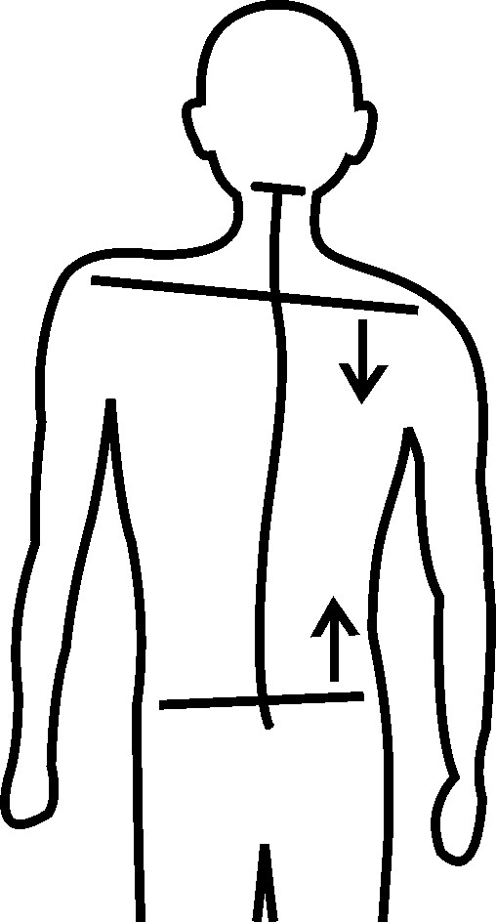

The upright position is possible due to the right shoulder and right side of the pelvis coming together. This enables our body to stay upright but it also the cause of the curvature of our spine. The human body is not a machine, but it is made of bones that are like levers, thus Archimedes’ principle applies to our body as well. A mechanism for measuring weight is a lever in the state of balance. For it to be correct, the point of support should be in its position before measuring so that the lever is in balance. The weight of an object is measured by comparing the weight of the weight and of the object. Salespeople who trick their customers move the point of support one fraction of a millimetre. When the atlas is displaced one millimetre or more the body is damaged. If the atlas is one millimetre misaligned, it misaligns the centre of the body by two centimetres. That is how the point on the skull and the point between the feet stay one above the other but in old age, it is no longer possible and the body curves rapidly, causing the elderly to be more ill. The following image shows loading forces through the body that exist in most people.

THE DISTRIBUTION OF LOADING FORCES
OF THE UNIVERSE

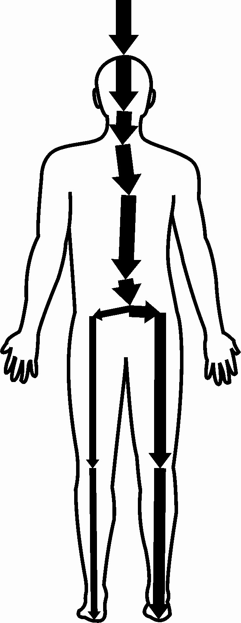

The human body is the only ‘skyscraper’ among other ‘ground-level’ animals. There are only a handful of species of animals that try to straighten up. Kangaroos straighten up so that their young won’t fall out of the pouch and rabbits and mongooses do so in order to spot danger in time. Kangaroos and mongooses use their tails as the third point of support and rabbits have a short tail so instead, they lean on their shins to straighten up. Because they straighten up, these animals have a different atlas than that of other mammals. In our species the atlas is completely different than in other mammals, but our problem is not the size and shape of the atlas but its misalignment. Our atlas is as equally misaligned as it was fifty years ago, but we are now more ill. In the past fifty years, humankind has become ten centimetres taller and because of this additional height, the body curves more easily and therefore is getting ill more quickly. Every additional centimetre makes it more difficult for the body to balance and creates health issues.

THE SKELETON

Because the atlas is misaligned, almost all bones of the skeleton are displaced from their correct positions. The human body consists of several parts but when it is analysed for statics, it seems that we only have two parts, namely the head and the trunk. The head is a small part of the body, but it moves the body. A thought is a conscious initiator of the body, but there is a tilt that we are not aware of. Due to backwards atlas misalignment, the head pulls the body forwards because it is at the top of the body. Small displacements of our bones from their correct positions occur during the development of the foetus and during life atlas misalignment leads to even greater displacements. The atlas is located between the head and the trunk, so it is like a switch that makes decisions about their mutual relation.

Thousands of scientists have dealt with the appearance, stance, shape, proportions and different positions of the human body but they haven’t discovered where in the body irregularities originate. For several years, I lectured on atlas tune up and I examined five thousand children and adults. Noticing the relation between atlas misalignment and positions of skeletal misalignment, I reached some new conclusions and one of them is about the rotation of the shoulder girdle. In most people, the right shoulder is displaced forwards and the left one backwards. It was easy for me to realise that the rotation of the shoulder occurs due to atlas rotation, but it was more difficult to realise that in one third of people whose right shoulder is pushed forwards while standing, while sitting it moves backwards.

Since the floor and seats are horizontal, I realised that this difference occurs because the pelvis is misaligned. After the atlas is realigned it becomes horizontal and because of this the pelvis also becomes horizontal, but several months later. That process makes it possible for the spine to straighten and decrease scoliosis, however the rotation and tilt of the shoulder girdle disappears only after several years. The reason for the slow repositioning of the shoulders is that the bones in the girdle have already formed according to the wrong body position and bones regenerate very slowly. Most people don’t notice that their or someone else’s shoulders are tilted and rotated, so it isn’t an aesthetic problem. It isn’t a health problem either because in that part of the spine everyone’s last cervical vertebra and the first and second thoracic vertebrae are well positioned, so the nerves next to them are not pressed.

Modern civil engineering copies natural processes by building pillars and crossbeams first and only when these are strong enough are the exterior walls and partitions built. Muscles are like walls and organs are like partitions, but the role of muscles is not to carry, the skeleton already does that. The skeleton carries itself and soft tissue but apart from this main function, one more very important function is performed in bones. Red blood cells are produced in bone marrow. Up until the age of twenty, blood is produced in all bones and later only in the bones of the trunk and spine. There is a misconception that our muscles hold the skeleton and that is why many people try to strengthen their muscles through exercise or sport. That is how you get somewhat better body posture but when you stop practising, the body recurves rapidly. Internal organs hang on the skeleton and muscles are attached to the bones. Because the atlas is misaligned, the skeleton and bones are not in their positions, so neither organs nor muscles are in their correct positions. When the atlas is tuned up, the skeleton attains a better configuration and organs return to their anatomical positions, able to function more regularly. Neural pathways around the atlas and other vertebrae are free and that also improves the function of internal organs.

When dominoes are set horizontally and the first one is pushed, all the other dominoes fall, one by one. This is considered ‘the domino effect’. In our body, the skull is like the first domino that tilts because the atlas is misaligned and that is why the skeleton slowly ‘falls’. Nerve signals are pressed because we get shorter with age, causing organs to deteriorate and that causes premature death. After death, the deceased are placed in a horizontal position on their back and they stay like that for hundreds of years until their bones decompose. It would have been better if people had slept like that, on their backs, during their lifetime because they would have lived healthier and longer lives. During sleep, our bones regenerate and sleeping on your back allows better regeneration. Unfortunately, those who can comfortably sleep on their backs are few. One year after the atlas is realigned, people are one centimetre taller and that happens even to those who are over eighty. Of course, these people stopped growing sixty years ago so they are not growing, but their body is elongated because the first vertebra is placed in its correct position.

THE SPINE

The spine is formed to protect the main neural pathway and when larger organisms appeared, the spine got the additional role of connecting the entire body. In animals, the spine is like a bridge between the front and back limbs where different organs hang. The spine has that same function in our species too but due to the upright position it has an additional task – every vertebra carries the body part that is above it. It is usually thought that the spine stretches from the skull to the pelvis, but it is more precise to say that the skull, spine, pelvis and caudal part of the spine represent one unit. In that sequence, the skull is like an engine and the other parts are like carriages of different sizes and different functions. When an engine derails, it pulls the carriages with it. With the skull displaced, the other parts of the body are pulled out of position. The caudal part of the spine is the last in that unit and no attention is paid to its shape, although its irregular shape is the cause of haemorrhoids.
In our species everyone’s head is, more or less, outside the longitudinal axis of the body, causing the entire body to be asymmetrical. The head is displaced in one direction, the neck in the other. The atlas joins the head and the body, and it is formed in such way, that its position can satisfy the opposing directions of the head and neck. During life, the atlas tries to balance the head with the body in vain, because it is misaligned. Humans grow until the age of twenty and we grow while we sleep, when the body is in a horizontal position. However, there is also shrinking during growth. You have never heard of this phenomenon but it’s a reality for children in puberty whose atlas is severely misaligned backwards. During the night children grow and then during the day, due to gravity, they are shrinking back down in size. This starts after puberty and happens even more rapidly in old age because the atlas misaligns backwards even more on its own.
The lower parts of the brain control normal body functions and for the brain to react to what occurs in the body, it needs unhindered signals. Because the atlas is misaligned, there isn’t enough blood in the brain, making it unable to function properly, ultimately leading to insufficient signals flow to the body. The misalignment also decreases signals at the beginning of the spinal cord and they are decreased even more due to the irregular shapes of the spine. The openings through which the nerves from the spinal cord run are located between the vertebrae and thus the irregular shape of the spine narrows the openings, putting permanent pressure on the nerves. Signals are sent from the body to the brain and as they travel the same path, that is pressed in several places, the brain ends up missing out on some of information. Therefore it can’t react to the needs of the organs properly.

As mentioned in a previous section, between the vertebrae there are discs which have a role to join the vertebrae and as well as a task of relieving the pressure on the neighbouring vertebrae, due to our upright position. Discs lose a bit of fluid during the day and get refilled during the night. When discs are thinned, the openings through which nerves run decrease and that is one of the reasons why we are healthier and taller in the morning than in the evening. Youth is the morning of life and old age is the evening. In old age the process of filling and emptying of discs slows down, so the thickness of discs and the flow of signals decrease, leaving organs to become ill even faster. The correct shape of the spine can only be found in pictures in anatomical encyclopaedias.

THE CORRECT SHAPE OF THE SPINE

from the side from the back

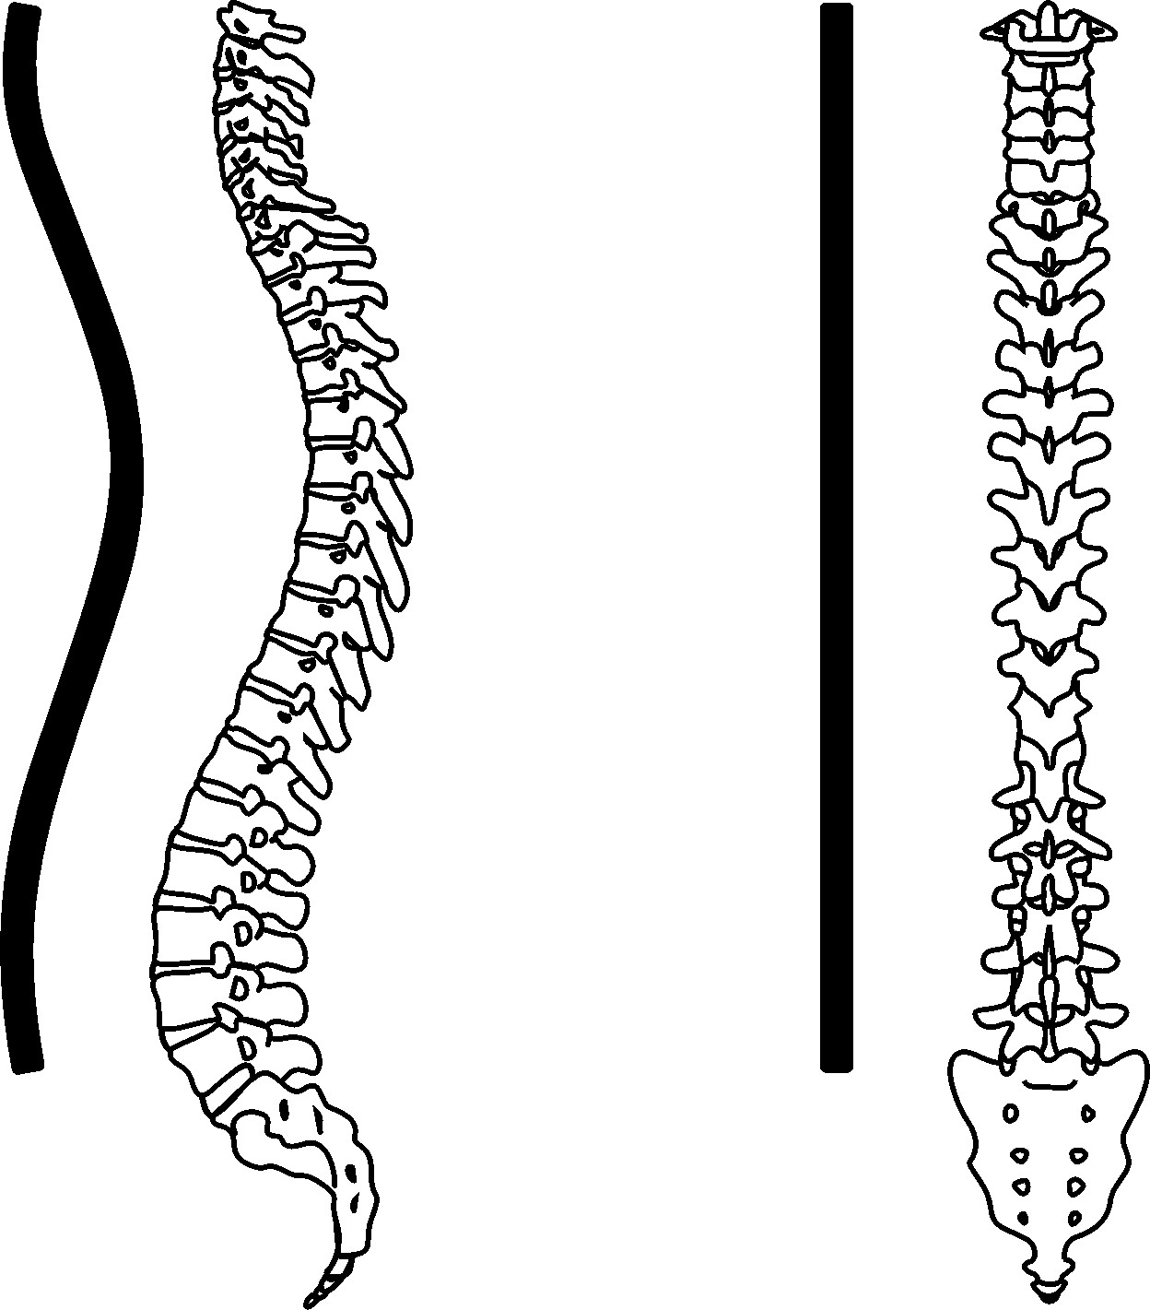

What is it that prevents one person from being affected by all possible illness? The reason is that there is at least one part of every individual’s spine that has the correct shape, allowing signals to flow unhindered. A Japanese proverb read: ‘A wry neck is a sign of short life’. This is very true, and I would add that if the spine is curved, it is the cause of diseases and premature death. In all other mammals, a single species shares a very similar spine, but in our species, there are different shapes. This variance is because of the displacement of the skull and upright position. Most people’s atlas is misaligned and therefore it is almost impossible to find a human being with a completely normal shaped spine. In majority of people, the greater part of the spine has a normal shape but in old age, even more of the spine curves.

From the skull to the pelvis, the spine consists of twenty-four vertebrae. This should be redefined because the atlas is actually not a part of the spine. The atlas is tightly connected to the skull from the moment of its formation till the end of life, but due to its misalignment, that connection is not strong enough to prevent displacements during physical trauma. The cartilage on the atlas and skull is smooth and that is why the atlas can be displaced. When any kind of physical force is inflicted to the head or body, they additionally misalign the atlas and as a result, the spine takes on incorrect shapes.

There are as many spine shapes as people in the world because not only do we have misalignments that we are born with, the atlas and as a result, the spine, is misaligned and changed into different positions numerous times throughout one’s life. The spine keeps its previous irregular shapes and every time the atlas moves again, new irregularities are added. According to the shape of the spine it is possible to tell at what age different displacements occurred. When the atlas is more misaligned in youth, they experience more significant spine curvatures and more health problems.

If you look from the back, the spine should be completely straight, but it is almost impossible to find a person who has a completely straight spine. Scoliosis is when the spine curves to the left or right. Until atlas misalignment was discovered, we didn’t know why scoliosis occurred. The causes of scoliosis are the tilt of the atlas, the misalignment of the atlas to the side, or both.

Because the atlas is tilted to the side, most people suffer from two types of scoliosis: in the thoracic spine to the right side and in the lower part to the left. In a small number of people, the atlas is tilted to the left. This tilt occurs due to a head blow from the left or a body blow from the right, so the left shoulder is lower than the right one, and the pelvis is displaced to the left. In these cases, different directions of scoliosis occur and different diseases, because certain organs don’t get all signals from the brain.

THE MOST COMMON SCOLIOSIS

The neck tilts to the opposite side from the direction of atlas misalignment and in the middle part of the spine scoliosis occurs in the direction of atlas misalignment.
SCOLIOSIS IN THE MIDDLE OF THE SPINE

Scoliosis is a health problem but the shapes of the spine that are noticeable from the side are a much more serious problem, so I will deal with these curvatures exclusively for the remainder of this chapter.

NORMAL LORDOSIS AND NORMAL KYPHOSIS

A healthy spine curves forward in the cervical and lower spine area and curves backward in the thoracic spine area. The normal curve forward is called normal lordosis and the normal curve backward is called normal kyphosis. Unfortunately, the number of people whose three curves are normal is extremely small because their atlas is neither misaligned forwards or backwards. In most people, only one part of the spine is abnormally shaped but in old age all three curves become abnormal. During the development of the foetus and up until the age of six months, the spine has a C shape. When babies start to crawl, lordosis occurs in the cervical part of the spine. When they start to walk it appears in the lumbar part as well. Even at this age the atlas affects the shape of the spine.

In childhood the vertebrae and the discs between them are not solid enough, allowing the existing spinal shapes to influence the formation of their individual shapes. When the atlas is in a position opposite from the previous one, the vertebrae and discs are formed according to that different spinal shape, which happens because of gravity that influences the entire body.
Kyphoscoliosis and lordoscoliosis occur in early childhood due to several opposing atlas misalignments that have changed the position. These extremely abnormal spinal curves occur in only a small number of people because fortunately, such great misalignment positions of the first vertebra occur only rarely.

Using special splints, orthopaedists try to straighten children’s spines during puberty, but this only slightly corrects its shape or simply slows down the process of curving. It is not possible to solve this problem permanently using this method however, and so people go to a surgeon to have metal rods inserted along the spine. The discovery of atlas tune up allows a more humane approach to permanent straightening of the spine. The best thing to do is to realign the atlas in babies, to prevent these situations before they even happen. If there are already huge deformities, however, it is best to tune up the atlas as young as possible and to correct the shape of the spine permanently through stretching.

Boxers suffer because their atlas is misaligned more often than in other people. I realigned the atlas for a few former boxers, who were over seventy years old at the time. Their atlas was in a better position than their peers’ and that is why they were healthier. I thought that was strange, but I realised that they had been lucky to receive head blows from the front. These blows moved the base of the skull backwards, causing atlas to constantly return forwards. In boxers who received strong blows to the head from the side or from the back, illnesses occurred, and they died prematurely due to a greater misalignment. For some of them this sport is fatal and for most of them it is a noble art.

Before birth the first vertebra is misaligned backwards but during their second year some children experience forward misalignments, because children fall and sustain frontal blows to the head. From the age of three, when falling, children land on their hands, and this is why in some children the atlas is misaligned forwards, so their head and behind are displaced backwards. This results in the spine becoming too straightened, the feet elongated, and flat feet occur.

CORRECTED LORDOSIS

Any deviation from the normal spinal shape is bad but if you could choose, it is better to have a straightened spine. It is known that straight people are healthier than others but there is a small number of those who maintain that spinal shape for the rest of their lives. These people are healthier, but a spine that is too straight is not good either, because the vertebrae don’t lean normally and decrease the openings through which nerves run. These people have health problems with organs that don’t receive all signals from the brain but because the shape of their spine doesn’t change, they don’t get new diseases. However, in older people discs between the vertebrae become thinner and organs get fewer signals, so existing conditions worsen.

When the spine is too straight, lordosis at the bottom of the spine occurs and due to it, problems with the organs at the bottom of the stomach occur together with pain in the legs. The worst shapes of the spine are kyphoscoliosis and lordoscoliosis, but there are shapes when kyphosis is where lordosis should be or when lordosis occurred instead of kyphosis.

REVERSED POSITIONS OF LORDOSIS AND KYPHOSIS

This changing of places occurs if the atlas was pushed forwards in early childhood and then was suddenly misaligned backwards. After realigning the atlas, these spinal shapes slowly become normal too. In over ninety percent of children and adults the first vertebra is misaligned backwards, causing more serious lordosis and kyphosis which is followed by greater health problems. There are a lot of reasons why the atlas is misaligned backwards in most people. During the development of the foetus the atlas is displaced backwards, which causes the base of the skull and atlas to develop according to that position. In childhood and throughout our youth, our head is bent when we study and often similarly when we get a job. During life we grab objects that are lower than our head and so we must bend to reach them. Our head is mostly bent also while we eat or sleep. The eyes are in front, so we don’t see objects that hit us in the head from behind. All these situations contribute to the atlas being misaligned backwards and depending on how far backwards it is misaligned, affects how pronounced the lordosis and kyphosis appear.

After the age of thirty, we are a centimetre shorter every decade, thus by the age of eighty, we are on average five centimetres shorter. Those whose atlas is misaligned forwards have a straight spinal shape and they don’t experience this shrinkage but due to thinner discs they are still a centimetre shorter in old age. There are many abnormal spinal shapes because of the atlas being tilted and misaligned backwards. In most people, the atlas is also rotated, causing the spine to become twisted as well. In some people, the entire spine is equally twisted and that is why the vertebrae don’t press nerves but in most people the spine is too twisted in the lower part, so the organs around the lower abdomen area and legs don’t function as well as they should. The spine is affected by scoliosis and lordosis at the bottom of our back, and when in addition the spine is twisted, disc herniations occur. After the atlas is realigned disc herniations slowly disappear and signals begin to flow unhindered. That is why organs function better and pain and numbness in the legs disappear.

The basic purpose of all existence is procreation. Everything is subordinated to that basic biological task and it is the same for our species. Because of the nerves being pressed at the bottom of the spine, the function of our reproductive organs is decreased. There are more and more young men who experience problems of impotence. During an erection, the penis is filled with blood but when the centre that regulates circulation in the first brain is pressed, less blood flows to the penis. Likewise, problems with sperm production occur at the base of the spine because the nerves leading to the testicles are pressed.

Similarly, greater lordosis at the base of the spine in women is the main reason for period problems and a premature amenorrhea. After the atlas is tuned up, menstrual pains decrease, and periods become regular. Realigning the atlas decreases pronounced lordosis and allows the signals to once again reach the ovaries and uterus. Decreased lordosis makes it possible for some women, who previously couldn’t get pregnant or couldn’t carry a pregnancy, to have a child. The main role of women is to give birth and become mothers, so the absence of periods in their early forties leads to hormonal disorders and impairs health. After the atlas is realigned, periods start again in some women who were going through premature menopause.

Pregnancy is an altered state of the body and it influences health. Most women become healthier, but some become more ill after labour. Hormones can’t be responsible for this, because pregnancy is a normal, natural process. Those women whose health deteriorates are the ones whose atlas was misaligned during labour. It is well-known that women who have multiple births are healthier, but the reason for this is unknown. In the final months of pregnancy, the foetus and the uterus become enlarged, so they push the spine from inside and making the lordosis decrease, allowing the signals to run along the vertebrae more easily. During multiple pregnancies the shape of the spine becomes more normal and that is the main reason for improved health.

There isn’t a significant difference in the atlas position between women and men but the difference between their spinal shapes occurs due to the weight of the breasts which change the statics of the female body. During the twentieth century, women started wearing bras and the lifting of breasts changed the statics of female bodies even more, worsening their health even further. Apart from this, bras press lymph nodes and pathways, resulting women to be more ill than before. Because they wish to look pretty, the function of mammary glands’ is decreased, and babies don’t get enough mothers’ milk.

Men’s heads are tilted forwards while women’s are straight in relation to the body. Due to the weight of the head, lordosis increases in women. Cervical lordosis is especially increased and that is why women have problems with the thyroid gland in their thirties. In most women, problems first occur on the right side of the thyroid gland because the right side of the atlas is lowered and rotated backwards in most people. The consequence of this is lordosis and the cervical spine twist, causing signals to the right side of the thyroid to be deficient. Due to pronounced cervical lordosis women suffer more from headaches, vertigo, thyroid disorders and pain in their arms. In women, however, kyphosis in the thoracic spine and lordosis in the lower part have a more normal shape, which enables most organs in the female body to receive enough signals, making them healthier than men. Men have kyphosis in the middle of the spine and it decreases signals towards the most important organs. That is one of the reasons they have shorter lives.

After the atlas is tuned up the tilt, rotation and left-right asymmetry slowly disappear. The rate at which the shape of the spine improves depends on age and on how big the curvature was.

THE AVERAGE APPEARANCE OF THE FEMALE BODY AND SPINE AT THE AGE OF FORTY

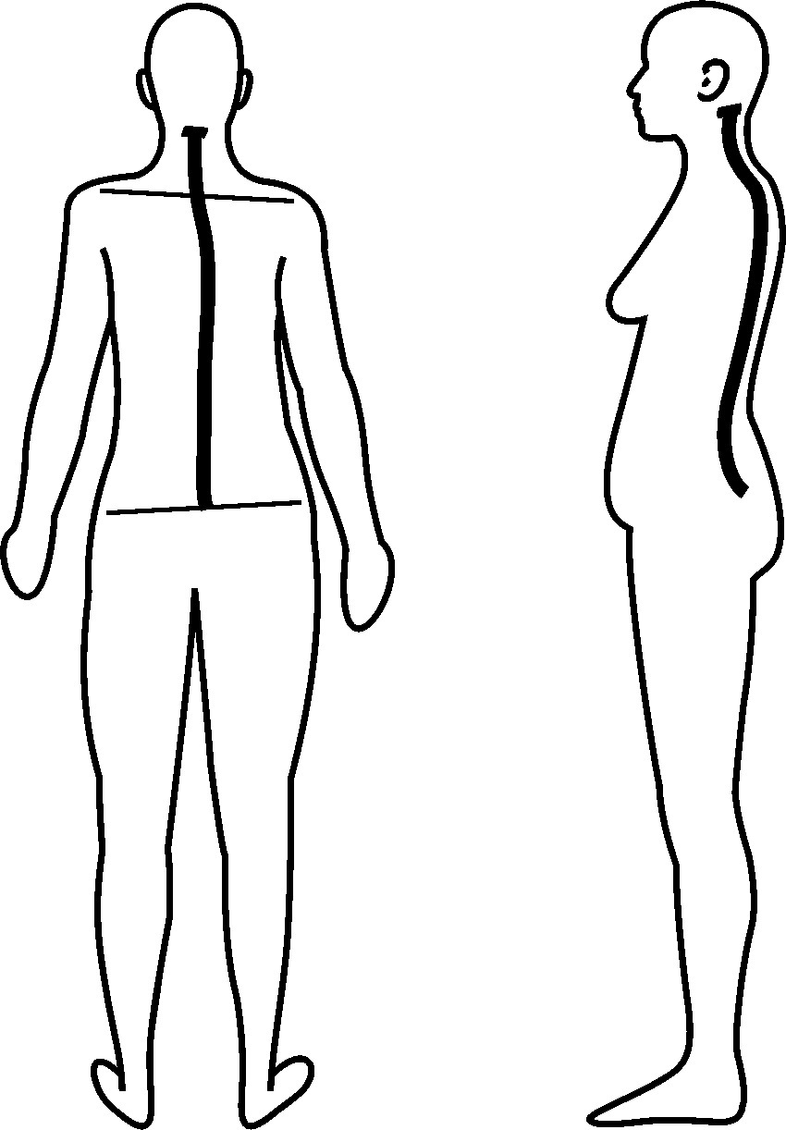
THE AVERAGE APPEARANCE OF THE MALE BODY AND SPINE AT THE AGE OF FORTY

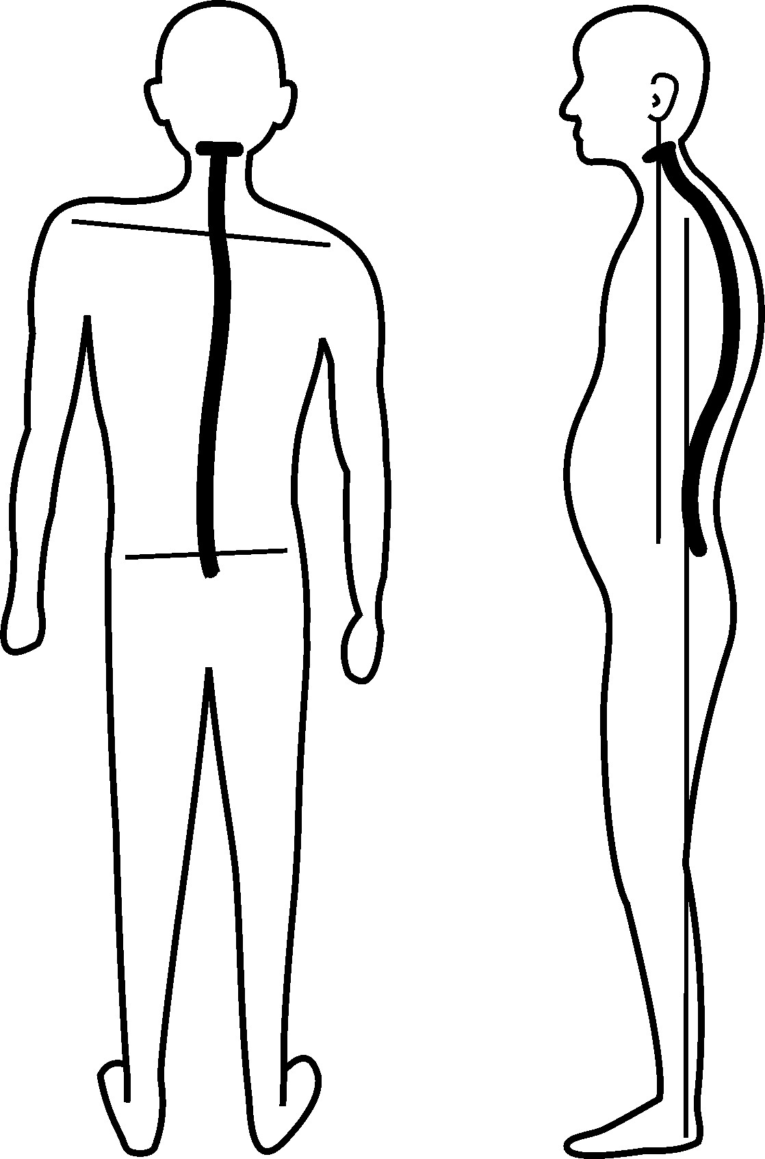
Head displacement is the only reason for abnormal shapes of the body and spine. It isn’t easy to hold the smartest head in the universe. The brain constantly sends and receives information. Nervous signals flow through nervous pathways from the brain to the body and from to body to the brain simultaneously and signals can flow unhindered only if nerves are not pressed.

Due to poor blood flow, fewer signals are created and these are additionally decreased on their way to the organs by the pressure exerted on them by the atlas. Abnormal spinal shapes worsen that state by causing a third decrease of these signals. The brain doesn’t receive all the necessary information and can’t react appropriately, causing the body’s organs to slowly lose their function and become ill.

When the atlas changes its position several times in childhood in the forwards-backwards direction, strange spinal shapes occur which can be seen in the following images.
EXTREMELY ABNORMAL SPINAL SHAPES

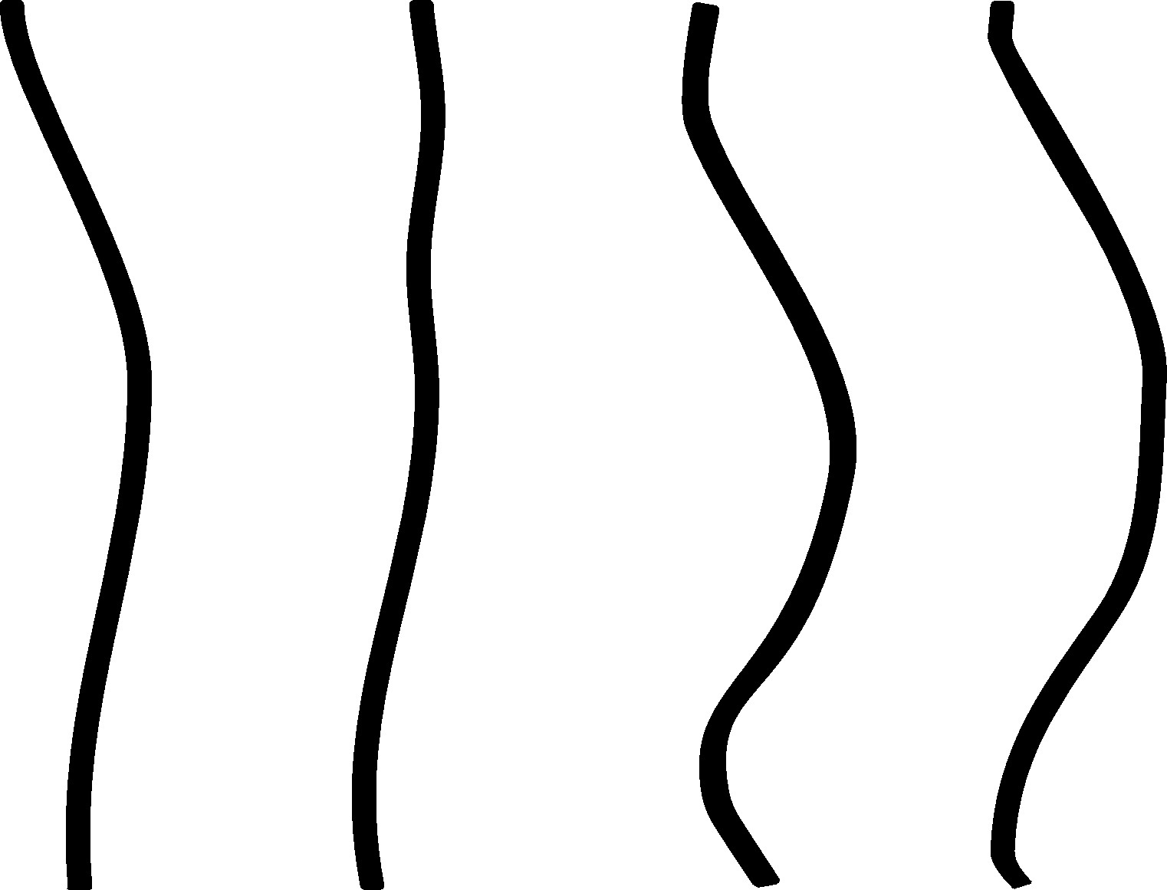

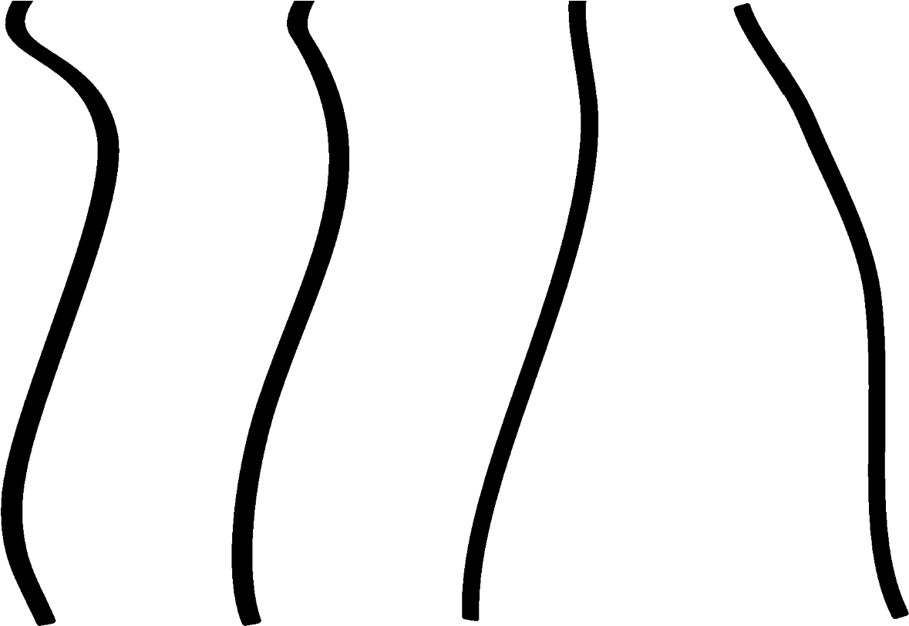

Every person has a more or less abnormal shape of the spine, and the only solution is to realign the atlas.
You can bend a young tree, and as it gets older it becomes tougher. Unlike trees, the human spine curves faster with age due to a greater misalignment of the first vertebra. When the atlas is tuned up in babies, the spine becomes normally shaped and stays like that during life.

The spine is the pillar of life and when the spine is unstable, health deteriorates and before you know it, life collapses.
HEALTH

There is no such thing as perfect health but there are constant aspirations towards better health. This principle is present in all living beings and the same goes for humankind. We consider ourselves to be the most perfect beings and this is true in many segments of life, however our health is worse than in animals. Good health means that organs and systems in the body are compatible and functioning well. Somebody needs to control all the processes so that everything functions harmoniously. We can compare the body to an orchestra. All instruments need to be tuned and musicians must play the same notes at the same time, as when there is a single instrument that doesn’t play the right note or when a single musician doesn’t play at the right time, the orchestra doesn’t produce good music.

Musicians can’t see each other, they hear others and join in their sections. However, man is a visual being so for everyone to be harmonized and for music to sound harmonized, there needs to be a conductor who conducts the orchestra. In our body, the lower brain is the conductor that issues orders and monitors how organs and systems function throughout life. The lower brain is most active during sleep because that is when regeneration and self-healing take place. The higher brain oversees consciousness and that is why we are the only species that can use thought processes to maintain or even improve our health. The lower brain constantly maintains our health and the higher brain takes care of health whenever it becomes aware of a problem.

If the musicians are not in sync, the conductor stops them, they start all over again and through practice the orchestra comes together in harmony. The lower brain doesn’t have that possibility, because it can’t stop life and start it again. When there are health problems, the lower brain keeps sustaining life and at the same time it tries to improve the state of those areas where the anomaly has occurred. The lower brain consists of several parts that work together constantly. That is a perfect natural process that has been developing for hundreds of thousands of years and is still perfecting itself. Neuroscience is trying to discover the magnificence of such a complex structure but still can’t figure out how the brain functions. It is merely known that the brain contains 90% of water.

Water is the basis of life and the latest scientific papers prove that water has the ability to remember. For us, water is a common substance but the more we research it, the more we realise its exceptional abilities. The future development of computers is based on organic components where water is the basic constituent. Using the language of computers, the lower parts of the brain have the perfect programs for maintaining good health. Our higher brain is the most developed brain in the known universe, but even with the help of the most powerful computers we still can’t understand how the brain functions. Neuroscience is developing rapidly, and it might solve this greatest mystery.

Apart from its basic role of maintaining the function of organs and systems, the lower brain is in charge of defence from bio attackers. When viruses, bacteria and parasites get into the body from the outside, the lower brain activates the defence system and usually manages to fight for good health. In the past several thousand years, the cerebrum has tried to help but it would be better if it stayed on its own tasks. Modern medical science has especially damaged these natural processes. When health is impaired, we want to get better as soon as possible and so we take medicine, which weakens our immunity that has been perfected for millions of years. Rapid healing leads to the deterioration of our health in the long run.

The consciousness of the cerebrum has come up with medical science that treat those who are ill, and it has developed a series of procedures to improve the state of the organism in advance and to secure good health for the future. Consciousness relies on logic and it is logical that by strengthening the body, we can preserve our health. Every day for several hours tens of millions of people participate in sports, exercise, run, swim, do aerobics, drink teas, eat healthy foods and take either natural or chemical substances that delay the process of aging. To increase their muscle mass, bodybuilders use steroids, even though these chemical substances are bad for health. All these activities are fashionable in the modern age however such attempts usually turn out to be futile. Prevention is a short-term solution which in the long run impairs health. People run to be healthier but running damages spinal discs and cartilage in the hips, knees and feet. Doing too much yoga can deform the shape of the spine. Professional sportsmen are more ill than their peers and yet parents sign their children up for sports activities. Rhythmic gymnasts deform their spinal shape because they practise from childhood. The fact is that although it is true that children are not physically active enough, not all sports are useful. Too much sitting at school and at home can harm children but a better solution to this is games rather than sports.

Everyone has a perfect doctor inside of them, more powerful than all medicine. This perfect doctor is the lower brain and it has received its ‘education’ for hundreds of millions of years. The lower brain could maintain health just fine on its own, if its functioning wasn’t being obstructed. The lower brain can do anything, apart from realigning the atlas. There are ‘programs’ in the brain for normal body functions but a misaligned atlas is an obstacle between the brain and the body. Realigning the atlas makes it possible for that perfect doctor to do its job, unhindered. Every second, the lower brain performs billions of activities that sustain life and maintain health.
The word ‘health’ is always singular, but the word ‘disease’ has a plural form. Health is singular and because the atlas is misaligned many diseases occur.
ILLNESSES

How can we be ill when the lower brain is so powerful? The lower brain is not able to tune up the atlas, straighten the body and improve the flow of signals and matter through the body and so until this is corrected, it cannot influence the illnesses which occur as a result. The higher brain can help the lower brain and the body for the first time. Since it is conscious, it can decide to have the atlas realigned. Majority of humankind doesn’t know that atlas misalignment is the cause of illnesses. Now there is a solution, and people still suffer needlessly. The problem is we lack information, but even those who have heard that it is possible to live healthier don’t believe that the solution is so simple.

Believing is difficult. Everyone is always promising this miracle or that and nothing ever seems to actually happen. We tend to base our new experiences on those we’ve had on the past, so even when we are presented with a great idea that is worth trying, we may be very sceptical. The atlas tune up is not a treatment but a healing - it doesn’t simply deal with consequences, it eliminates the cause. I am providing much information throughout this book about what it is, how it works and what it means for you and for the world but ultimately, getting your atlas realigned and seeing for yourself is the best way to be convinced. When people have come and got the alignment done, they’ve quickly realized that this is completely different and more powerful than all types of treatments and they begin sharing with others. This is the most effective way to spread the information, even though it is quite slow.

There is a difference between illness, difficulty and disease and these concepts should be explained. Illness is temporary whereas difficulties and diseases are chronic, permanent states that worsen over time. Illness occurs due to an external factor, such as bacteria, viruses or a parasite. Diseases occur due to an internal factor, like the misaligned first vertebra. There are processes of self-healing and healing to get rid of your illnesses but to remove difficulties and diseases, the only solution is to have the atlas realigned. External factors cause illnesses in animals because they can’t influence the environment. Because the atlas in animals is in its correct position, they don’t have difficulties or diseases.

Homo sapiens discovered how to protect the body from their surroundings, reducing outside causes to a minimum. The modern man saw parasites and bacteria under the microscope, got scared of them and that fear led us to another extreme of battling against them in both, our surroundings and within our own body. They really look frightening but some of them live in us and help with the process of metabolism. Extremes and excessiveness interferes with natural states and should therefore be avoided. Chemical stabilizers pollute the environment and it doesn’t help that our flats and houses are squeaky clean. Excessive hygiene weakens natural immunity, which has been working hard and developing for millions of years. Any excessive meddling with natural processes only harms us.

Bacteria represent eighty percent of life. There are many types of bacteria in nature. They can be classified into three groups, all of which are trying to live in a mutual balance. These three groups live harmoniously in our body as well but depending on the food we eat or medications we use, we upset that balance and we become ill because of it. It is generally thought that diseases are genetically inherited, but genetics is not to blame. The atlas is similarly misaligned in most people, including family members and that is why similar illnesses occur. When doctors are unable to find the causes of disease, they suppose it must be hereditary. If it turns out that heritage is not to blame, they say perhaps you suffered from a virus in your childhood that has left behind lasting effects. They check your medical records and discover that this isn’t a case either. There’s nothing else they can suggest, so they tell you it must be stress or an autoimmune disease. It is certainly possible that a disease is hereditary or that it is caused by a viral infection that you had as a child, but it is not nearly as significant as the problems that occur due to a misaligned atlas.

Life has never been easy. Our ancient ancestors also suffered from stress. The modern way of life and existential fears create more stress, which then leads to disease. Although our ancestors were afraid of predators, cars cause us stress whether we are the driver or a pedestrian. Being afraid of predators was an occasional happening, whereas we experience stress every day. It is known that stress affects health, but it is unknown exactly how that works. When we experience danger, we must make decisions quickly and react. For the cerebrum to make a good decision in a matter of seconds, it requires a certain amount of blood. The body sends blood to the brain and adrenaline levels rise, preparing the body for whatever the stressful situation is. The atlas presses blood vessels and that causes insufficient blood reaching the brain, causing some psychosomatic diseases. People whose atlas has been tuned up still suffer from stress, but blood reaches the brain unhindered.

The practice in realigning the atlas has given me the opportunity to see how diseases disappear after treatments and when I understood these processes, I realised how diseases occurred.
The atlas is slowly spontaneously displaced and over decades, people become more ill. Diseases occur slowly as less and less signals are able to reach the organs and lose their function and that is why new centres of diseases develop. We are not aware of some of the problems until pain intensifies and some of them simply can’t be discovered through medical examinations. When a disorder occurs, the symptoms begin as exhaustion and sleepiness, and later pain develops. Through exhaustion, sleepiness and pain, the body warns us that something is not right, but we don’t understand the signals and these problems slowly become diseases which waste our energy and weaken immunity. It then becomes even easier for external factors to damage our health.

This is how prostate diseases occur in men. When men are in their fifties, because of an outward misalignment of the atlas, the upper part of the body gradually bends forwards which causes the lower part of the spine to become too straight, decreasing signals towards the prostate. In their sixties, corrected lordosis in some men becomes kyphosis and it all ends up with prostate surgery. The same sort of process is what causes women to have increased thyroid problems. Over time the spine curves and causes gradual decrease of signals, prostate and thyroid diseases develop and with time they become more pronounced. Functional disorders of other organs and systems in the body also develop slowly due to decreased signals and matter flow.

If there is a disorder in the body, even though a small part of it is not functioning properly, the whole body still functions but it is weakened because of that smaller part. During the twentieth century, medical science developed rapidly, and we should be healthier, however we are only getting sicker. The main reasons for this paradox are chemical pollution of the environment and processed food. Most diseases exist only because the atlas is out of position. If everyone in the world were to realign their atlas in the next two generations, most diseases would vanish, because their internal cause would be eliminated. By using natural substances, illnesses that occur due to external infection would likewise be eliminated. In this way humankind would not have health problems in the future.

SELF-HEALING

Self-healing has existed since the beginning of life. More complex organisms were formed over time until the process of self-healing has been perfected. Both, plants and animals have that ability. The human body has an extraordinary ability to self-heal, but atlas misalignment gets in the way of that ability. Apart from sustaining life functions, every organism constantly works on preserving health and when an illness is eliminated, the organism activates the processes of self-healing. The term ‘heal’ in Serbian originated from a word similar to the word ‘whole’ or more precisely ‘remove from the whole’ something that does not belong to the body and worsens health. In English ‘heal’ means ‘to make something whole’.

Animals remove waste products through urine and faeces, they have much stronger antiseptics than humans in the mouth and the entire digestive system. The human body has different ways of healing but unlike animals, healing is mostly done through the upper third of our body. That is one of the advantages of humankind, because it is better to prevent infections than for the body to need to activate the processes of self-healing. Removing bio attackers from the upper part of the body prevents them from going through internal organs, especially the small intestine. If they were to get into the small intestine, blood would carry them to cells throughout the entire body. That is why the mouth is the dirtiest part of the digestive system in humans and urine and faeces can be curative.

Bio attackers are trying to get into the body through the skin as well but since they are unable to, they usually get in through food, water and air. We have to breathe, drink water and eat, so this is why the first line of defence is in the upper part of the body. Saliva, apart from preparing food for digestion, has the role of destroying some bacteria and viruses using antiseptics. That is why it is important to chew food longer, to allow the hydrochloric acid in the stomach to destroy the rest of the bacteria and viruses more easily. People used to apply the first morning saliva on small sores and eczema, making it heal faster because saliva contains lymph which has antibodies.

The sinuses are also a part of the digestive system. When there is more secretion in the sinuses, it is a sign that there have been a lot of bio attackers in the food and that the body has returned them upwards to remove them through the nose. Some people sniff the secretion up and swallow it but that is a mistake. The secretion coming from the sinuses and lungs should always be spit out. Other way of purification is sweating. This seems irrelevant and sometimes even makes us uncomfortable. We think that the role of sweating is to cool us down, but it is more than that. In summer there are more viruses, bacteria and parasites around us, however we are healthier in summer. That paradox is possible only because we sweat more in summer. Of course, the body cools down as well but through sweating, we remove impurities and the biological causes of diseases.

When viruses attack, the best thing to do is to cut down on food, drink more water and sweat several times during the night. When we are ill, we lose our appetite, so that blood isn’t flowing towards the digestive system but rather can be used for self-healing. During an illness, the energy for self-healing and life functions is created from fat tissue, so it is good to have a couple of extra kilos. The process of sweating is carried out through the skin, but most profusely through our palms and feet. Homo sapiens walked barefoot and later we used animal skin to make shoes. The ground and leather used to absorb impurities that were removed from the body through sweating. Lately we have started using plastic shoes instead of leather and that is bad for health. It has become fashionable to shave under the armpits and wear deodorant. That is a place where the body should remove impurities and not take them in. Chemical scents that are used under the armpits are toxic and that is why there is more breast cancer. The period when mothers breastfeed their babies is getting shorter even though a mother’s milk is necessary to improve their babies’ immune system.

Out of nine orifices in the human body, seven are located on the head and that is why bio attackers mostly come in through the mouth, nostrils, ears and eyes. On average we blink ten thousand times a day and we aren’t even aware of how much energy is spent on blinking to keep the eyes constantly clean. Lacrimal fluid is created in the lacrimal glands and after cleaning, the residue is disposed of in the corners of the eyes. Tears contain antiseptics and that is why it is said that tears are curative. At the base of the occipital bone on the left and right side there are mastoid elements which are porous. This is where ear wax is created, and it also contains antiseptics. During an ear infection, the secretion of ear wax is increased, and the secretion comes out of the ears.

The skin, our largest organ, is a barrier between the body and the surroundings. It prevents bio attackers from entering the body, but it also functions to remove impurities from the body. Sometimes there are small abscesses that we remove forcibly which causes damage to the skin. It would be better to inspect our diet and see what adjustments need to be made. Medicine is trying to help, but sometimes it is more harmful than helpful. If bio attackers penetrate the defence system, leukocytes destroy them. Apart from blood, one of the roles in the battle against infections belongs to lymph which collects bio attackers and carries them to certain places where antibodies destroy them. This strategy of collecting them into specific places means that bio attackers are surrounded and destroyed, which is more effective than conducting hundreds of different processes. There are many such areas in the body and the most important place are the tonsils, which is why we shouldn’t have them removed. For a certain period of time it was mandatory to remove both the tonsils and appendix in babies in some European countries. That is why their children started getting sick more often and so the decision was reversed.

When bacteria penetrate the defence systems, they get into intercellular spaces, but they can’t penetrate cells because they are too large. Bacteria harms our body by using the matter from intercellular spaces that cells need to live. Viruses are smaller than cells and that is why they can penetrate cells. If that happens, the last line of self-healing defence is activated, when cells themselves try to beat viruses. Viruses and bacteria do not cooperate but when they attack us at the same time, that is when the process of self-healing faces its greatest threat. Our skin is soft and injuries, such as cuts and scrapes, occur. These injuries are how the bio attackers get into the body as well and that is why the process of healing is activated. If an injury occurs, the consciousness from the cerebrum is activated and it helps with the process of healing. In these cases, modern medicine is of great help.

Because the atlas is misaligned our body isn’t a coherent whole. Once when the atlas is realigned, everything within us returns to its proper position. The cuts heal faster. Surgeons notice that surgeries are easier, that these people handle anaesthesia better and that the process of recovery is faster. The process of regeneration is much faster when signals from the lower brain can flow through the body unhindered and when blood flow is better. It takes blood twenty-six seconds to go through the body and to collect impurities, contributing to self-healing. Blood flows fast through wider blood vessels and slowly in capillaries so that cells can get enough oxygen and nutrients. That slow flow is also necessary to collect impurities, which will be purified in the kidneys and liver and then removed from the body.

Blood is transferred through the system of capillaries by contractions of micron-sized tissue and these contractions are like having billions of little hearts. Most attention is given to the larger blood vessels and the heart, but it is important to also recognize the capillary circulation, which is extremely important for health. Among other things, our blood pressure depends on it. Blood is curative and therefore should flow around the entire body unimpeded. Arthritis occurs when there isn’t enough blood in the arms or legs. Under normal circumstances, there is just the right amount of blood in the body and when a disease occurs, blood is directed towards the centre of the disease. That is why there isn’t enough blood for peripheral circulation. In healthy people peripheral circulation improves after realigning the atlas and in sick people it takes a few months, the time necessary for the body to heal itself.

Blood brings a special type of sugar and oxygen to the brain and their interaction creates energy for neural activity. The cerebrum is the biggest energy consumer and it is referred to as a ‘luxury loving organ’. We spend one third of our lives sleeping, during which time regeneration and self-healing take place. For these processes to occur more easily, the body needs to be in an idle state and for the cerebrum not to spend energy, the first brain ‘shuts it down’ and brings its activities to a minimum. During sleep we are unconscious but the senses of hearing and of touch remain alert in case of danger. While we sleep, our brain activity is infinitely greater than while we are awake. That is the activity of the lower brain. While the cerebrum is asleep, the lower brain is servicing six billion cells and conducting regeneration and self-healing.

The state of being unconscious is similar to sleep because the process of self-healing occurs as well. When we faint, the first brain puts the cerebrum to sleep quickly so that more blood can flow where it is needed but also so that we wouldn’t panic and harm ourselves. The first brain is the oldest and smallest brain, but it controls the younger, higher brain, which uses most of our blood and energy. Only when the first brain restores the vital functions, does it wake up the higher brain. What I am writing about does not occur somewhere outside our body, it occurs in every one of us and it occurs every second, whether we are aware of it or not. One billion is a huge number, and one trillion is three zeros more. Every one of us has around thirty to forty trillion cells in the body, which function in harmony, for the benefit of the entire organism.

Through the process of self-healing the normal cell environment is restored. All these processes happen on their own without us even being conscious of them. Instead of being grateful for the processes that maintain our health, it seems like we continue testing our limits and treating the body as if it weren’t ours and by using chemicals, we pollute the environment and harm ourselves by consuming polluted food, water and air. We are also testing our limits through physical activities, which cause harm to our body. The food and pharmaceutical industries pander to our needs to gain more profit, but these aren’t even actual needs, they are imposed upon us by advertising. The need to do sports is also something imposed upon us, because sporting goods manufacturers want to make a profit too.

The practitioners who realign your first vertebra make it possible for you to live healthier lives, but you have to maintain your body properly. The most common mistakes are eating the wrong food, not drinking enough water and improper physical activity. For our body to function normally everything needs to be in its place, and when the atlas is tuned up, everything else slowly returns to its position. That is when the process of self-healing functions in its entirety and restores our good health. The higher brain should do its clever job and not get involved with medical treatments. The ideal is not to treat but to nurture and maintain good health and that is why the subtitle of this book is ‘Health Without Treatment’.

TREATMENTS

In the past mothers would treat their children, using natural remedies. When they were successful, they would go on to treat other family members and the people around them. People never had to pay to receive treatment whereas now, being a doctor is amongst the best paying professions. It is extremely expensive to be ill these days; you must pay for your treatments, you can’t work while you are ill, so you aren’t making any money, and you aren’t able to utilize your time, so you waste a lot of your most valuable asset in life. Many types of treatments are available and that continues to expand rapidly every day. You would think this means we should be healthier, but we are getting more ill. The misalignment of the atlas hasn’t changed much so that’s not what is making us more ill, it is rather our inadequate lifestyle, unhealthy diet and the wrong treatments. Hippocrates established the core principle of medicine: do not aggravate a person's condition. While modern medicine has good intentions and does improve things in the short term, it only worsens things in the long term. When a healthy person spends a few days in the hospital, his really becomes ill.
This isn’t public data but statistically speaking, diagnostics is only accurate about thirty percent of the time. That means only six out of twenty patients actually receive a correct diagnosis, while the other fourteen people slowly become more ill as they receive the wrong treatment. These are most commonly diagnosed incorrectly: Parkinson’s disease, angina pectoris, multiple sclerosis and stroke. This happens because their symptoms are similar to those that occur when neural pathways are being pressed due to a misaligned atlas. Chest pain is incorrectly interpreted as a heart problem whereas, the pain is occurring because the body curves and exerts pressure on the chest. Because of incorrect diagnoses, we are getting the wrong treatment, and medications create a wrong picture of the state of our organism.

Not only are ill people taking too many medications, people who are relatively healthy are also given medication as a preventative factor. The organ functions are therefore affected in both healthy and sick people, making everyone become more ill. Sometimes there are problems, but medical findings are showing that everything is normal because they simply don’t have a proper diagnosis. In these cases, the atlas displacement is the cause of the symptoms, but medicine has no knowledge about those problems caused by this displacement. Even if they can guess what’s wrong, often they are not able to heal us. They give us medications to keep our diseases under control and despite receiving all these treatments, new diseases occur as the atlas becomes misaligned over the course of time. Treatment is an attempt to remove the symptoms of a disease, but it is not enough to treat the consequences because misaligned atlas is will cause illness. A lot of times, we treat the area where the problem is present, when we should actually be looking to its place of origin, which is usually somewhere near the atlas.
Modern medicine has declared certain symptoms to be diseases so that they are able to market more medications. Every profession has a similar way in which they manipulate things to earn more. No one can be an expert in all professions and it is normal that there are phenomena which laypeople can’t understand. In every profession, it is necessary to explain to users how something can affect their life, and this is particularly important when it comes to medical treatments. Patients get their diagnoses, discharge summaries and prescriptions in written form and are often left to read them on their own but they can’t understand them, and they become scared. We need to know exactly what we are ingesting when we take medications and what they will do once they’re inside. Medications are a double edged sword, because they weaken our natural immunity.

Every organ in the body plays a very significant part. The brain is the most important thus it has several levels of protection. Chemistry, however, has managed to breach the security and so now we harm even our brain with the medications we consume. Science has good intentions, but it is too often that these good intentions lead to fatal mistakes. Medications make us believe that we should never feel pain and we forget that pain is a useful piece of information for the process of healing. In turn, a lot of these modern treatments postpone real healing. We go to different doctors, different specialists and are subjected to a wide variety of examinations and analyses and none of it is providing any real solution. Atlas misalignment has already decreased neural signals and medications decrease them even more, causing our body and health to decline even more and what’s more, our body is blocked from initiating the process of self-healing. Even though medicine does have its benefits, most people still die of illnesses rather than of old age. By realigning the atlas, this will change, and, in the future, people will live long lives that are not plagued with diseases. They will die after a long, healthy life, not having it cut short or impeded upon by illness.

Using antibiotics has decreased infections but it has also upset the balance between the three groups of bacteria and weakened our natural immunity. When antibiotics are prescribed irresponsibly, the natural flora of the body are decreased. Bacteria and fungi are natural, and they exist everywhere in the natural world, including our body. When the majority of bacteria in the body is destroyed, fungi start to dominate, making it possible for cancer cells to appear. No one knows for sure how or why tumours occur. So far, we know that tumours form from the cells in our body which divide uncontrollably. Cells multiply through division, but that process is controlled by the brain which prevents excessive division taking place. When there is no communication with the brain, such tissue acts as if it isn’t a part of the body. It is still unknown what blocks signals from the brain towards these cells, but in my opinion, when there are too many fungi in the body, they are responsible for this blockage and thereby allowing the cells to start dividing uncontrollably. The body tries to defend itself by isolating that tissue in a membrane but sometimes it isn’t enough. Fungus decomposes the tumour and creates rot, the tumour grows, penetrates the membrane and poisons healthy tissue.

The brain needs to be able to communicate with the body in order that the process of recovery can run smoothly once the atlas has been tune up. Realigning the atlas will not help with cancer because neural signals can’t reach the affected tissues. With other severe and long-lasting diseases, it also happens that there is no improvement because the tissue is already too degenerated. Those of us who realign the atlas are not omnipotent and so we refer those who are gravely ill to be treated with modern medicine. When the atlas is tune up, although it may not be able to heal these diseases, it allows the treatments to be more effective and successful. This is possible as we are eliminating the cause and thereby creating conditions in which the body can return to its optimal functioning and ultimately to better health. Atlas realignment is a perfectly natural prevention and is safe to utilize at any age. Preventative health should be the most important part of medicine but unfortunately, most doctors are too busy treating illnesses to give proper time to educating people on how to restore and maintain their health. Russian medicine is the most successful because they have kept the experience of traditional treatments alongside modern medical discoveries and they also educate their population on the prevention of illnesses.

The need for better health is huge which is why medicine has turned into such a profitable business. Going back to what was mentioned previously, every profession has their ways of manipulation that winds up costing us more health, wealth and time. It is similar with the dairy industries, pharmaceutical companies, and other businesses that market a story of improving our lives whilst in reality, they are damaging our health to put money in their own pockets. It is true that there is some benefit obtained in most cases, but way too often the damage is much greater. Doctors and pharmacists for example, know that a single medication used correctly can cause improvement but as you add a second medication, a third and so on, the effectiveness not only decreases, the potential for causing harm increases. However, doctors are persistent when they prescribe drugs. In 1973, an English magazine published a text which said ‘More people die of medications than of illnesses’. Medicine has become the industry of illnesses and in the future it needs to become the industry of health.

HISTORY

We can follow certain human activities throughout history, the good and the bad of it. These things have been written down or recorded in some way and handed down through the generations. In this chapter, I’ll explain how the discovery of atlas tune up was made. The natural law of cause and effect creates history. If the atlas had never been misaligned, we wouldn’t have looked for a way to realign it. There is nothing new in the universe, including the atlas realignment. Although it seems like something new, it is one of the oldest human activities. For tens of thousands of years people have been trying to realign the atlas, their own and that of others. They have tried and continue to try, but they don’t really know what they are doing. Most people feel there is something wrong somewhere in the back of their neck and they constantly push on this area with their fingers or tilt their neck to eliminate the problem, not knowing what exactly it is that bothers them.

A few thousand years ago, that spontaneous pushing and fiddling turned into conscious attempts to tune up the first vertebra. As the knowledge of the human body developed, in China and India, people started looking for a way to reposition the atlas. Shaolin Monks and Yogis devoted more attention to the body than other people. They realised that there was an obstruction in the neck area and searched for methods to eliminate it. Using their fingers and hands they tried to eliminate the obstacle from each other’s neck and they used the thumbs to push the base of the skull and hands to rotate the head. Over time certain manual methods developed, which have survived with only minor adjustments up until today and are still practised. The cervical vertebrae were reset by stretching the neck and rotating the head with a sudden jolt but that sometimes displaced the first vertebra to an even worse position. There is also a method where a person pushes with his head at the nape of the one who is having his atlas realigned and another person slaps him in the face. In that way the base of the skull would slide backwards, and the atlas would return slightly forwards. There have been other methods, but these are all violent and dangerous because the atlas is displaced uncontrollably.

Today we still use the spinal stretching that was developed several thousand years ago. Yogis have bands which they position under the nape and lower jaw and they hang like that for a little while. In that way, they corrected the shape of the spine. The atlas can’t be realigned that way, but it can be kept in a better position and that is why Yogis are healthier and live longer than other people. The secret to good health and long life was discovered a long time ago but it was kept secret for many reasons. Shaolin Monks and Yogis were the elite of their society because they were the most enlightened ones. They kept their knowledge to themselves and that is the case with their knowledge of the atlas. Even if they had wanted to, they couldn’t have passed the knowledge on to the uninformed because to reposition bones and the atlas, you need special skills. They also kept it a secret because manipulations of the atlas are very risky.

After the Middle Ages, knowledge developed rapidly, along with the knowledge of human body. Some of the knowledge became medical science. Towards the end of the nineteenth century there were people who didn’t have any medical knowledge, yet they contributed to the development of medicine. One such contributor was a man named Daniel Palmer. Daniel Palmer was a talented chiropractor and he realised that all our bones were displaced just because the atlas was not in its position. That discovery was extraordinary and even more important was his discovery that most problems and diseases occurred because of this misalignment of the atlas. For the rest of his life he was trying to find a way to reposition the atlas. Chiropractic has existed since ancient Greece, Palmer however, was the founder of modern chiropractic. Even though his results were amazing, he was condemned because his skill and knowledge weren’t accepted by medicine at that time.

Daniel’s son, Bartlett Palmer, was a doctor and he continued with his father’s attempts to find a way to reposition the atlas and to improve chiropractic care. He named it ‘All In One’ because a single treatment would prevent the development of illnesses or provide better health without treatment, but he, like his father, failed in finding the right way of realigning the atlas. However, thanks to him, in the middle of the twentieth century, chiropractic care became a part of official medicine, despite advocating treatments without medications or surgeries. Unfortunately, history itself makes mistakes due to lack of information, as well as manipulation of historical facts. Temporal distance is required for history to judge whether chiropractic is useful. Just like other types of treatment, chiropractic has helped hundreds of millions of people in the short term but in the long term it has caused mostly harm. At the end of the treatment, chiropractors rotate the head using sudden jolts and, in that way, reposition the cervical vertebrae, but many times, while doing that, they misalign the first vertebra. Chiropractic adjustment is mostly used in the United States of America and that is one of the reasons why the Americans are among the sickest nations despite having the best medical services.

It is well known that chiropractic is not an exact science as there are many chiropractors and types of chiropractic. However, thanks to chiropractic, hundreds of self-taught chiropractors as well as those with medical education have tried to find a way to tune up the atlas over the past century. I will mention those who have contributed the most. Dr. Albert Arlen discovered a technique of realigning the atlas using the middle finger and he named the technique ‘Atlas Therapy’. Dr. Peter Huggler discovered a possibility of realigning the atlas using a single palm blow to the rear neck area and he named it ‘Vitalogy’. Dr. Roy Sweat developed a procedure he called ‘Orthogonal’, using a device with a spring and inflicting a single blow, the atlas moves slightly. X-rays are made before and after the treatment, after each of the several treatments that are necessary with each of these techniques. Dr. Richard Bartlett found a method of realigning the first vertebra which he named ‘Matrix Energetix’, which means that the atlas is tune up in a contactless way using energy. Dr. Aslam Khan developed a complex technique of realigning which moves the first vertebra using gentle blows with the help of a device over the course of six to nine months, with many X-rays throughout the treatment. Dr. William Blair discovered a method he named ‘The Blair technique’, which is a slight variation of ‘Vitalogy’.

Those who discovered their own methods of realigning the atlas took in apprentices in order to pass on their ways and keep them alive. Some of those apprentices went on to tweak their teacher’s method and make their own version. All these people are trying to do good work but often they accidentally misalign the atlas. They are not aware that a sudden rotation of the head misaligns the first vertebra uncontrollably. The therapists who utilize these different methods to move the atlas, after studying X-rays, claim their methods to be scientific. Before and after the treatment they need three X-ray images to determine how much the atlas has moved. The head shouldn’t be subjected to that much radiation in such a short period of time. Atlas can’t be seen from an X-ray of the back because it is covered by the base of the skull and with an image from the side, you can’t tell which side is left and which is right. Three months later new images are taken, showing that the atlas is no longer in the place where it was moved to, proving these methods to be unreliable.

In most methods, the atlas is repositioned into a better position relative to the second vertebra, but the mistake is that it is additionally misaligned in relation to the skull. After the treatment, some people feel better, but some also feel worse. Those that were feeling better often feel worse several months after the treatment, but they still return to have their atlas realigned again to gain back that sense of relief that they had experienced. In that way the atlas continues to be misaligned even more and their health continues to worsen. For each new method of atlas realignment, it is said that it is better than the previous one. In the past people would hide their knowledge of atlas tune up and today, those who are creating new methods are hiding their information from the public and from potential competition. Because of this, none of these methods have yet been accepted by medical science.

Chiropractors push the vertebrae and stretch the spine, so they tried treating the atlas in the same way. Palmer announced his discovery of atlas misalignment in 1895 but only a hundred years later, Swiss Rene Schumperli realised that the atlas could not be realigned by pushing but rather it needed to be done by massaging the ligaments which hold it in the wrong place. Rene Schumperli practised ‘Vitalogy’ and he had his atlas realigned dozens of times using this method. He tried some other methods but none of them helped, leading him to spend several years trying to figure out what mistakes were being made in these other methodologies. This is what lead him to his realization that the misalignment needed to be worked on through massaging the surrounding ligaments using a device which produced fast short blows not through physical manipulation. Schumperli was forced to find this improved way because he too was ill. He patented the ‘Atlasprofilax’ method and trained four hundred people all over the world. I had the great honour to be one amongst those few hundred that completed the training with him.

I practised this method for three months and realised that it wasn’t the final solution. Schumperli developed his method supposing that the atlas was always displaced to the left but throughout my work, I have noticed that such cases are rare, and that the atlas is mostly misaligned to the right. He didn’t know if the atlas was misaligned backwards or forwards either. I started perfecting his method and I got better results. In the following three years, I lectured on atlas tune up and examined five thousand people, ultimately allowing me to perfect my method. My discovery is that the atlas is misaligned backwards in most people. The only thing that I kept from the Schumperli method is the use of short blows from the device which realigns the atlas. This discovery ended the search for the correct way of realigning the atlas, which lasted for thousands of years. It is perhaps the most important discovery of humankind.

Modern medicine has been developing for thousands of years and today it is better than ever before but people are nonetheless becoming more ill and so we are turning back to massages for proper healing and thus the circle closes.

Everything new should be named. I realised that the name HumanUP is fitting because people straighten, and their health improves. The full name is the HumanUP Atlas Tune-up. Of course, the discovery of atlas tune up is crucial but how it is to be conducted is extremely important. When something is discovered, it then needs to become known and accepted. This discovery should become a part of medicine, because medicine should be the most humane science. However, since after realigning the atlas people become much healthier, the medical industry has no interest in this discovery because it would decrease its profits. Therefore, it is best to practise atlas tune up through associations of citizens, because these are non-profit organisations. A scientific paper dealing with the future predicts that those who have created problems won’t be able to solve them, so citizens’ associations or non-governmental organisations will fix what professionals can’t.

I have established the HumanUP Association of Citizens, through which I have started teaching other people. One of the most important advantages of this method is that it is easy to pass on. I want as many people as possible to have their atlas realigned and that is why I teach others so that they can also help the ill. Massage is not a medical procedure, so no certificates are required. This is a job for people who are humane and not those who wish to profit which is why I sign contracts with everyone I teach. The only way to tune up the atlas is by using the HumanUP method and I expect time will confirm that this is the best solution. I believe that in the future, most people in the world will have their atlas realigned using this method. Just like the Greek civilisation was created on the outskirts of existing civilisations, that is how the discovery of atlas tune up was created, on the outskirts of official science. Palmer and Schumperli had no medical education but the confirmation of their discovery came from the top of medical science. Dr. Rainer Seibel conducted a morphological study called ‘Our Head is Twisted’ from 2006 to 2010 and in this study, he proved that everyone’s atlas is more or less misaligned and that it can be realigned using massage.

The greatest discovery of humankind developed spontaneously over three centuries. Without the discoveries of Palmer and Schumperli, to whom I express my deepest respect and gratitude, I would not have been able to find the way to tune up the atlas completely.

Accelerated tempo of degradation started one hundred and fifty years ago due to chemical pollution of the environment and chemically polluted food. Medicines are adding to decline. Atlas misalignment and chemistry are the two evils that not even our species can survive. If we want to survive, we must tune up the atlas as soon as possible to live healthy. It will be easier to survive until our planet is cleansed. With more blood in the brain we will become smarter and more aware of the need to be in harmony with nature. We have created these problems for ourselves and for the creatures around us but now, through this discovery, we finally have an opportunity to gradually make things right again.

Without this discovery there might not have been future historians to describe the downfall we have suffered for the past two centuries

THE MISALIGNMENT

The misalignment started when the liver was enlarged because all parts of the body need to be in their correct position for the body to function well. Depending on the amount of food, internal organs can change their shape and size because the middle part of the body is not limited by the skeleton. In other mammals the stomach hangs because of their horizontal position, giving each organ enough space. Due to the upright body position, in our species organs hang differently and because the liver is enlarged this creates disorder in the size, shape and position of our organs. Every change is both good and bad. Our enlarged liver did not bring anything good and yet, our organs somehow continue to function because the stomach is not limited by the skeleton.

The brain is the most important organ and that is why it is well protected by the skull. Unlike internal organs, the brain is limited by the bones of the skull. When the brain got larger, the skull had to grow yet everything functioned normally. The problem occurred when the first vertebra started to misalign and to create pressure on the blood pathways. When the atlas is misaligned, it presses the vein and reduces the outflow of blood, so the pressure in the artery increases, causing blood vessels in the brain to rupture. Due to limited space, the brain can’t expand, and the swelling exerts pressure on the parts of the brain which, due to lack of oxygen, start to die off. When the first vertebra pushes on the artery, there isn’t enough blood getting into the brain and the cells also die.

During development in the uterus, bones are formed in minimally wrong positions and that worsens during life because the atlas misaligns more. Because the liver is enlarged, bones are incorrectly arranged and that is a problem because everything is hung on the skeleton. When our bones are displaced, they displace, internal organs and the incorrect direction of bones exerts pressure on the joints which causes dislocation during physical traumas. The term ‘dislocated’ means that a bone is forced from its normal position. Usually when a dislocation occurs it is not life-threatening but unlike other dislocations, if the atlas is dislocated the signals from the brain are interrupted as well as blood pathways, ultimately leading to death. The term ’misaligned’ refers to a small displacement of a bone in its joint, and when that happens the bone can return into its position on its own. The first vertebra is misaligned more or less in all people, but it can’t return on its own due to the thinness of the cartilage on both the atlas and the base of the skull. Due to our upright position and atlas misalignment everything in our species becomes more displaced, leading us to become increasingly more ill.

The first vertebra is formed already somewhat misaligned and that is why we need to introduce the term ‘additional misalignment’, which starts during labour, even when labour is easy. During labour the atlas is displaced in babies, as well as in mothers. The head of a woman in labour is often pushed into a bent position and straining causes the atlas to misalign. Most misalignments happen in hospitals, but they can happen in other medical facilities as well. The atlas can become additionally misaligned at a dentist’s office when a tooth in the upper jaw is either fixed or pulled out and it can also occur during endoscopy through the oesophagus or trachea. All over the world the atlas is additionally misaligned all the time. Children who start to walk can’t cushion their fall or soften the blow and at that age the atlas is easily misaligned. As they grow up, children play and start taking care of their body but that is when blows are more powerful. The atlas is misaligned when they fall off a swing or if a swing hits them in the head and even during certain sports. Due to these different additional misalignments to the atlas, irregularities occur in our development.

Balance sensors are in the middle ear and they are well protected by the skull bones. Blows to the head displace the skull bones minimally, upsetting the position of the sensors and for them, even micro-displacements are huge. When the atlas is misaligned often the functioning of the centre of gravity worsens and people fall more often, causing the atlas to misalign even more. The upright position has existed for a million, five-hundred thousand years but people still fall. The atlas can be misaligned during daily activities, sports, swimming, and it can be misaligned when we sleep as well. Soft pillows are responsible for misaligning the atlas. Also, most people sleep on their right side towards the ground, because they ease their neck pain to fall asleep, so while we sleep the pillow pushes the head to the left and misaligns the atlas further. The most common cause of death are heart attacks and strokes, which usually happen during sleep, as the atlas is additionally misaligned. Depending on the force of the pressure on the first brain or vagus nerves, signals towards the heart decrease and these disorders occur in the centre of circulation, of blood pressure or both. These situations are even worse when the atlas presses blood vessels towards the brain. After the atlas is realigned the possibility of a heart attack or stroke is reduced because nerves and blood pathways are freed from the pressure.

Until the HumanUP method was discovered, Atlasprofilax was the best method but this method misaligns the atlas to the right and in most people the atlas is already misaligned to the right.
There are people whose first vertebra is only slightly misaligned, but they too should have it realigned so that it doesn’t misalign more in case of any kind of physical trauma. The atlas should be tuned up by our early fifties at the latest because that is when it starts to slide gradually. There are countless types of misalignment but only a dozen methods of realignment, which are usually imprecise, so there must be only one correct method. The atlas can’t tune up on its own, so everyone in the world will have it realigned in the future.
REALIGNING THE ATLAS

It is the same today as it was in the ancient past. In youth, most people feel pain on the right side of the neck and many try to alleviate the pain by rubbing the area or tilting the head. Although they may not be doing so intentionally, they are trying to tune up their atlas. The atlas can finally be tuned up, and it takes only a minute. In that way the mistake that occurred several thousand years ago is corrected. In medicine there is a principle that the treatment shouldn’t aggravate the state of the patient. Realigning the atlas is not a treatment and since we don’t treat, we can’t worsen health. After the atlas is realigned problems might seem to deteriorate in people who are ill but rather it is a sign that healing is taking place and that an illness is in its final stages.
When a joint is dislocated, it needs to be repositioned whether it is a one-year old child or a hundred-year old man. Depending on the degree to which the atlas is misaligned, it helps to determine if having it tuned up is urgent or not. Regardless of whether it is urgent though, when people have their atlas realigned, they always remark that they should have had it done sooner. When the atlas is tuned up, the realignment of everything else in the body begins. In time, the skeleton becomes better shaped and organs return to their anatomical positions. When everything is in its place, the body functions better and because of that extraordinary possibility we might call the atlas THE MAGIC BONE. Realigning the atlas is ephemeral magic which gives us better health. However, it is impossible only to gain and not to give anything in return. In this case what we give is minimal and that is a bit of patience until the pain is over, and the gain is immense, getting better day by day.
Those who consume dairy products feel more pain in all muscles, including the neck. During the massage the pain isn’t intense but everyone’s tolerance to pain is different. Some say that it feels good and that they massaged themselves a lot harder and have felt more pain. These minor pains are forgotten immediately and because of them, the much more intense pains that lasted for months or years can be alleviated. Vertigo and heart arrhythmia disappear after the atlas is tuned up and they won’t occur again. For these people, the device we use is like a magic wand because it removes the problems which lasted for years and couldn’t be solved in any other way. For those who have different problems, it will take a few months until their health improves. People whose first vertebra is too misaligned usually don’t let anyone realign it. They suffer more pain in the neck and they don’t want that place to be touched but that is a big mistake because they need realignment the most.
The atlas is tuned up by massaging the muscles in the rear of the neck and relaxing the ligaments that hold it connected to the skull. A person can’t do it alone because the massage is done from behind and because it’s more difficult to cause any pain to ourselves. Professional sportspeople are very healthy, and physiotherapists and doctors maintain their health. The centres of orientation, coordination, concentration and motivation are in the first brain, so when we tune up the atlas for sportspeople, they become even better in their activities. By realigning the atlas, the physical condition of the body improves dramatically, as well as the mental condition because the centre of mood is located in the first brain. After the atlas is tuned up, people feel better both physically and mentally. Our character is impossible to change, but when illnesses are gone a person’s true character comes to life, the one that was repressed by illnesses before. It sounds unbelievable but apart from improving people’s mental state, we also improve people’s souls because the centres of emotion and compassion are located in the first brain. Atlas tune up relieves our soul and allows people to become more humane.
During life a lot of money is spent on different treatments, but the truth is, money can’t buy health. Health is priceless and the only price you can put on it, is life itself. Something is expensive only for someone who is unaware of how much it is worth. By realigning the first vertebra we get much better health and a better quality of life and therefore it is priceless. How much is it worth if your pain, migraines, high blood pressure, vertigo, heart problems and other diseases disappear, and no new diseases occur during life? People whose health problems disappear after their atlas is tuned up say that it is worth more than anything. People who realign the atlas do humanitarian work, but it is natural that we also charge for the treatment because we too have expenses and we constantly invest money into research, education and training. When a painter was asked why a drawing that took him a minute to finish was so expensive, he said: ‘For you it’s a minute, but I have been drawing for ten years.’ It takes us a minute to tune up the atlas but before that, we examine you and after the massage we give you advice on how to get healthy as soon as possible. Within a year we massage you three more times, we follow the process of healing and advise you on how to stay healthy permanently. After that you come once every year to have a short massage to ensure that your atlas stays in its position for a reduced fee.
For aesthetic reasons even healthy women come to have their atlas tuned up. Cellulite disappears in a matter of months because the lymphatic system functions better. Dark circles under the eyes are reduced and their skin becomes more radiant.
Metabolism improves, pimples are reduced or disappear. The skin regenerates and tightens due to better body posture. Breasts are more accentuated. The bump at the top of the back disappears over time because the head returns backwards and the chest forwards. After the treatment women will have fewer cosmetic treatments and spend less money on their hair, skin, nails, cellulite removal and other treatments. Money is spent on beauty, but a lot of money is spent on medical treatments and medications. When you pay to have your atlas tuned up, you will save money in the future.
All generations come to get treatment. Women, men, healthy and ill people, sportspeople, people of different level of education, all come equally. People with medical education, priests and monks come as well. Some people realise why the atlas should be realigned but don’t want to change anything because they think it is natural, until they become ill or when they are in pain. There are no contraindications of atlas tune up. If the skin is damaged at the place which we massage, we must wait until the skin heals and that is when we tune up the atlas. People have health problems because their atlas is misaligned, so they shouldn’t think twice before they have it realigned. Everyone who has had strokes, heart attacks or surgeries should have the atlas realigned to recover faster. People with brain aneurysms or those who have had stents, artificial hips, bypasses, pacemakers or something else implanted, can have the atlas realigned. In these cases, and when someone is under the influence of medications or has low blood pressure, the massage is performed slowly.
Pregnancy isn’t a contraindication for atlas tune up either. If a pregnant woman who has already given birth previously has her atlas realigned, her current pregnancy will be much easier. The nutrition and development of the foetus is much better when a pregnant woman’s metabolism improves. However, there is always the risk of miscarriage during pregnancy and if it happens, it is not because of atlas tune up. There are still no scientific studies on the influence of atlas tune up on pregnancies but when these are published, they will show that realigning the atlas decreases the risk of miscarriage. When there is kyphosis in the cervical or lumbar part of the spine it is necessary, for several months after the atlas is realigned, to lie on your back with a rolled up towel or blanket under the lumbar spine for ten minutes before going to bed. That is how the spine will return to a natural shape in those places again, and without this it would curve backwards even more and serious problems would occur because the neighbouring organs would receive fewer signals.
REDUCING CERVICAL AND LUMBAR KYPHOSIS

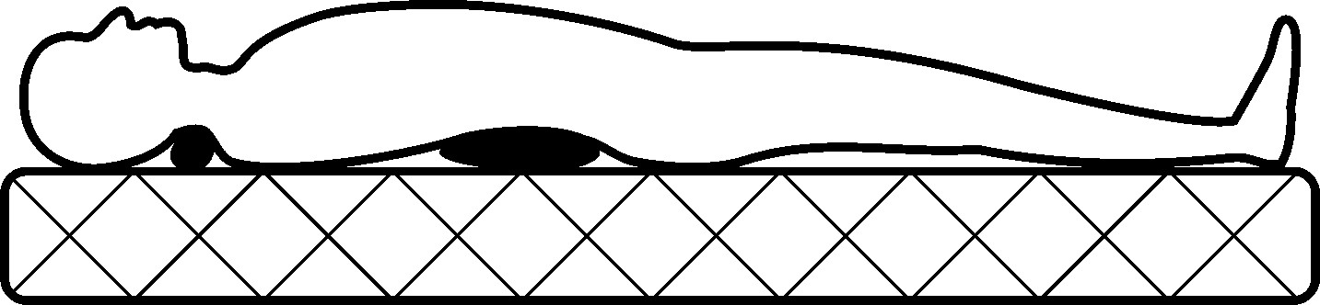
There is only one case when we should approach atlas tune up with special care and a precise explanation: when a disc herniation is towards the spinal cord. So far, the only solution has been to operate and when the atlas is realigned there is a possibility of improvement but also of deterioration, so it is necessary to monitor the condition in cooperation with a doctor. If surgery is needed, the patient will tolerate the operation and anaesthesia better and will recover faster due to better regeneration. We are all subject to the force of gravity and the law of the lever. If someone doesn’t believe in atlas tune up, that person doesn’t believe in the existence of gravity and Archimedes’ principle. It is normal that some people don’t believe in it because we have spent thousands of years searching for the method of realignment and now that it is finally discovered, it will take time for people to accept it.

In the future realigning and maintaining the atlas in its correct position will became a part of life and health culture. It was difficult to discover how to tune up the atlas because three discoveries were necessary. The first two discoveries came from René Schumperli: the atlas should not be pushed but rather the ligaments need to be massaged and it is performed with a device. I have made the third discovery, which are the angles from which the atlas is tuned up, how many times the pressure should be exerted and how strong it should be depending on the type of misalignment. The atlas can’t be realigned using the fingers because it isn’t possible to produce a sufficient number of blows per second and our fingers don’t have enough strength. On the top of the device there is a finger shaped rubber, and this is what touches the nape. Without the device the atlas can’t be realigned but our hand is more important, because we need to know how much strength to exert and where.

There are hundreds of types of massage devices and millions of them are used in massage studios or at home. Vibrating devices were discovered around the same time when Palmer discovered the misalignment of the atlas and it was a hundred years later that Schumperli discovered that the atlas could be realigned using vibrations. Four ligaments join the atlas to the base of the skull. Two ligaments are in the nape and two are in the front, next to the throat. All four ligaments hold the first vertebra connected to the skull with the same force. Massaging one side of the nape, one ligament relaxes and the other three return the atlas to a better position. Then the other side of the nape is massaged and when the ligament on that side relaxes, it allows the atlas to return to its anatomical position, where it wasn’t positioned even during its formation in the uterus.

Dr Rainer Seibel proved that our skull was misaligned at the beginning of the twenty-first century. To better understand how it is possible to realign the skull, imagine a pebble and on it, a stone the size of the head. When you vibrate the larger stone, nothing moves but when you vibrate the pebble, the pebble moves even though it is pressed by the larger stone. The atlas is like the pebble, and the head is like the larger stone, that is how it is possible to massage the skull into its anatomical position. It is amazing that you don’t have to push either the skull or the atlas and that everything returns to its place. The massage relaxes the ligaments and muscles in the rear area of the neck, so that through a natural process, the atlas returns into its anatomical place.

It was Rene Schumperli who realised how to tune up the atlas and his ingenuity will make it possible for humankind to live without health problems and diseases in the future. Finally, a new method of tuning up the atlas will be adopted and it will replace all the other methods. I claim that the HumanUP method is the only correct method of atlas tune up and I base my claims on the fact that people come to us to have their atlas finally realigned, even after having experienced other methods.
HumanUP

We count the days, months, years and decades of life since our birth but really our life starts at conception. During the first nine months of life we are well protected in the uterus but at that time a tiny, almost immeasurable disorder occurs which will damage our health throughout life. Today there are procedures that are performed during labour, and for hundreds of thousands of years women gave birth simply through the laws of nature which seems harsh to us now. However, life formed and survived in nature and because of comfort and an artificial way of life, our health is becoming more and more sensitive. It seems impossible that our species will disappear one day but because of the modern way of life that process is underway. Due to human activities and chemical pollution, different plant and animal species disappear every day. If we go on like this, our species might disappear as well.

Despite all difficulties, life has developed for billions of years and the result of this is Homo Sapiens, who should be a superior species, but instead we are the ones who pose the greatest threat to both ourselves and others. The term HumanUP implies survival and what is even more important, a return to the law of nature so that the future generations are better than the previous ones. That law enables our species to develop yet we have been deteriorating for several generations now. A reversal is finally possible, and it is high time for the HumanUP.

Every labour is a reminder of our ancestors who left the oceans and started a new life on land and in air. Before birth, the uterus pushes the foetus towards the birth canal using contractions which massage the foetus gently so that it releases the water from its lungs. For thousands of years people have known that the moment of birth is of critical importance and they named it ‘the stamp of destiny’, not knowing why it is so.

The destiny of humankind showed us the right way. My discovery of how to realign the atlas is the final stage of the discoveries made by Palmer and Schumperli and the solutions I have found are original and are implemented for the first time. Other methods of atlas tune up usually hide from the public what their treatments look like. Unlike others, I will gladly describe the HumanUP Atlas Tune-up. I can’t describe the very procedure of atlas tune up and it is of no relevance to those having it realigned, because even people with a medical education cannot learn how to tune up the atlas by reading about it. This knowledge is transferred to others with great care because it is an epochal discovery about human health.

It is best if the rebirth of humankind starts from the moment we enter this world. The term HumanUP refers to a fresh start but it is important to keep the good from the past.

Modern methods of delivery have introduced some improvements, but they didn’t consider any previous experience. In the past, as soon as babies were born, they would be grabbed by the feet and lifted in order to hang upside down and in a single jolt downwards would get rid of the rest of amniotic fluid. It seems violent, but people noticed that children were healthier, even though they did not realise why. The jolt straightens the body and the atlas is forced into a better position. Today if babies don’t start breathing, obstetricians lift them up holding their feet and slap them on the back to eject amniotic fluid, but that does not force the atlas into a better position. Jolting a newborn seems cruel and slapping it on its back can misalign the atlas even more and make the child ill. The baby’s body is fragile, and our modern way of life pampers us and facilitates everything from birth, but it is ultimately making us ill. The atlas can’t be positioned with the greatest precision in that way, that is why it is necessary to realign it before babies start to walk.

It is easier for obstetricians to deliver babies when pregnant women are half lying down but in that position the babies’ atlas can misalign even more and that is why it is necessary to bring back the natural squatting position, which existed for hundreds of thousands of years. During labour a pregnant woman’s head is pushed forwards to protect the thyroid from contractions and that is completely wrong. After giving birth, women have problems with the thyroid because their head was pushed forwards during labour, so their atlas gets misaligned backwards and that is why they have more pronounced lordosis in the cervical spine. This pushing should be forbidden because in order to raise the baby, the mother needs to be healthy.

It is best if babies have their atlas realigned when they are ten months old because when they start to walk and fall, their atlas gets more misaligned. If a baby is ill before it reaches ten months, it is because their atlas is too misaligned and should therefore be quickly tuned up. The atlas can be realigned just hours after birth. In babies and children, the atlas is tuned up by a single gentle push on the left and right side of the nape. The massage is thoroughly explained to parents before the treatment and we suggest that they have the atlas tuned up first and bring their children later. When they feel better after the treatment and when they realise how simple it is, they decide to bring their children. The massage is performed in a comfortable atmosphere and that is especially important when children have their atlas realigned.

For children to get used to the device, their parents massage them gently first and that is why children are relaxed during atlas tune up. Some children laugh because the device tickles them, and some children become tense and feel a bit of pain but immediately after the massage they forget about it. When growing up, children are often lively, and it is possible that the atlas moves a bit even though it has been realigned. Children should be brought twice a year, so that their atlas stays in place. If a child suffers a powerful blow to the head in the meantime, the atlas should be realigned again.

To understand how it is possible to live healthily without treatment, it is necessary to have some prior knowledge about atlas realignment. When we are healthy we don’t think about treatment but that is the perfect time to tune up the atlas, so that we never become ill. In this case, it is about a different approach to a healthier life and that is why we need the right information. Few people have heard about atlas tune up, but they are not very well informed. There are a lot of misconceptions and there is a lot of prejudice, so it is best if you come to us for more information. We can’t see the shape of your body and spine on the phone and you can’t see the device which we use, so it is best to come for a visit. We will assess how misaligned your atlas is and talk about your health problems and we will show you how the massage is performed.

The treatment is public, and you can hear people, who have already had their atlas tune up, talking about their improvements. Apart from this book, you can also get other printed editions: ‘Formation of the atlas in a wrong position, ‘Revival of life’ and ‘Atlant’. You can likewise find more information on atlas tune up on our website www.humanup.co.uk and people living in different countries where we still don’t have any activities can find detailed information on how to contact us. Most people come through recommendation from their family or friends who have already experienced surprising health improvements when their atlas is tuned up. Many have tried everything before coming to us and if they had realigned the atlas first, their health problems would have disappeared by now.

You should come to the treatment out of your own volition, knowing that this is the most important event in your life. When you decide to have your atlas realigned, we will give you a questionnaire about your basic information and health. Some people can’t remember all their difficulties or health problems and they only mention what bothers them most because they don’t expect that after the treatment their hair loss, age spots, snoring, flat feet, bunions, pain and other problems will be reduced. At the bottom of the questionnaire you commit yourself to three more sessions within a year because only then will the process be over, due to the natural process of regeneration of the cartilage on the atlas and the base of the skull. The text also mentions your willingness to have your atlas tuned up, adding that the massage is not a form of treatment but that the body itself improves its condition and that this process depends on your age and on the type and duration of your disease.

We don’t have to know what your health condition is because we know that after realigning the atlas, your condition will either improve or your diseases will disappear. However, it is better to write down everything you can think of, so we can tell you about possible reactions and to explain the processes that start after the atlas is realigned. We have a lot of practice and we know how problems disappear and we give you advice on how to heal faster. After the interview, we observe your body while you stand because the curving took place over the years or decades during standing or walking. When we look at you from the front and from the side and when we feel the shape of your spine, we usually know in what direction and how badly the atlas is misaligned. Then we look how far you can raise your hands to the back and when you sit down, you will turn your head to the left and right so that we can see how limited your rotation is. In most people, the rotation to the left is more limited because the atlas is misaligned in such a way and it limits rotation.

Before we start the massage, we will demonstrate on both our palm and yours, how the device works, and we will tell you how many times we intend to press the right and the left side. The massage is performed in a sitting position and during the treatment you should be relaxed like during an ordinary massage. The massage will be pleasant if you don’t contract your neck muscles. When we realign the atlas, we will feel the gap between the atlas and the base of the skull again, as well as the gap towards the jaw. You will feel for yourself that the first vertebra is in its place. Then you will turn your head to the left and right and you will notice that you can rotate your head more. Over time, the head will return backwards and the chest forwards, so the cervical vertebrae will reset, and you will be able to turn your head more.

During the massage different improvements occur and continue immediately after the atlas is tuned up. Some people feel a short flow through a body part and that is a sign that neural signals are fully functioning, and that blood flow is improving. Some people’s palms sweat because the nerve through which sweating signals run is freed. After the massage, it is mostly women who register improved vision because there is more blood in the centre of sight. After realigning the first vertebra, your sight is permanently improved, and some people experience an improvement of their dioptre. Many people feel as if a burden has been lifted from their back. The pain eases and tension is gone in the neck, shoulders, legs, arms and back. Sitting down and standing up is easier and those who couldn’t squat and stand up, can do these movements immediately after the massage.

Breathing is improved, and some people breathe through the nose for the first time. Soon after the massage, most people sleep better, and you can notice the relaxation of the body as well as improved mood. These improvements occur in most people because their atlas was misaligned in a similar way and in other people, the order of improvements depends on misaligned positions and the body curvature. Those over the age of twenty come three more times within a year and the best thing to do is to come after a month, four months and again after a year. Most changes in the body occur within the first couple of months. When we continue the procedure, we will talk about the reactions and I will explain different changes in the body. Later on, you feel the reactions less, but the process of self-healing still continues and contributes to better health.

The atlas is fully realigned within a year and that much time is needed due to the natural process of regeneration of the cartilage on the atlas and the base of the skull. After that, it becomes nearly impossible to misalign the atlas. There is a small possibility that during the most powerful force to the head, the atlas could move minimally and if that happens, you can come and have an additional massage. To keep it in its place, it is best if you have a short massage once a year. After atlas tune up, those who are ill may need support and we will offer advice on how to eliminate all your health problems. After that there are no more new diseases during life and it is up to you to maintain good health through a moderate diet, activities and rest. If you follow our advice, we can guarantee a prolonged life.

The advantages of the HumanUP atlas tune up are extraordinary and the most important one is that this is the only way to return the atlas into its anatomical position. The massage realigns the atlas safely because the atlas is moved by the ligaments and that is a natural process. Atlas tune up is performed with the head bent down and that is why the HumanUP method is the most gentle and shortest method of realignment. In that position the ligaments can be reached, making it so that only a small force of pressure is enough to tune up the atlas accurately. You don’t need a medical diagnosis before the treatment and this simplicity is one more advantage of this method.

All our activities are public because our goal is to inform as many people as possible that there is a solution to health problems. You can read as much as you like about the HumanUP method but only when you have the first vertebra tuned up, will you feel it is more than what you have read or heard. Your mothers give birth to you and now we offer you a rebirth.

THE REACTIONS

It is common knowledge that for every action there is a reaction. When the first vertebra returns to its position, everything else in our body returns to its proper place and our pain goes away and diseases slowly disappear. It took years and decades for difficulties and diseases to be created but the process of their disappearance, after the atlas is realigned, is much shorter. Everyone’s reaction will be different and the amount of time it takes depends on the individual. A few months into it, because they aren’t as drastic as when they first began, you won’t feel the reactions any longer. They are still going on inside however and the condition of the body is constantly improving. After the atlas is tuned up, healthy people feel relieved and pleasant, while those people who were ill, although they too experience relief in the first couple of days, at some point they begin to feel certain unpleasantness as the changes occur in their body. The unpleasantness is not a bad sign but rather it is because the lower brain is able to receive all the signals from the body for the first time and it is beginning to work on improving things. The higher brain is not comfortable with what is happening because it is different than what it has been used to for so long but when you understand these processes, it makes it a bit more bearable.

After their atlas is realigned most people sleep better and they tend to have more energy during the day despite needing less sleep at night. People who were previously suffering from illness tend to sleep more following the massage but later, they too will need less sleep. During sleep the body performs self-healing and at first you should pay more attention to its needs. If you feel the need for more water and food, then drink and eat more, if you are feeling like you need more rest, remember that sleeping is the most important thing. It would be best if those who were very ill could take some time after they get the massage, to stay at home and really pay attention to themselves and support the process of self-healing that is underway.

The strongest reactions occur during the first month. The disappearance of diseases is a complicated process and sometimes even those with medical education can’t understand them and the exact experience will be different for everyone. We can’t tell you precisely what will happen within your body as a reaction to all the healing going on, but we are available to support you and provide information to you if you give us a call or come visit. After a month, we continue the massage and we talk about the reactions that have started and we give advice to help you along with the process. Depending on how they start, we can tell you what reactions to expect.

It happens very rarely that people will experience such violent reactions that they feel as if they have become ill due to the atlas tune up. This happens because the signals of their illnesses used to be blocked from the brain but now, the signals are being received and the body has to work through it all. Realigning the atlas cannot cause your health to deteriorate, rather only to improve but it takes time for it to happen.

After ill people are having their atlas tuned up, more energy is released which is to be spent on self-healing. Although you may feel that you have energy, you should not engage in strenuous activities but rather you should wait until after you have given yourself time to fully heal. Some people feel pain in places where there was no pain before and that happens because the body straightens. For the body to straighten the opposite groups of muscles start to tighten and it is painful because these muscles were less active before. However, this is less painful than when it was in the wrong position and only lasts for a short time. Because of this pain, people sometimes get the impression that realigning the atlas hasn’t helped and that money is wasted. Other therapies and treatments ease the pain but aren’t long-lasting and they don’t eliminate pain. Unlike other treatments, after the atlas is realigned, your pain eases and continues to disappear.

Immediately after the atlas is tuned up, neural pathways are freed due to better body statics, and some people feel instant relief. In most people the process of straightening takes several months and that is why the process of pain elimination is slower. During life, our body curves and the pain moves from the neck to the lower back. After the atlas is realigned, the pain first disappears from the lower back, then from the middle of the back and then the neck. Headaches stop within three months of atlas tune up, but it is necessary to cut down on painkillers so that it doesn’t prolong this process. Sometimes you feel pain in one of your internal organs because they are being repositioned. The intensity and duration of the pain depend on how curved the body was but, in most people, it lasts less than a month. Some people feel pain in the sternum and they get scared because they think their heart isn’t functioning well. The pain appears due to the chest moving forwards and has nothing to do with the heart.

Within a month, digestion improves and the reactions you can have are burping, flatulence or less consistent faeces. Stomach and duodenal ulcers disappear within two months after the atlas is realigned. You don’t feel any reactions, but some people might have reddish sludge in their faeces. Very rarely, people still don’t feel any changes within the first month or two after the atlas is tuned up. When the shape of the spine starts to improve, the vertebrae are placed into better relative positions and free neural signals and when that occurs, the reactions begin. The lower part of the brain receives certain information for the first time and it can finally start to heal. In the first months after the treatment, both men and women notice better skin and hair quality. Dandruff and greasy hair are reduced. Sinusitis disappears, and the reaction is more secretion from the sinuses, which can be eased by reducing or eliminating dairy from your diet. This will not only help with sinuses but also allergies in general, as well as eczema.

Sometimes people experience increased swelling of the joints on the arms and legs as the function of the lymphatic system is improving and doing a thorough cleansing of the body. As soon as that process has finished, the swelling will go away. Old surgery scars can become red and itchy which is also a reaction, indicating that your tissue is regenerating better. If you ever received a strong blow to any part of the body, that place can become mildly itchy after the treatment as it is recovering. Those with flat feet can feel short pain which is a sign that their feet are becoming properly curved. In children, flat feet disappear within six months and in adults, this change occurs within two years after the atlas is tuned up. Within the first year after having the atlas realigned, the reactions occur throughout the body, all the way to your bunions, which can swell or become red. As your body is healed, part by part and system by system, these reactive symptoms will go away, and you will feel better than ever.

It is impossible to gain without having to give anything in return. In this case, dealing with different reactions is what you must give but that is nothing compared to what you gain. You gain good health that will constantly improve. The reactions last for years but are not felt beyond a short period of time, because these are only fine tunings of everything in the body. I have mentioned the most common reactions and even these can be different, depending on the type of misalignment and the damage it caused. It is best if the body itself improves its condition and, in most people, everything happens spontaneously but sometimes it does need support in the process. It is best that those who come to tune up their atlas, follow the advice we give them, to gain the most out of the experience and that they can help a speedy recovery and maintain their increasingly good health.

THE ADVICE

After the atlas is realigned we will give you advice on how to recover as soon as possible and to maintain your health. That support is very important, especially in chronic patients. Health problems have lasted for years and we have been using medications to maintain our health. The body was unable to heal properly because of the atlas being misaligned and due to the medication. In the first couple of months after the treatment, the body functions better and permanent healing takes place. In that period, chronic patients continue using their medication but depending on their improvements, they should cut down on the dosage after consulting their doctor. When, after a few months, your health improves, it is best to stop taking medication because it is no longer needed at that point and it can upset the natural flora of the body.

Reducing or eliminating dairy products from our diet can help speed up your healing process. After we have stopped consuming dairy products, it takes several months for the body to eliminate toxins from soft tissues through the skin and alleviate the pain which is more intense because of lactic matter that is deposited into soft tissues and which reduces blood flow, causing pain to be more intense and to last longer. It will take several more months to eliminate them from cartilage and the areas affected by arthritis. It is best to press these painful places with your fingers for about ten seconds several times a day to speed up the elimination of toxins and have someone else press the places you can’t reach. You can also ease the pain by drinking tea for relaxation or by applying woollen cloth on the painful place.

High blood pressure is one of the biggest health problems and it occurs because the centre of pressure in the first brain is pressed. Over the past decade people have been drinking less water and using too much salt, which both cause problems with blood pressure and damages the kidneys. In two slices of bread there is already enough salt to satisfy your body’s daily needs. After the atlas tune up, the centre of pressure is freed and better circulation helps purify the blood vessels. At first you will need to resume your medication to make sure your blood pressure doesn’t go too low but after a few months, you will be able to stop taking it and your blood pressure can regulate appropriately on its own. Depending on your daily activities, it is normal that your blood pressure oscillates. When your pressure is rising, it is enough to put your elbows and wrists under cold water. Your pressure will be lower after eating two apples and another good practice is to take two sips of apple cider vinegar fifteen minutes before breakfast. It is beneficial for all people to embrace this practice as well, because it cleans blood vessels and regulates metabolism.

Several months after atlas realignment diabetes disappears and you can stop taking medications then. Those using insulin can lower their dosage depending on how much lower their blood sugar is. To improve your blood sugar level, you shouldn’t eat cooked vegetables because it increases your blood sugar level, instead you should eat fresh vegetables which lower blood sugar levels. It is best to eat a raw carrot with a bit of cinnamon every day, and that will keep your blood sugar balanced. After the atlas is tuned up, the thyroid also functions again, and it is necessary to go for a medical exam and make sure it is functioning properly. These will become better over time as well and when the thyroid becomes fully functional, you won’t need medications any more. Cooperating with their doctors, people who have mental problems should gradually decrease the dosage of medications. For the body to detox, it is best to take a few sips of bentonite clay dissolved in water every day. Everyone’s body is different and so is their process of healing, so we will give you updated suggestions every time we speak to you as you progress through your healing.

DECREASING KYPHOSIS AND LORDOSIS

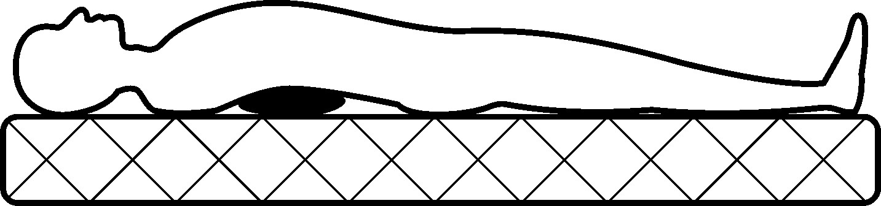

If the thoracic spine is displaced backwards too much, these people should put a pillow under that part for about ten minutes before going to bed. In the meantime, there is no pillow under the head and that way kyphosis of the thoracic and lordosis of the cervical spine will gradually decrease.

If there is a pronounced lordosis at the base of the spine, every night before going to bed people should put a blanket under their behind, so the pelvis will straighten faster and decrease lordosis.

DECREASING LUMBAR LORDOSIS

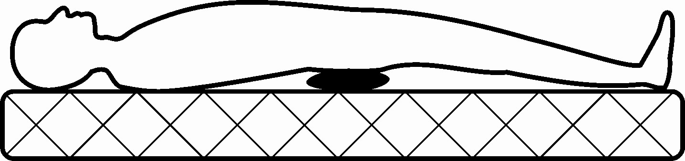

Stretching the body and spine exists as a form of treatment in medical institutions but improvements are temporary because a misaligned atlas pushes the spine back into its previous position. When the atlas is realigned, it is finally possible for the spine to become normally shaped. During standing or walking, gravity will improve the shape of the spine but if the curvature is pronounced, that person needs to stretch his spine every day to hasten its straightening. People who have more pronounced scoliosis, lordosis and kyphosis should stretch their spine for three minutes before going to bed to speed up the improvement of its shape. It is important to do this before sleeping because the spine shrinks during the day due to gravity. That hastens the improvement of the spinal shape and the vertebrae and discs regenerate better.
Anyone can make a stretching device for the spine using two strips of fabric. Pin the strips on a nail that is attached to the pediment of your door, throw your head back and put one strip under your jaw and the other one under your nape and pull the strips. Bend your knees and hang like that, relaxing, every night for three minutes. Always stand on your feet so you won’t stretch your spine with all your weight. You can ease the pain in your nape and neck in this way and your headaches will become less painful.
A STRETCHING DEVICE

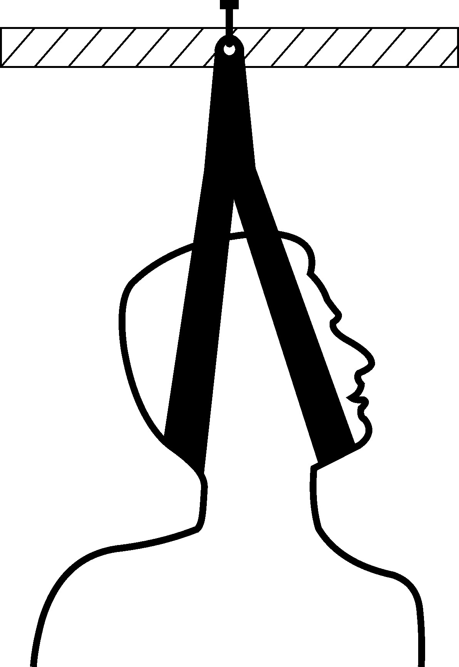

While the shape of your spine improves, it will be uncomfortable at first but later it feels great. That process may last for several months or even a year, depending on your age and how abnormal the shape of your spine was. The most important thing is to be persistent, because that is the only solution and the reward is a more normal spinal shape. Atlas tune up will improve your health and it is up to you to maintain your body for permanent health.

MAINTENANCE

Everyone needs to take care of their body and if they don’t, then they will need someone else to treat it. It is best to maintain your body correctly because no one, not even doctors, can know precisely what the needs of someone else’s organism are. Not many people can feel the needs of their body and those who do feel them, don’t know how to deal with their bodies. We pay more attention to devices than to our own body. We know how to maintain these devices, but we don’t know how to maintain our body and then we wonder when we start becoming ill. Despite the knowledge we have and the abundance of information, we know less today about how to keep up with our body than they did in the past, and due to our modern way of life, we don’t have enough time to pay attention to it. To finish all our obligations, we invest more time and money in maintaining the car than on maintaining our health.

When a device breaks down, we fix it or replace a part. We don’t have a spare body, so we really need to take care of the one we have. No one else is responsible for your condition. Only you can allow it to become ill and only you are able to improve yourself. Looking after your body is your responsibility and the body will respond with better health, the more you take proper care of it. Dedicate yourself to yourself because no one else can do that for you. The body should be maintained properly whether you go to have your atlas realigned or not but if the atlas is in its position, it is easier to maintain one’s body and health. To function normally, the body needs enough sleep, water, a proper diet and moderate physical activities. This seems simple and you are sure you are doing everything right but in the following chapters you will see that you’ve got it quite wrong.

SLEEP

The biggest mistake is not sleeping properly because it is during sleep that our body self-heals and regenerates. We spend one third of our life sleeping and although that may seem like a waste of time, it isn’t. We think that the day begins when we wake up, but the day begins while we sleep, as our body prepares for our daily activities. During the night the body regenerates and gathers energy for the following day and these processes can only take place when the body is still. The human body is a perfection of nature but not even our body can have enough energy to regenerate and perform physical activities at the same time. In our species, not only do we require enough energy for physical activities, but enough to maintain our mental activities as well. It seems like nothing happens while we sleep but while we sleep, the internal activities of the body are much more intense than they are during the day.

Only blood can access cells because it brings them what they need and takes away the products of cell metabolism. There is enough blood in the body for the necessary activities of both, day and night but the two can’t occur simultaneously. The cerebrum and muscles are the biggest spenders of oxygen; thus the first brain puts us to sleep so that blood can service the cells. The role of blood changes for night metabolism and for daily activities. Sleep is curative and that is why we sleep more during an illness. When we are ill we lose our appetite so that blood isn’t distracted by the digestive system and the energy for vital functions and self-healing is created from fat tissue. By sleeping, we reduce the possibility of spending energy on mental and physical activities.

There are too many people who don’t sleep enough, and this is one of the causes of illness. Without adequate sleep, your body is not prepared for its required daily activities and when that lasts for months or years, the body eventually becomes exhausted. Electricity is extremely useful to humankind but nothing in the world is totally useful. Artificial light has disturbed the natural cycle of day and night, causing us to become tired and sick more often. The health of people working night shifts is worse and it is especially damaged when they switch shifts. When changes occur within only a few generations, that is not good. People used to sleep at night and take a small rest at noon as well, to gather strength for their afternoon activities.

Babies sleep a lot because they are growing. Children sleep less but because they are physically active, they sleep also in the afternoon to gather strength for their afternoon activities. It would be good if we could all have a nap in the afternoon because our health would be better, and we would have more energy for afternoon and evening activities, but the modern way of life doesn’t allow that. It is best to have a nap at noon, but you should sleep whenever you feel sleepy because your body is telling you what it needs. If you can’t have a nap, then lie on your back, raise your legs and close your eyes, because the system of vision and memory spends a lot of energy. When you are at work, you don’t have a bed so instead you can sit with your eyes closed and relax for ten minutes during a break. In that way your body will recover a bit and when you come back home lie for ten minutes or so before you continue with your activities.

When children come back from school and parents from work, they are all tired, but it is too early to sleep. They become grumpy because they are so tired, and this disturbs their family relations. Watching fun TV shows, they try to be cheerful and to stay awake until going to bed in the evening but to finish what they have started watching, they don’t use that time when the first brain feels sleepy. Later when they go to bed, they can’t fall asleep immediately because they are no longer sleepy. It is best to be ready for sleeping from ten o’clock at night and use the moment when you feel the need for sleep. It would be best to get rid of television even though it seems impossible these days. You should spend time with people and not with the two-dimensional characters on your screens.

When single cell organisms merged and became multicellular, the development of life was possible, and plant and animal species lived in communities in order to survive. Man is a social being but due to the modern way of life, there are more people than ever experiencing loneliness and depression. We are living among millions of people and yet we are so lonely, and that lack of human interaction creates more illnesses. To have a break from our daily activities, in the evening we sit and watch TV. It seems like you are just resting but while we sit, the venous system is under similar pressure to when we stand and while we’re watching TV, our centre of vision has to spend a lot of energy. Humans are visual beings but sometimes it is better to just close your eyes. To rest your brain and work more easily, you should close your eyes for a minute every fifteen minutes.

Man is destined to be in a horizontal position during sleep and in an upright position during his daily activities. We are under the impression that we rest when we sit but, in that position, we are putting pressure on the venous system. People who spend several hours lying down and watching TV wry their neck, causing them to have health problems. It is better to hang your TV from the ceiling and to put a pillow under your back. In that way your spine won’t curve and if it is curved, that position will help it straighten faster.

In the past people used to sit for a while to rest their bodies but in the present we sit too much. We are always sitting - in schools and universities, our cars, at work and in front of our TV. During the Roman and Ottoman Empires people used to lie down, even when they ate and if they had TVs, they would have sat too. It seems that different devices and comfortable armchairs are there to improve our life, but they actually cause harm. Not only do we have too many TV’s, today we study, work and have fun while we look at a monitor. Sitting in our big, comfortable chairs, we are curving our body even more. If you have to sit at the computer, it is best to lift the monitor so that you look up at it so that you will curve your spine less.

For the body to perform its functions normally, it is best to sleep on the back in order for the skeleton, spine and joints to be in their anatomical position in which they regenerate better. Because we start snoring, which interrupts the process of recovery, that is the position we least sleep in. During sleep we unconsciously turn so that our organs can work better but we usually sleep on the right side and we have a thicker pillow under the head than we should. We sleep in that position to ease the pain on the right side of the nape but that is the worst position because it misaligns the atlas even more. The position on the right side is bad because other organs press the liver and prevent it from functioning normally.

Children often sleep on their stomachs but to be able to breathe, they must turn their heads to the right side. The position on your stomach is also good but we couldn’t sleep like that all night so that position should be used for a nap in the afternoon. I suggest that a mattress be made with a comfortable hole for the face and an opening for air. The body turns during sleep because of metabolism and the hole can be used when we sleep on the left or right side. Our widest part is the shoulder girdle and we can put one shoulder into that hole and the head will be in line with the body. In that way, you won’t need a pillow.

Due to the importance of the processes that occur in the body during sleep, we need appropriate conditions. Science has proved that the ideal temperature for sleeping is between 19 and 23 degrees Celsius. Most people can’t afford this, so it is best to sleep on a woollen mattress and cover with a woollen blanket. Wool is the best natural insulator. Synthetic materials are cheaper and cosier but also more harmful. Rheumatic pain increased during the twentieth century, because of artificial materials.

After atlas tune up almost everyone sleeps better because of decreased pain and because the atlas doesn’t press the first brain as much, allowing it to decide when we fall asleep and when we wake up.

WATER

When we wake up in the morning, the first mistake we tend to make is not drinking a glass of water. We get oxygen from air, but our organs and cells get molecular oxygen from water. Our organs need water to prepare for food intake, to enable the processes in the body and to cleanse the body from the inside. We live on land, but we are aquatic creatures because our body is mostly made of water and although we can’t live in water, without water in the body there is no life. There is water in our cells and cells are surrounded by a liquid that is of similar composition to the ocean, where life first appeared.

Books on health start by emphasising the importance of water for the body and its healing properties. When we have a cold or flu we should drink even more water to eliminate the viruses and bacteria from our body faster. When someone faints, people immediately splash some water on their face and the back of their neck and when they come to, the first thing they do is drink water. Some people drink water only when they take medications, but in that combination, water has healing properties.

Obesity is not only an aesthetic problem but a health problem as well. One of the most effective ways of losing weight is a water diet which reduces weight and improves health. Most people think they drink enough water, but the research has shown that 99 percent of children and adults don’t drink enough water. The consequences of such disregard are high blood pressure, arthritis, poor blood flow, slow metabolism, vertigo, headache, obesity among other health problems. The state health insurance service is too burdened, and people pay a lot of money for treatments. It would be much better and cheaper if we simply drank more water.

Eating too much food isn’t the only thing that causes people to become overweight, not drinking enough water has the same effect. Fat is mostly composed of water and when you don’t drink enough water, your body stores it which causes extra weight and bloating. Due to obesity, people try out different diets, but the body continues to become heavier and people become more prone to diseases. Scientists are still studying the nature of water and each new discovery brings in more proof of the unique and extraordinary qualities of this seemingly common substance.

It is devastating that in the twenty-first century we no longer have a good relationship with water and we don’t use it properly. Water used to be sacred and people took care not to pollute it. Now we pollute it more and more, ruining our own drinking water. To provide enough food for the growing population and our constant over indulgence, we are spending water reserves on growing plants and animals. The paradox is that we live on the planet of water but due to our activities, we are reducing the amount of usable water and thereby endangering our own survival.

Only water can clean us from the inside and outside. We use too much water while having a shower, leaving the water running while brushing our teeth or doing the dishes but we fail to consume enough of it. It doesn’t help us even if we have a shower every day, if our body is dirty on the inside. The immunity of our skin has been developing for hundreds of thousands of years and we damage and destroy it in a matter of minutes with such frequent showers. Our body is meant to be cleaned through the skin pores and not polluted by chemicals.

For the body to be cleaned from the inside, it is best to drink sufficient water and for outside cleansing it is enough to rub your skin once a week with a wet towel and then have a shower. It is best to alternate between hot and cold showers to improve blood flow and to clean the skin from impurities, always finishing with cold water. If this is unpleasant, start off by only doing so with your hands - first washing them under hot water and then cold. Cold water is also helpful in easing the headaches and neck pain by splashing it on the back of your neck.

We drink water, but we don’t take care to pay attention to how much, how often or the quality of the water we consume. Water from vegetables, fruits and food is not sufficient and it can’t replace pure water. Most people drink a lot of juices, teas, coffees, alcohol drinks, but that doesn’t make up for drinking water either. These are all impure fluids where the structure of water has been altered. Water has no taste and it is manufacturers who make tasty juices from artificial chemical aromas that we buy for our children and consume ourselves. It would be better if we just get ourselves and our loved ones used to drinking water so we don’t have to get used to hospital rooms and doctors’ visits.

Everything is polluted today, including water. It is very important to be aware of the quality of water that we are taking into our body. With food, we are taking waste materials into our body and water is supposed to cleanse us, but if it is itself impure it is unable to clean. At water supply systems, chlorine is put into water to remove bacteria and bottled water is treated with antibiotics. The content of chlorine and antibiotics, both of which are poisons, is small and the water dilutes them, but it is still enough to kill bacteria. We don’t die from that water, but chlorine slowly damages our body and antibiotics weaken our immunity. The influence of chlorine is even more damaging when water is boiled and that is why mothers make a big mistake when they give their babies boiled water.

It is up to us to improve the quality of water we drink and use for cooking our food. We don’t have a spring of perfect water, but we can influence the water which is available to us. It is enough to buy an appliance for water purification. The money you give for a filter, distiller or ozoniser will improve your health and it is cheaper than continuously buying bottled water. Scientists recommend drinking distilled water because fruits and vegetables contain water which has all the necessary minerals. If you don’t have enough money or time to prepare water, you could also pour water into glass containers and use it the following day.

Drinking distilled water serves two purposes, the first is that it prevents us from ingesting calcium through our water and it also helps get rid of calcium surplus that comes from our food. In micron blood vessels there is too much calcium which slows blood flow and that is one of the reasons why we are more ill when we don’t drink sufficient water. You shouldn’t wait until you’re thirsty to drink some water. Each day you should be drinking at least two litres, three at the most. Less than that can be hurtful, and more than three litres can harm the kidneys by making them have to do too much work. When it is hot though, you can drink more water because the excess is removed through the skin.

You should have water half an hour before eating to give your organs time to prepare to digest the food and it is best to avoid drinking water during and up to an hour after a meal because that causes gastric juices to become diluted. However, after the meal your mouth is best cleaned with a sip of water. In the evening you should stop taking water and food so that you can urinate before going to bed, with the exception of having a glass of water just before you go to bed to help your body with its metabolic processes and to prevent dehydration as we eliminate quite a bit of water when we’re exhaling during sleep.

At dawn we are awaken by the mistaken impression that we need to urinate, but we are in fact thirsty. It is helpful to keep a glass of water next to the bed so that you can drink some water and continue sleeping to allow your body to complete all the processes happening in our body. Our brain doesn’t differentiate between hunger and thirst so that is also one of the reasons why we eat too much. Before you decide to eat something, have a glass of water, because you are probably not hungry, but thirsty. Those who drink enough water, eat less.

FOOD

Overeating is the cause of the greatest health problem of humankind and it started a long time ago. Our ancestors didn’t have access to food every day, so they had to overeat when they found it. Now we have a lot of food and constant access to it therefore we don’t need to consume as much. Nonetheless, we still eat way too much, not because we’re hungry but because we enjoy eating food. The law of balance has no mercy and the happiness of feeling full turns into the misery of feeling ill.

In the mid-twentieth century, the global food reserves were sufficient for six days but today, they are only enough for one. We produce more food than ever before, but we also consume more. We used to eat to survive but now some people live to eat. Health used to come through the mouth but now it is often the gate of illness. Modern illnesses occur due to overeating, and because our food is polluted with chemicals. We spend too much time sitting and it would be good if we stood while we ate. Although it is difficult to eat while standing, the stomach receives food more easily in this position. A research has shown that we eat forty percent more when we watch TV. While we eat, our stomach needs a lot of blood, so we should eat in quiet surroundings, so our senses and our digestive processes can focus properly on their task.

We have so much information surrounding us yet most of us are clueless how to properly drink and eat for good health. Magazines, TV and the Internet advise us but too much information can confuse us. We read books, listen to nutritionists and doctors and we continue to become even more confused. Food trends seem to change every day - the worst thing today becomes the absolute essential tomorrow. Our clothes become tighter and then we get into the realm of dieting, which helps temporarily but ultimately leads to getting fatter and sick in the long run.

Cavemen had no one to advise them on food and so they simply ate what they could find around them in accordance to their body’s needs. Their choice of food depended only on their sense of smell and taste. Originally, we used to be herbivores, we know that by the shape of the jaw and teeth but over time we became omnivores. While populating the planet humankind adjusted to the food from different areas and the digestive system changed as well. Although we have become omnivores, our stomach can’t digest different foods at the same time. Not only did we not consume so much food at once, our ancestors would eat one kind of food per meal and although our diet has changed, our digestive system hasn’t upgraded much. It would be in our best interest if we eat like cavemen used to eat. Our stomach can’t digest proteins and carbohydrates within a single meal and fruit should be eaten separately. We also shouldn’t mix different fruits. If this is too complicated, then simplify your menu and eat one type of food.

Eating a diet that is specific to your blood type is best for your health and keeps you slender and fit. It may sound like it would be complicated but it is quite simple. The basic food of a human being is fresh fruit and vegetables and everything else is just an addition to your diet. Meat is an addition to blood type 0 and cereals are an addition to blood type A. People with B and AB blood types can eat any kind of food, but they shouldn’t eat meat and cereals in the same meal. Blood cells collect nutrients and carry them to cells in the body and when we eat food that doesn’t suit our blood type, the nutrients don’t attach to the blood cells properly, so they stay in the intestines and the colon where they rot and feed parasites and bacteria.

After the atlas is realigned, our metabolism improves because the signals for digesting food are freed, but we still need to adjust our diet according to our blood type and be cautious when combining multiple foods in one meal. The basic rule is not to eat meat and bread in the same meal. The last vertebra carries two thirds of the body; thus it is left to carry the burden of obesity if we don’t take care of ourselves properly. This is not the only vertebra that carries the load, the vertebrae above are also required for support, which is why the flow of neural signal towards the legs and neighbouring organs decrease even before disc herniations occur. With too much food, especially when it’s not the right kind, we are feeding bacteria and parasites. There should be about half a kilo of these in a healthy person’s body but now an average person not only carries more than a kilo of bacteria and parasites, we also carry food for them.

Vegetarian and vegan diets are becoming fashionable and our ancestors used to eat like that for thousands of years. Some ate plants only, some combined plants and meat and some only meat. They didn’t know about different diets like we do today, they ate depending on the food that was local to them. Due to different types of food, different blood types were created. Depending on what kind of food predominates, the connection between a blood cell and a nutrient is different. Our digestive system is extremely flexible, which is why we have been able to settle the entire planet. Vegetarians and people who eat meat believe they are both right. The conflict gets even more complicated with a vegan diet which excludes all animal products, and raw foodists, which recommend we should eat all food but only in its raw state. These conflicts are ridiculous because everyone is right in their own way.

Many believe that our ancestor ate only raw food, which is not the case. Let’s go back to the time when mammals were small and dinosaurs big. Different species of dinosaurs inhabited the earth, ruling over the planet. Big dinosaurs posed no threat to mammals because they were herbivores, but the smaller dinosaurs hunted and ate meat, including smaller mammals. Mammals found refuge in treetops and ate fruit; however, it required a lot of energy to climb trees. When dinosaurs disappeared, mammals got bigger because they started eating different food, with fruit being the basis of their diet. When the threat of dinosaurs disappeared, some species of mammals returned to land while some stayed in treetops. Tens of millions of years went by and those mammals who stayed in treetops became monkeys, whose main source of food was fruit. Over time monkeys got larger as well and because their size frightened smaller predators, they came down from the trees.

Fire was used before Homo sapiens, who perfected its use. Among other things, Homo sapiens used fire to cook and bake food, as well as for softening the roots of different plants. Processed food is easier to chew which means you need to spend less energy on chewing it as well as digesting it. Food has been prepared using heat since people came into existence. Finding and preparing food was the basic human activity at that time, which developed thinking and the brain, so it could be said that our relation to food made the modern man.

Gathering and preparing food led to the division of labour between men and women but it also led to the relationship of one woman with one man. Women used to gather fruits and roots while the men used to hunt and gather honey. In that way they had different types of food for themselves and their children and eating together developed family relations. Individuals teamed up to gather food and hunt together and, in that way, a hunter-gatherer community was formed. This made it possible for them to collect food reserves for the seasons when there wasn’t any food in nature.

Thinking process was the beginning of agriculture as well. More food meant more free time which led to new activities. This allowed for creations that made life easier as well as creativity which later stemmed into art. Banging into a hollow trunk and drawing on the walls of caves did not help our survival but today we can’t live without music, painting and other forms of art. At the beginning of the twentieth century there were two billion people living on our planet and at the beginning of the twenty-first century that number increased to seven billion people. This rapid increase in population was made possible by pesticides. In order to satisfy an ever growing need for food, we cultivate almost all fertile land. Natural resources are insufficient, and the population is still growing. Because of that, people are inventing different types of artificial food which will affect the future generations’ digestive system. People used to live simple lives, but good intentions have complicated things.

The development of thought enabled us to gather and store food, and in order to protect it from bacteria and pests, food is stored and chemically treated today, even though such food hurts us. Cookery has become more than science, cooking food has become an art. In kitchens there are tons of food that looks good but has little or no nutritional value, consequently we have to eat more. Food is becoming tastier but also more dangerous. The food industry can copy natural tastes with the help of chemistry and they produce artificial tastes which seem better than the natural ones. We also have the problem of processing food, specifically heating and cooling it in order to preserve and prepare it. Freezing slows rotting but because of low temperatures food loses its nutritional value. Frying and boiling decrease the nutritional value even more and to fulfil the needs of our body we need more food.
Our body is a perfect natural engine which creates a lot of energy with little fuel. Science still doesn’t know how energy is created in cells, but we know that most of the energy we get from food is spent on digesting that food. The main source of energy is the sun. Plants get energy from the sun and water and that energy becomes beginning of the food chain. We are at the end of the food chain, but we also get a lot of energy from the sun and water. However, we need to eat to regenerate and to gather substances necessary for the development of new cells. Among seven billion people there are just a few who can live without food and water. Scientists at space centres are studying how that is possible to aid future missions to space, not to show how we could all eat a little bit less.

The First and Second World War brought much suffering to humankind, among others the change of the natural ways of women’s life. While men fought, women produced arms but even when the wars ended, women continued working. Ever since that time, women have been working double shifts, one at work and another at home. They exercised their right to work but this has caused harm within themselves and for their families. While they are at work, someone else raises and feeds their children and in this way, women have been robbed of their basic purpose of existence – taking care of their offspring.

It is a common saying that women keep their husbands with good sex and tasty food. At the beginning of their married life, people are more sexually active, and it dwindles down as time passes, the women’s sexual desire decreases and the men’s’ appetite for food increases. Wives want to please their husbands, so they make different food, but they are actually causing harm. It would be better for everyone if simple food were prepared but women wrongly think that their husbands would find it monotonous, whereas it is women who find it monotonous to cook similar dishes.

Fruits and vegetables are the most important foods. In traditional Chinese cuisine they use a lot of vegetables. They are cooked for only a while, just enough to remove bacteria and parasites and to keep their nutritional value. The Chinese don’t eat wheat products and they don’t use dairy products, which is why they are healthier. Statistics have shown that people today are several times more ill than half a century ago and the reason is not atlas misalignment, because misalignment is the same as it was fifty years ago, but rather because people use more milk and animal based dairy products. The increase of diseases coincides with the increase of milk usage. Regardless of types of food and diet, no one should use milk and animal sourced dairy products in adulthood. We are the only species that uses milk after the period of breastfeeding and we are the only ones who consume the milk of another species.

A baby's digestive system isn’t fit to digest animal milk and after the age of three, it loses its ability to digest its mother's’ milk. Only mother’s milk can give us immunity and start the development of the brain, bones and muscles. When mothers drink milk, their babies get stomach cramps and that is why some babies stop sucking. That is why there is no milk in the breasts, leading babies to have to drink artificial milk. Nothing can replace mother’s milk. Although the nutritional value is small, it is enough for the baby’s body. From the age of one, mother’s milk is not enough and that is why babies start eating other foods. The nutritional value of animal milk is so low that an adult would have to drink several litres to meet the needs.

Milk and dairy products are very dangerous food. There is no milk in dairy products because bacteria have already used it for their metabolism. The content of dairy products is mostly made of the remains of dead bacteria, a small portion of live bacteria, and the rest is faeces from both dead and alive bacteria. Smelly cheeses are an expensive delicacy which our stomachs take even more time to digest than meat. When people buy dairy products, they are essentially paying to become ill. Yogurt, curd milk, sour cream, cheeses and other products only harm our body. In medical schools students learn about the harmful effects of milk on human health but apparently the marketing of the dairy industry has more power than scientific knowledge.

Our immunity is deteriorating due to the surplus of bacteria from milk. Our body identifies proteins from milk as viruses and bacteria and it reacts by producing more antibodies. Our natural defence mechanism is weakened in that way, allowing us to fall ill more often. These antibodies are also directed towards healthy tissue. The pancreas can be permanently damaged in five years, causing us to take insulin for the rest of our lives. Milk and dairy products cause diabetes, osteoporosis, arthritis, bad teeth, enlarged thyroid, obesity, heart conditions, breast, uterus, colon and prostate cancer. Milk causes diarrhoea and dairy products cause constipation. The liver and kidneys are under more pressure, but they can’t purify the waste from dairy products, so they slowly become ill. The levels of proteins from milk are dangerously high in our body and cause cataract in our eyes. Today even children develop cataract.

Elevated levels of triglycerides and cholesterol are also caused by dairy products. These products cause allergies, sinusitis, asthma, bronchitis and infertility in both sexes. Milk is the ideal carrier for bacteria, parasites and viruses. Using dairy products, we increase pain, headaches, exhaustion, and the acidity of the body rises. The solution for most health problems is to cut out all dairy products from our diet. We can only use butter because there is no calcium in it and because butter fat is useful. A misaligned atlas twists and curves the body, decreasing the flow of nutrients and then it is additionally decreased due to the deposition of milk impurities. The flow of food among organs is disturbed, there is no proper matter exchange in our organs. The atlas exerts different pressures on the centre which control blood flow and neural pathways, so we digest certain foods differently and because the tissues for nutrient exchange are pressed in different places, everyone reacts to dairy products differently.

When there is a disorder, the body tries to balance it and that is why the function of certain organs decreases or increases and by using milk we speed up these processes. Depending on the type of disorder, some people experience osteoporosis, some osteopathy and the function of the thyroid increases or decreases depending on how our metabolism is disturbed when the atlas is misaligned. Information on using dairy products is confusing. It is recommended and then suddenly it isn’t. Women are often confused the most and make mistakes out of fear. They give their children milk, causing them to become ill and due to dairy products, their mental capacity decreases and they are unable to excel in their studies. Women break bones more often because they use dairy products more often than men. It is a huge misconception that the calcium found in milk is useful. Only one-fourth is used, while most of it wastes energy as the body is removing it.

The calcium from dairy products is unnecessary in our body because we already ingest a sufficient amount from our food and water. Children and old people should eat a lot of fresh vegetables, as well as adding in some dry figs and sesame seeds which are good sources of calcium, to help with building bone mass. Our digestive system can’t eliminate the waste products created from dairy products, so they are mostly eliminated through the skin. This is a large factor in pimples, which is not only a huge aesthetic problem but can also be linked to poor health. Although it may take several months, once you eliminate dairy from your diet, your skin will clear up.

Gastritis and bloating are difficulties that occur mostly due to dairy products. Leukaemia and multiple sclerosis are both worsened through dairy consumption. Based on how much damage dairy alone can do to our body, it seems as if the dairy industry exists to keep the medical industry in business. Science has confirmed that milk is extremely harmful, yet we are still paying to keep the dairy industry open and running. Health insurance funds are already extremely burdened in countries across the world, regardless of economic status, and the overriding solution would be to shut down the dairy industry. Financial experts can prove that the country would gain more than it would lose and even if that weren't the case, having its citizens in good health can’t be measured in money.

Abolishing the dairy industry won’t affect cattle breeders because there would still be a need for meat. They would still require monitoring to ensure that they don’t give the cattle any form of hormones. Cows can naturally produce three to five litres of milk a day, the amount a calf needs but now cows are injected with a synthetic hormone which makes them produce more than forty litres of milk. Hormones exhaust them, and they become ill. To treat the damage of hormones, they are given antibiotics and by the time we drink milk from these animals, we are pumping ourselves full of bacteria, hormones and antibiotics that damage our health.

Milk isn’t what it used to be. There are no clean pastures due to the polluted atmosphere so that even when the cattle are being treated right by their caretakers, they’re ingesting chemicals from the air and from the grass they graze upon. Pasteurized milk has more bacteria and parasites than when it is freshly milked, such that if a calf were to drink it, they would die within a few months. Because we are eating other food as well, we don’t die but it does great damage to our health. Dairy producers don’t use milk because they know what they feed to their cows just like those working in the production of industrial food don’t eat it and they don’t feed it to their family. If people were aware about how their food is produced, they would rather go hungry.

We can substitute animal milk with different types of vegetable milk. You can either buy it from a store or just make it yourself, which is safest and quite easy to do. Vegetable milk improves health and saves money. This milk is made of oats, buckwheat, millet, sesame seeds, almonds, walnuts, hazelnuts, barley, rye, hemp, rice, coconut, sunflower or pumpkin seeds. These foods are useful because they contain elements that our body needs, and they aren’t full of pollution. Vegetable milk is made through a process of cold pressing which allows its natural values, such as B17, to be preserved. You should avoid vegetable milk made of wheat or soya because wheat is chemically treated, and soya is chemically prepared. Vegetable milk is tastier than animal milk and if you want it to taste better, you can add honey, cinnamon and some fruit and mix it all up. Children will love all these different natural tastes and they will avoid the artificial taste of the dairy industry.

For thousands of years we modified plants and animals for our benefit, through the process of selection first and then even more through genetic engineering. Insects don’t eat such plants so crop yields have risen but this kind of food harms our body. Modified plants have little nutritional value, making it so that we need to eat more to satisfy the needs of our body. These modifications change the molecular structure of plants and their shape is altered due to industrial processing. It’s been made to fit the industrial machines, but it no longer suits our digestive system. Straight carrots are easy to peel but difficult to digest.

Margarine is made of vegetable fat and it seems to be less harmful than dairy products, however it clogs tissue. Food can be curative if we eat it properly. The acidity or alkalinity of our body depends on what kind of food we eat and how we prepare it. Our bodies should be slightly alkaline, not too acidic nor too basic, because either extreme will lead to illness. When our body is too acidic, certain bacteria multiply and cause damage. Intercellular spaces are neither acidic nor alkaline and this provides a suitable space for healthy bacteria to live in. If we maintain a balanced level of alkalinity, our body is able to keep our bacteria, good and bad, at an appropriate level.

The life cycle of bacteria is short, they mutate fast and the antibiotics which used to be effective several decades ago no longer work. Pharmacists are constantly making stronger antibiotics while our natural immunity continues to weaken and if we continue this way, we are allowing ourselves to be lead into an abyss of no return. We aren’t dying quickly but we are spending most of our life suffering from disease whilst the food, milk and pharmaceutical industry are making a lot of money. The combination of the industrialized food and dairy that we are consuming feed the bacteria, our immune system isn’t strong enough to fight and the antibiotics we are treated with weaken our immunity even more. Food, milk and medications are destroying us and if we want to live, we must leave this enchanted triangle as soon as possible.

In the past, when people were sentenced to death, they were forced to dig their own graves. We aren’t forced to do this but too often, people are willingly digging their own grave through the choices they make. Even one small choice, such as cutting dairy out of our diet, is enough to be much healthier. There are lots of options aside from dairy, yet it is hard to find healthy food due to polluted crops by our modern lifestyles. It is safest if we grow our own food but a lot of times we don’t know how, and in some places, they have laws that prohibit growing fruits and vegetables in a garden of our own.

Gardening is useful not only for our health but for life in general. The contact with soil, air and sunlight is healing, the contact with plants relaxing, and the quality of food is better and more suitable for our body. We are what we eat so we must be mindful in our choices. We eat food that is too acidic but often, we can’t avoid that, so we must cut down on our portions and eat foods that are alkaline to neutralize the acidity. If that seems complicated, an easy solution is to drink lemon water every day. Lemon is sour but once it’s in the stomach, it becomes alkaline and reduces the acidity within the body. Other options are apple cider vinegar or baking soda diluted in water. For the benefit of intercellular spaces, we need to balance the intake of salty, sweet, sour and bitter foods. We eat too much of salty and sweet and not enough of sour and bitter food, so the chemistry of intercellular spaces is disturbed. Sour and bitter do not suit our sense of taste but that doesn’t negate that we need to eat them.

We eat too much sugar because it is added into everything by manufacturers to make people addicted. Children are more active than adults, which is why they like sweets and juices that give them energy, but they spend that energy fast, and when they spend it they become nervous and addicted to sugar. It is beneficial for children and adults to eat a tablespoon of honey in the morning without water. The sugar in honey is released slowly throughout the day and provides energy for brain and muscle functions, so we are getting enough energy but aren’t left addicted to sugar. Honey has a number of benefits and archaeologists have found pots of edible honey dating back to several thousand years ago.

Cinnamon is a perfect natural antibiotic, destroying bio attackers without weakening our immunity. The climate of India is favourable for bacteria, viruses and parasites but the Indians keep healthy by using cinnamon. You can make a simple but powerful syrup using one litre of apple cider vinegar, a kilo of honey, six tablespoons of cinnamon and two tablespoons of grated ginger and keep yourself healthy by taking two sips every day before breakfast. With this syrup and your atlas tuned up, you will avoid external infections. Cut down on the amount of food you eat and adjust your diet according to your blood type and you will be even more healthy and fit.

Lunch should be the largest meal. It takes twenty minutes for the signal of satiety to travel from the stomach to the brain, so we should eat slowly. Adjust your food intake with sunrise and sunset, eating just a little before and after midday while having your biggest meal at noon. When we eat our biggest, most caloric meal at noon, it gives the food enough time to reach the small intestine in time for the evening, when the substances for the regeneration of the body are extracted from there. For thousands of years our digestive system has been adjusted to it and it can’t be changed in the matter of a few generations. Three meals are enough and between them drink only water. That is necessary for your organs to rest sufficiently and gather all the necessary ingredients to be able to digest your next meal.

Our metabolism is attuned to the cycle of day and night. The body needs time for recharging, working and releasing. The modern way of life has moved the day cycle of our metabolism, preventing our body from functioning properly. When the first vertebra is realigned, it is necessary to stabilize the cycle of day and night modelled on our ancestors. During the day we work and eat and during the night we sleep. It is very simple, but our modern way of living can make it complicated. People are often staying awake late into the night and sleeping through the morning. This has a huge impact on our health.

We often focus on the details of eating and very little is said about the importance of bowel movements. If we eat more food than we eliminate, that becomes an obstacle for our metabolism. We eliminate less water than we ingest through urine, because some water is eliminated through sweating and exhaling but the excess of solid waste cannot be eliminated through the skin or nose. A lot of waste can fit into the colon, but it is best if it is empty. The best time for bowel movements is in the morning. Those who empty their bowels several times during the day, live healthier and longer.

Constipation is a serious problem in modern times because instead of taking time to empty our colon, we are rushing around in the morning and the time for emptying has passed once we’ve finished with work or school. This continues throughout the week and then it’s too late. Thus, several years go by and your colon has had to hold on to waste, which is one of the causes of colon cancer. The physiological position for emptying is squatting but because we are a civilisation that sits, we sit for this as well. Sitting position bends the end of the colon and stops excretion, whereas if we were to squat, our thighs press the lower abdomen and excrement is removed more easily. It is not enough that some of the digestive organs are functioning well, the entire system needs to be in harmony from the first brain. Digestion is improved after the atlas has been tuned up because the centre of digestion is freed as well as the signals through the vagus nerves.

Our ancestors survived for two hundred thousand years with little food and they ate simple food. If they managed through severe conditions, then we too, having much better conditions, can manage. However more people die nowadays because of food, but from over consumption rather than scarcity. Food is necessary to maintain us but too much food can destroy us. If we continue eating too much, food will consume us. There is a saying in China: ‘The cause of your illness lies at the bottom of your plate.’ People analysing the future predict that the Third World War could start because of the lack of food and water but this war would not be fought between countries. It would be mutual extinction and that is why some people store food and buy guns. Air and water are still available to most people but whoever controls food will rule the world. To prevent us from growing our own food, plants are modified so that a new generation cannot sprout.

While the Western Roman Empire dissolved, The Eastern Empire continued to exist for another thousand years. One of the reasons for the dissolution of the Western Empire was too much enjoyment of life and overeating whereas although Byzantium was a powerful state, where the richest people of that age lived, they lived modest lives just like their subjects and they didn’t overeat. There are thousands of books on diet, but people are still making mistakes. People try to complicate things whereas the key is simply to harmonise the amount of food you eat with your activity level.

ACTIVITIES

When we’re referring to human activity, this includes not only physical activities but also mental activities, both of which spend a lot of energy. The upright position of the body during walking enables us to spend less energy than walking on four feet and when we’re walking in this position, we bend forward unconsciously, which urges us to move. It is our upright position and our brain that sets us apart from other animals and for the brain to work properly, it requires a lot of glucose. Our ancestors lived in such climate conditions which offered them fruit all year round, which gave them consistent access to the energy they needed to keep up with daily activities. We still choose fruit over vegetables, mostly because it is sweet but when we’ve eaten enough, our body requires vegetables for regeneration.

They say that work created man, but it is the opposite – laziness created man. Our brain and thinking processes were developed due to people being lazy and trying to figure out the easiest way to do the things they had to do. The modern man is too lazy and that is why inventors and scientist invent devices and technologies to appease our laziness, but we have overdone it and that is now leading to our rapid degradation. Our laziness is not the only reason why we are being replaced by machines at work, manpower is expensive, and companies want bigger profit. We used to work six days a week but now we work five and this isn’t because of the humanity of industrialists but because they want us to spend money on different products.

Working time is getting shorter and there are even some suggestions that we should work only three days a week. Machines make our lives easier in some ways, but they also disrupt our lives in several ways. Because machines now substitute manpower, we are much less active, and inactivity has become a significant health risk factor. Research has shown that over the last century, our physical activity decreased by 99 percent. Inactivity leads to muscle atrophy and because of the amount of food we eat, we’re not burning off the energy and instead we are getting fat. Our leg muscles cannot carry a heavy body, causing us to sit even more and become more ill. It’s a continuous trap that people are falling into.

In the past, species disappeared due to natural disasters and we are on the verge of disappearing due to being too lazy. It seems impossible to tell what the future might bring. If human beings disappear, another species will take the opportunity to replace us. With the technological advances coming so quickly, there are many mistakes made which could also jeopardise our survival. Futurology is a science that is dealt with by responsible scientists and they predict that we could live to be one hundred years old in the future but that’s if we survive the next one hundred years.

We can’t live if we don’t work. The sole purpose of work is not only to make money but to keep our body active as well. In order to be healthy, we should be active until the end of our lives, being sure to do things that bring us pleasure as well. Some people’s illness disappeared when they continued their hard physical labour despite their pain. In the future, with their atlas tuned up, people will be able to work throughout their lives. Physical labour is curative, and it is better to have a hobby that moves your body, as well as your mind.

When men retire they often become inactive, which is one of the reasons why they tend to live shorter than women. They mostly sit and watch TV, leading them to become ill and requiring them to lie down which eventually leads to their dying. Different treatments prolong their lives for a few more years but ultimately, they are living miserably in the end of their lives and die shortly thereafter. Unlike men, women are generally still active when they retire. While they play video games, children need a lot of energy for the mental activities that go into it and only little for physical activities. Children don’t eat enough fruits, but they eat quite a bit of sweets. It is harder to turn refined sugar into glucose and it is easier to store it in fat tissues, aiding to childhood obesity.

Today’s children don’t know any of the games their parents used to play in their childhood, instead they resort to video games. Anything is possible in their video games except the chance for normal physical development. During sitting only their fingers move along the keyboard and the only active muscles are those in their forearms. When they grow up, they find jobs that allow them to work while seated at their desk, leading more people to become disabled. Physical activity is more important today than ever before because we eat and sit a lot. We need to protect our muscles from atrophying.

Muscles and joints need physical activity but too much activity damages them. Most sports weaken the body and in old age professional sportsmen are more ill than their peers. Because they jump, people who play basketball, handball and other similar sports, have thinned discs in the lower part of the spine and thinned cartilage in the hip, knee and foot joints. When they fall or are hit, their atlas gets misaligned more than in other people and too much physical activity exhausts the body. The strongest young men used to be prepared to become warriors through exercises and now they become sportsmen. Many people exercise recreationally to straighten their body, but they can’t because their atlas is misaligned. It is better to have your atlas realigned in one minute than to exercise your whole life.

During running and exercise, acid crystals gather in the muscles and because of calcium deposits from dairy products, it is more difficult to eliminate them, so the pain become more intense and last longer. Man is not supposed to run and too much running is bad for health. Our ancestors would sometimes run to get away from danger or to chase after their prey, but they wouldn’t run every day for several kilometres. In old age, once people can’t run anymore, they go for long walks but that’s a waste of time and cartilage. The ideal sport for both, the young and old, is speed walking. It is enough to walk a kilometre every day and this will be useful for muscles as well as eliminating waste products through sweating.

The human brain is constantly thinking. This is several times more pronounced in women than in men, which bothers women and causes them to try to be more physically active in order to slow their thinking. Women become exhausted by their level of physical and mental activities making them more prone to headaches and vertigo than men. Women mostly stand while they work and they don’t rest. Men do harder jobs and that is why they rest. For the sake of better health women should rest several times a day. The body relaxes while sitting but it is better to lie on your back to balance your blood and lymph flow.

During children’s games the body and spirit activate naturally, enabling normal psychophysical development in children. When we grow up, the body still needs movements but the physical activities in most workplaces aren’t enough to keep the body functioning properly. In the past there was no television and people used to enjoy going dancing, which activated their body and developed social connections. For thousands of years people celebrated life through dancing and folklore. With our static way of life, we need that now more than ever.

There is also less time and desire to have sex, which is both, physically and mentally curative. Due to the deficiency of physical activities, there is a diet called ‘The Sex Diet’. A lot of money and time is spent on different diets, exercise equipment and psychologists but the best solution is enjoying your loved one. Men prefer morning sex while women enjoy night sex more. The best solution is to have sex in the morning and at night, so you will be in a good mood all day. Happiness hormones are released, muscles are activated, and excess fat is burnt. Women rely on reason more and men on natural needs. The female principle continues our species with men supporting them. Science has confirmed that men are right about morning sex because both sexes have a stronger sexual desire in the morning. Couples that start their mornings with sex are happier, are more connected and live longer. It is just as important for a couple to have a great physical connection as it is for them to have a strong spiritual connection. After realigning the atlas, the sex drive will be increased, and men’s potency will be improved because of better blood flow and because neural pathways towards the penis are not pressed.

During our activities, all the tension from our body gathers in the nape and our jaw muscles are tensed because when we are upright, only our lower jaw hangs. It is like our head is in a clamp due to the tension of the nape and the cramp of muscles in the lower jaw, which creates nervousness that we aren’t even aware of. When the atlas is tuned up, it eases the tension and to ease it even more, we should press hard under the skull with our thumbs. The treatments of atlas tune up are similar, yet slightly different because each body is different. Only people, using a device, can realign the atlas in other people and advise on how to eliminate illnesses rapidly and maintain good health once you are healed. That connection of mechanical and human activities will enable individuals, as well as mankind, to live healthier, happier lives.

MODERATION

It is necessary to find the right balance in everything to have a better quality of health and life. Although we all are quite similar, we each need to find our own limitations. Moderation in sleep, water, food and activities corrects mistakes and improves our health. Too little or too much of anything can affect our body in a negative way. If you wake up tired, that is a sign that the processes which take place in your body every night haven’t finished, letting you know that you need a little more sleep. We need to drink water according to our limits and likewise be mindful of our food intake. Moderation in all things is necessary but it is of utmost importance when it comes to our food intake. The balance between the number of calories you consume and the amount of calories you burn is what is important. It is ridiculous to eat a lot and then spend these extra calories through exercise. Because of too much food, we have turned our enjoyment of eating into strenuous exercises and we spend money for the food and then for the exercise equipment.

Activity is necessary for muscles and joints, but we must be careful to neither do too much nor too little, both of which could be harmful to the body. To find our own limits, we need to find out what suits our body. We should make sure that we do a little work and a little of something we enjoy. When we find our level of moderation with our activities, it’ll be easier to figure out how much sleep and food we need. After having the atlas tuned up, it’s especially important to take care in being moderate in order that our body can properly and fully heal. Life won’t make sense, nor will it be satisfying if we focus solely on being disciplined, so we must be moderate even in our moderation.

For most people the limit of life is three minutes without air, three days without water and three weeks without food. Cities are known to be places where air, water and food are heavily polluted as is the countryside. We used to live in whatever harsh conditions happened to exist within nature. Compared to that, modern conditions seem better but unfortunately, we live amidst the harsh reality of universal pollution. This leads to obesity which is a huge factor in people losing their confidence or belittle others. If we don’t like our body and are constantly having negative thoughts and feelings about it, our body will reciprocate based on that. Our bad thoughts weaken our immunity and trigger illness. We should love our body, especially places that we see as being problematic.

The body needs to be protected, especially those parts which are sensitive because it is easier to protect the body than cure illnesses. During the day the body is protected with clothes and during the night with a cover. Most people think that the stomach is the most sensitive body part but in fact it is the back of the neck. It is especially inconvenient for men because unlike women, they usually don’t have any hair over the nape to keep it covered and warm. The nape should always be well protected because exposing it to the sun, cold, wind or rain can lead to the inflammation of the meninx, which causes the lower brain to be pressed. This is a rare form of inflammation which is quite severe.

Our body is not suited for being too hot nor too cold. Moderation in dressing and covering our body is regulated by the seasons but regardless, the nape is usually exposed to atmospheric conditions. When people go out into the cold or precipitation, they should make sure their nape is covered by a scarf or a hood. Our species is extremely adaptable and that has made it possible for us to live in extreme weather conditions. For example, if Eskimos and African people were to go and live in the others habitat, they would quickly adapt to the new conditions but if this were to happen too often, it would lead to illness. During winter we go in and out of our houses and the various places we visit in the day and within minutes we have gone from warm to below-freezing and back again. Humankind is adaptable, but we can’t take extremes, so it is much better for us to adjust our living conditions to our surroundings and do our best to avoid artificial manipulative inventions like air conditioners.

Most people pay more attention to material assets than their bodies. Unnecessarily we spend a lot of money on things that make us happy temporarily and then bother us later in our lives. Unfortunately, there aren’t many people who invest the necessary time and money in maintaining their health. People wait until they become ill and then try to restore their health but by then, it is too late. It is better to lead a moderate life according to your actual needs and balance one’s desires with one’s possibilities. Due to our fast-paced life we don’t have enough time to listen to what our body needs but we must balance the speed of life with taking time for our needs to reach the end of life healthily and happily. After realigning the first vertebra it is easier to deal with extremes, but moderation is still the golden key.

COMFORT

Since our beginning, we have always yearned for comfort. We live too comfortably nowadays which is why we have become so overly sensitive and we fall ill much more often than our ancestors. It feels good to work and live in comfortable, albeit mostly artificial, conditions but we are actually harming our body. Air fresheners can’t help us when we live surrounded by concrete and plastic. We can’t necessarily change that, but we can spend some of our time in nature and give our body some time to recover.

Lying down suits us best but we can’t lie down all the time. When we stand our venous system is under pressure, causing us to want to sit down but this still doesn’t allow as much blood to return from the veins as when we’re lying down. It is better for our health to lie down a couple times throughout the day rather than to stay seated for long periods.

Given the choice between an apple and a banana, most people choose a banana because it is easier to chew. Likewise, given the choice between a piece of fruit and sweets, most people choose sweets because they are tastier. Everyone has the right to choose but because we choose based on our desires, we often cause harm to our body. A short-lived pleasure turns into a life-long difficulty.

Our ancestors used to live in warm climates, which enabled them to sleep on the ground. When they moved to colder areas, they started sleeping on wooden surfaces, which provided insulation against the cold. Wood and ground are hard, so they began putting soft rugs on them. From there it escalated until nowadays where we often sleep on mattresses which are much too soft, damaging our body more night after night. People also try to ease their pain by resting in soft armchairs and comfortable beds, but these things cause the body to curve even more and intensify their pains. If that curving only lasted for a short period of time, it wouldn’t be that bad but most of us are living with this curvature for several decades, suffering pain and diseases.

Hot or cold surroundings are not pleasant, but they are curative because the body becomes more resilient. During winter, our clothes protect us from getting too cold, but we also shouldn’t wear too much, which would cause our body to overheat.

The modern individual weakens their own immunity by overly indulging themselves and thereby, becomes more ill. People have always used drugs, but it has become a serious problem. In some countries pain is legally treated with medical marijuana. Drugs reduce the perception of reality and occasionally they can create an impression that our health is good. Using drugs is a form of indulgence but the effects don’t last long, causing people to repeat it until eventually it becomes an addiction. In most people after atlas tune up, drug addiction decreases because health improves, and happiness hormones are secreted normally. They no longer need the effects that they had been seeking from their drugs.

They say that it is natural and normal to die from an illness but that is not true. People who have their atlas realigned won’t die of illness but rather, of old age. Everyone has a beginning and an end, but the most important thing is that we don’t suffer from illnesses while we are alive and that we don’t have shortened lives because of them. Our lives are limited because regeneration has an expiration date and life ends once the body stops regenerating.

REGENERATION

The division of cells starts from the moment of conception and it’s a continual process that lasts throughout life. Cells each have their own lifespan, depending on the type of tissue they belong to. When the life cycle of cells ends, the division of living cells creates new cells, which is called regeneration. The process of regeneration starts while the foetus develops in the uterus and lasts until the end of our life. The organism is renewed through regeneration and that enables longevity. If the process of regeneration were to run smoothly, our lifespan could be one hundred and twenty years but due to atlas misalignment, the connection of the brain to the body is not complete, decreasing the possibility of regeneration and causing degenerative changes.

Tens of thousands of cells die each second and new cells are created simultaneously. The process of regeneration has its end, and that is why life expires. Cells divide uncontrollably and that is why the brain controls the process of regeneration. At the end of puberty, we stop growing and at that time, there are on average thirty seven trillion cells in the body. From the age of twenty, the number of cells decreases, leading us into the phase of aging. Regeneration then continues to gradually decrease through the decades. Only the atlas regenerates completely throughout life because that is the most important place in the body and that is why it can be realigned even in the elderly. Due to the importance of that joint between the brain and first vertebra, that is the last place where complete ossification occurs.

After the atlas is tune up, the brain’s communication with the whole body is significantly improved and blood flow is much better. Neural signals from the brain flow unimpeded and blood brings substances for new cells. Better communication and flow enable better regeneration, the body starts to recover, and healing takes place. Better regeneration improves the quality of the skin, hair and nails. These improvements are things that can be seen but there are also processes taking place within the body. When the atlas is tuned up, the body is able to regenerate properly. However, if realignment has come too late, then a damaged organ cannot regenerate and must be operated on. Nevertheless, with the atlas tuned up, it is easier to handle any required surgeries, tissues heal faster and the time of recovery is shorter.

Organ transplant prolongs life and some organs can be replaced by devices. Better solution is the scientific discovery of stem cells because this supports the organism in recovering on its own. In the beginning of life, we have a certain amount of stem cells which are, when the time comes, activated at the place where regeneration has become necessary. Over the course of our life, our number of stem cells decreases, which is why we lose the ability to regenerate as we get older. A part of stem cells is harvested from babies and kept to be used one day for the regeneration of damaged organs. Thanks to atlas tune up and stem cells, people may be able to reach 200 years old at some point in the future. The regeneration of neural and bone cells takes a lot of time and that is why the nervous system and bones regenerate the slowest. All organs regenerate but maintain their size, except for the liver which can become enlarged depending on how much waste substances must be cleaned out from the body.

THE LIVER

Our present problem is misaligned atlas due to enlarged. The liver enlarged when Homo sapiens became omnivores. A wider choice of food gave humans greater chances of survival, but it also led to worsening of health and overeating. Overeating was justified in the past because there wasn’t enough food around but nowadays we have plenty of food and it’s just damaging our bodies and making us sick. All organs in the body are important, but the liver is extremely important. There is a saying: ‘How much your life is worth living depends on the liver.’ The word liver in both English and German stems from the word life. (LIVE – LIVER; LEBEN – LEBER.)

Over the past few decades, our liver has doubled in size due to the chemical additives in our food. Our liver wasn’t required to purify chemicals out of the body in the past, but now, with its enlarged size, it has to try to get rid of all that poison. Not even the double-sized liver can succeed in purifying all the waste materials that we deposit in our body, which is why we are becoming more overweight. Due to enlarged liver, the distribution of internal organs was disturbed in the past and has only worsened over time. The right kidney is positioned even lower and the heart and the right lung are positioned even higher. Despite the efforts of medicine, the number of heart conditions and heart attacks is growing, as well as some other diseases. The liver presses the organs and the same time they press the liver back, so that nothing functions normally.

THE LIVER IN PREHISTORY

THE LIVER TODAY

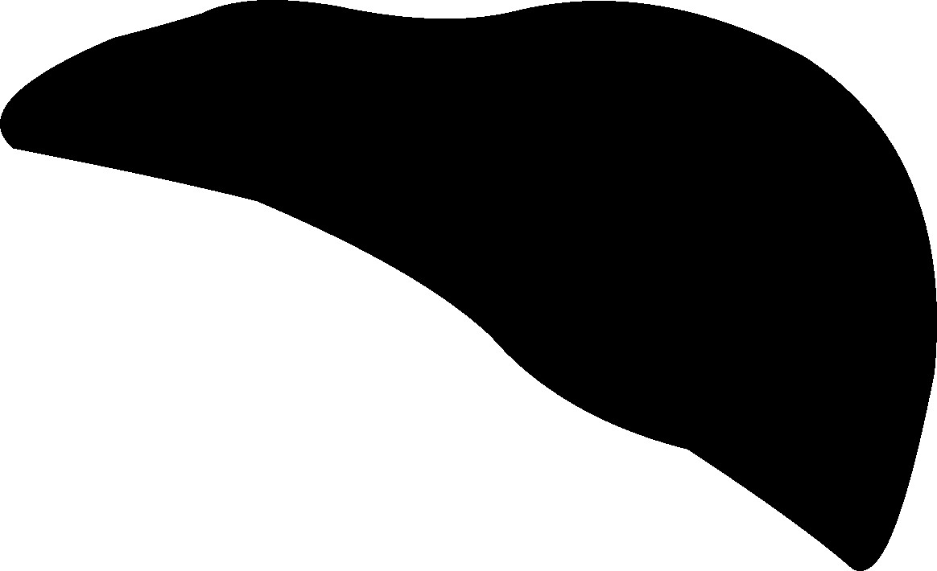
For cells to survive, they need to have clean intercellular spaces. Blood brings nutrients to cells and removes the products of cell metabolism. Also, white blood cells clear the remains of dead cells and bio attackers. Blood cleans the body and the liver cleans the blood.

We should thank the kidneys and pancreas because they regulate our metabolism according to a daily schedule and we should thank the liver seven times more because it also cleans the body according to a weekly schedule. Nerves that lead to the liver are located between the fourth and eighth vertebra of the thoracic spine and go past the ribs. The liver is on the right side, which is the side that most people sleep on, thus the pressure from the ribs decreases those neural signals which in turn disables the liver to perform its functions properly.

Degenerative changes in the body occur due to the accumulation of toxins. The changes can be seen mostly on the hands and arms but on the rest of body as well. There are spots on the skin which we call liver spots. They occur in certain people depending on misalignment of their atlas and their diet. After realigning the first vertebra, the spine becomes more normally shaped and transmits signals towards the liver. The liver can regenerate better, and it is easier for the liver to clean the body. When the body is being purified properly, these changes and spots will fade or disappear. High concentrations of toxins damage the liver, which is why the liver has to and can regenerate fast. It can become larger or smaller, depending on the type of food we consume and how much. If the liver of one person can become smaller, this means that it’s possible for everyone’s liver to become genetically smaller and in that way, remove the original cause of health problems. The liver could become smaller in as little as two generations and because it’s genetic, it would occur in foetuses as well. With this occurrence, the atlas wouldn’t be misaligned so badly.

In Serbia people say: ‘As stupid as a goose’. Geese are overfed to gain more weight and have more meat. This makes their liver become enlarged and causes them to become dangerously fat, making them sick as a result. We are not fed in order to be sold and eaten, but there are more and more people who are overweight. Our desire to eat and our sense of taste are the greatest enemies of our life and the hardest part is that they are within us. We are the only ones to blame for the condition we are in and the food industry has only exploited our human weaknesses. Its profit is based on indulging our need to overeat and enjoy food. The best solution is to return to the proper diet and that would be eating one type of food per one meal. It is impossible to repress our sense of taste and desire to eat in modern generations, so the only solution is to realign the atlas as soon as possible. After atlas tune up our digestion improves, allowing the liver to function better and to clean our polluted body.

Individuals used to enjoy food and alcohol in the past as well but today it has become universal. People get drunk in order to ease the tension of the modern way of life, which damages their liver even further. After atlas tune up it is easier to handle being drunk and you're not hungover. The HumanUP method enables everyone to have better health, even for the generations to come. The discovery of atlas realignment can finally balance the past and present for a better future.

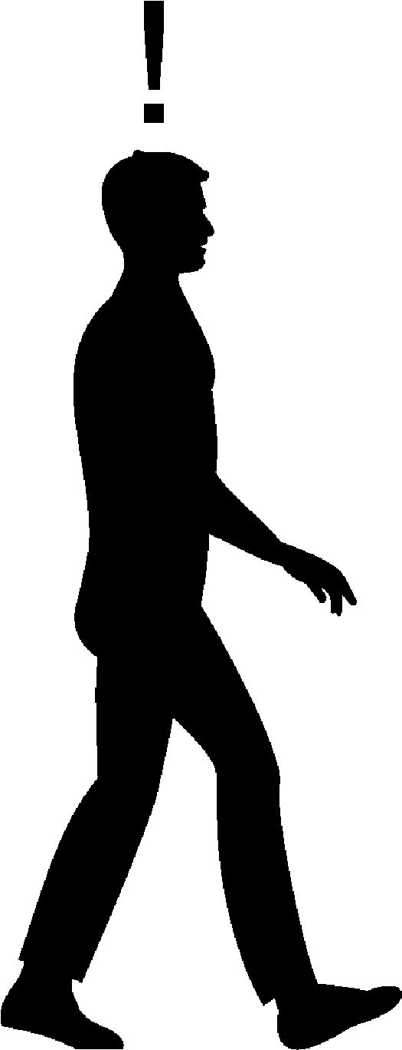

THE FUTURE

Because of the mistakes we have made, we have changed for the worse. Realigning the atlas allows the opportunity to reverse that and from now on, we will change for the better. We are the only species among millions that can consciously influence our own development but that means the mistakes we make now will cause ourselves and our offspring to suffer. Our awareness of atlas tune up can and must improve humankind in the future.

IMAGINATION

Imagination moves people, but it isn’t enough to fantasise alone. You need to realise what you imagine. The discovery of atlas tune up can finally make better health become a reality for all people which isn’t in the interest of most of big industries, thus it will be a long journey to make it a reality. No one has been to the future and so we don’t know how we will live then. Most people fantasise about their own improved future, some fantasise about a better future for humankind and there are those who don’t fantasise, but they plan out how the future will be. The problem is that these creators generally plan in their own interest more than for the benefit of others. In the past, individuals created the present and now their descendants enjoy privileges and the cycle renews as this generation plans to do the same for the next.

It seems it is difficult to fantasise about a world in which everyone benefits and what is more important, no one loses. It seems based on what we see in our current world that for someone to win, someone else must lose. At present the food industry is winning producing chemically treated and genetically modified foods which are making people more ill. The medical industry deals with treatments but a lot of their actions aren’t with the people’s best interests in mind. Not to mention that the pharmaceutical industry has a saying: ‘A cured patient is a lost consumer.’ When those who are responsible for taking care of such vital affairs are more interested in taking care of themselves, it makes it quite difficult to live but for now, it seems impossible to live in a more humane world.

Any attempts at creating a better social system have been prevented by different industries. Fortunately, once the atlas has been realigned, with better health and with more blood in the brain we will become more aware, so we won’t have to depend on different industries. This may seem utopian, but this was the reality of the original community and if it’s happened once, it can happen again. Can you imagine a life without pain, illness, suffering, treatment, surgery, bad teeth, glasses, baldness, wrinkles and other health and aesthetic problems? Imagine a world where people will live healthily and happily for hundred and twenty years. You may wonder what to do with all those years and why someone would live so long, but if you give rein to your imagination, the possibilities are endless.

The creators of the future shouldn’t worry because healthy people will be more productive, and they won’t ask for sick leave from work. Some will wish to work until the end of their lives when they enjoy what they are doing, in addition to working for compensation. In the future there will be enough time for both personal and family life, as well as for entertainment and hobbies. You don’t need a time machine to realise that life without disease offers pleasure, happiness and enjoyment.
ASTROLOGY

You might wonder what astrology has to do with the topic of this book. Every atom in the body is from the solar system, which is why everything around us influences our life. The sun has the biggest influence and if it weren’t for the moon, life would be a different shape. We are tiny but the Sun, the Moon and other planets influence us through the Earth which we live on. In the entire universe, everything simultaneously influences everything else. We may be small, but the development of thought has led us to the point where we can change the path of asteroids and in the future, we will be able to change the paths of the planets as well. Our descendants will bring Mars closer to the Sun and humankind will have a second home.

The word astrology is made of two words – ‘Astra’ and ‘logos’, which together mean ‘the science of stars’. Today most people think that philosophy is the science out of which all other sciences developed. In fact, astrology was the first science, from which philosophy originated. Early men used to look at stars and, in that way, developed deeper thinking, which eventually led to philosophy. Astrology is developing nowadays too but it is still not recognised as science. Time changes everything, including our relation to science. Depending on certain interests, some sciences are suppressed while others are developed. Mistakes are made in both cases because of opposing interests but over time, these mistakes are always corrected. It will be the same with astrology.

Astrology bothered many religions even though most religions developed from astrology. Different sciences had issues with it to, yet they too developed from astrology. It is neither the first nor the last time we have been ungrateful to the origin but if it hadn’t been for the origin, the successors who took us to the Moon wouldn’t have existed. Astrology explains phenomena, events, natural cycles, possibilities and predetermination. Because of this, astrology shouldn’t be used for predictions but rather for understanding why certain things happen. The Mayan civilisation dealt with astrology and they knew their end would come but they didn’t know why. Hundreds of Spanish soldiers couldn’t possibly kill the tens of millions of natives but the viruses and bacteria they brought with them did.

For thousands of years the Chinese and Indians knew which diseases belonged to a certain astrological sign and now modern science has confirmed it. People born in the sign of Scorpio are ill most often, but they recover easily because they have the amazing power of regeneration. It is no coincidence that most people working in the medical profession are Scorpios. Eras of certain signs last for two thousand years. The era of Pisces is ending and for the following two thousand years we will live in the age of Aquarius. Towards the end of the Pisces era, two world wars were fought and what is even worse is the pollution that occurred in the twentieth century. Transitions from one era to another are dramatic and take the course of 140 years. We are currently living in the time of transitioning.

There are no better or worse signs so likewise, there are no good or bad eras but each of them has its advantages and disadvantages. The Age of Pisces enabled manipulation which is why the majority has been used by the minority. The natural laws of the universe strive towards balance and that is why there will be more equality in the Aquarius era. The element of Aquarius is in the stratosphere. It’s no coincidence that people started flying into space at the beginning of the Age of Aquarius. Astrology gives hints about possibilities of that which humankind can change. By the will of those who have the authority of decision making and with the help of the Age of Aquarius, humankind will finally be liberated from health problems and exploitation.
People have dealt with the atlas for thousands of years and finally the planets and stars are in such a position that will enable humankind to have a better future. The time has come when the oldest science, astrology, and other sciences, are joined by the youngest science – atlasology.

ATLASOLOGY

The atlas is the smallest of all the vertebrae and it belongs to the smaller bones in the body. There are 206 bones in the human body, 24 of which are in the spine. It seems unbelievable to create a science about a single bone, especially the smallest out of so many in the body. Because of its significance for human health and life, there is an extraordinary need to create a science about the atlas. I suggest we create ATLASOLOGY. This book and ‘The Prenatal Theory of Atlas Misalignment’ are the beginnings of that science. Some are more and some are less important, but due to its importance for life, atlasology will become one of the most important sciences.

The morphological study done by Dr Rainer Seibel is the basis for atlasology, but it is necessary for other medical experts to write similar clinical studies about illnesses before and after atlas tune up for added credibility. This would lend itself to quicker implementation of the HumanUP method. Along with the science, the professionals using the HumanUP method to realign the atlas, should be given a name in order to differentiate it from those who move the atlas uncontrollably. The appropriate name is atlasologist. To become an atlasologist is a great honour but a great responsibility as well. Atlasologist is not a renowned occupation for now but it will soon become the most respected and humane profession, because we are helping people with what they value most. There are medically educated atlasologists, but we are different than doctors because our focus is not on treatment. However, it is not necessary to have a medical degree but rather you will simply need training to be able to become an atlasologist.

Through the establishment of atlasology, the public will understand why health problems occur and what’s more, find out that there is a solution for difficulties and diseases. For atlasology to develop, medical experts need to publish scientific studies, which will be the ticket to fame that some of them seek. Atlasology will improve human health and medical science and over time it will become the most important area of medicine. Furthermore, atlasology should correct the mistakes of anatomy. When this occurs, I will be grateful to all those who have helped atlasology become science and I am happy to have already started the process.

THE PROCESSES

What seemed impossible in the past has become possible now and what seems impossible now will one day come true in the future. Future generations will live healthily and won’t realise what kind of illnesses we used to have. Good health of humankind in the future will be possible due to atlas tune up, natural treatments, organic food production, stem cells and the further development of medical science. Everything takes time, but it is especially important that a better future starts as soon as possible. Many discoveries were accepted neither easily nor fast. The need for better health is stronger now than ever before, which is why the discovery of atlas tune up must be realised rapidly and for that to take place, it is necessary for several parallel processes to occur.

First, people need to know about it. Once the news spread, the problem will be lack of atlasologists. This knowledge can be passed on quickly, however it takes some time to train new atlasologists. There are dozens of methods of realigning the atlas so there will be some competition. The atlas can only be correctly realigned using the HumanUP method, but it will take time for medicine to prove it. Only an atlasologist can tune up the atlas so it is very important that the process of proving this doesn’t take a long time because with other methods of misaligning the first vertebra people can become more ill.

Today tens of millions of people work in the medical and pharmaceutical industries. Tens of millions more produce devices and supplies for these industries and people working in all these industries raise their children with their pay checks. There is already lack of doctors and nurses all over the world and the pressure on health systems are enormous. With the atlas realigned, people will hardly ever be getting ill and the pressure on these industries will decline. Atlas tune up in everyone in the world will last for decades more and eventually there will be equilibrium between health industry and the need for it.

Professors of medicine create an illusion for their students to think they are ‘little gods’ because they hold other people’s lives in their hands. When you instil something like that into young people’s brains, it is not good for them. Some doctors tend to feel like supermen throughout their lives and they can’t really connect with their patients. It seems unbelievable that up to 97 percent of all surgeries are unnecessary and damage human health but that is a fact revealed by medical experts who left their jobs. Millions of surgeons studied hard and they only do what they were taught to do but that is no excuse for performing unnecessary surgeries which aggravate patients’ health. There is a saying: ‘They saved a person’s life and worsened his health’.

Medicine will still be needed but much less than today. Surgeons will still operate on soft tissue injuries and orthopaedists will still cure broken bones. In the future, medicine will deal with prevention rather than treatment. Even people with their atlas realigned are prone to viruses, bacteria and parasites, so we will still need medicine to prevent and cure infections. The condition of the body will be checked through laboratory findings and research will be carried out at institutes so that medicine continues to develop further. With their atlas tuned up, people are healthier and have more needs than those who are ill. Different markets will be created with millions of jobs for new technologies and organic food production. Due to better health people will want to travel and have hobbies, so more people will be employed in the entertainment and tourist industries.

Because of increased productivity the global economy will grow and because of better health people will enjoy working. Some people will want to work longer so pension funds will not be burdened and because of fewer sick leaves health insurance funds will also become less burdened. Due to better economy and better health, countries will give less money for social and health insurance funds.

TIME

It is impossible to turn back time and correct the mistake that occurred in the past due to a misaligned atlas but now we can finally correct it and have a better future. We live in an age when people are obsessed with technological development and new scientific discoveries but in the future people will realise that some Nobel prizes were wrong and that certain discoveries were harmful to us. Time is the best judge and one day, it will become known that the greatest damage was done by some discoveries in the field of chemistry.

It happened in the past that certain discoveries weren’t understood in time, such as with Daniel Palmer and his discovery of atlas misalignment. The same happened to the discovery that the atlas can be realigned by massaging the nape that Rene Schumperli came up with. These discoveries are of key importance for humankind, so the Nobel Prize would be too small an award for these two geniuses. Palmer and Schumperli did not belong to official science but they made the greatest discoveries. To correct the injustice done to them, I suggest establishing the PALMER-SCHUMPERLI Award, and it would be given to those scientists whose discoveries really contribute to humankind.

The Mayan civilisation didn’t deal with science, but they measured time with great precision. Their discovery is that there are epochs which last twenty-six thousand years. The wrong interpretation of the Mayan calendar announced the end of the world in 2012, which of course didn’t happen, but it was the end of one epoch and the beginning of another. I was lucky and honoured to be among 400 people on the planet who were taught by Rene Schumperli, but I soon realised that his method wasn’t the final one. During 2012, I longed to improve Schumperli’s method and in June of 2013, I finally discovered the proper way to tune up the atlas. It is quite possible that this discovery will represent a turning point for humankind, the one which the Mayans predicted and if this happens, we will be able to measure time according to their calendar.

In the next epoch people will live without diseases and time will surely tell that the HumanUP method is an epochal discovery. The degradation of our species has been taking place over several previous decades and the discovery of atlas tune up is happening in a nick of time, but it is still not too late. When our atlas will be realigned depends on many factors, one of which is time. Scientific medicine makes mistakes, and its greatest mistake is not using the experience of treatments which have existed for thousands of years. When the atlas is tuned up, health improves but we are still prone to infections. However, because the atlas is realigned our immunity is improved and the body heals easily and with the help of medicine it will heal even faster. If in the future natural and scientific medicine merge, treatments will be much more successful.

Atlas tune up doesn’t substitute either natural or modern medicine, but it gives much better results for both - because it eliminates the cause of diseases. Atlas tune up is the most important project for everyone in the world, and for this to pass, humankind needs to unite, regardless of religious or political beliefs. If this doesn’t happen, people will become more ill and our lifespan will become shorter, despite the fact that medicine is developing faster and faster. Even though it isn’t important how long we live but to be healthy all the time, it would be best if everyone’s biological clock could work for 120 years. Time lasts equally for everyone, but everyone’s biological clock is different. Everyone has a time bomb in their nape, which ticks faster or slower depending on how much the atlas is misaligned. In one out of ten thousand people the atlas is in its place, and that coincides with the lifespan of one of those ten thousand people who live to be over one hundred years old. It would be better if modern humankind were to tune up their atlas as soon as possible, and one of the reasons why more time is needed is – fear.

FEAR

The two strongest emotions are fear and love. Love for ourselves and others is what separates us from animals. Being in love exists only in our species and the main purpose of that pleasant state is to procreate. Oestrogen secretion starts when girls are two years old and this hormone is what develops their need to care for others. It becomes especially strong when they become mothers as they begin caring for their offspring. In boys it is testosterone that is secreted more, which increases their aggression and sexual desire. Procreation is a basic need and in humankind, it begins to develop during childhood. Care for one’s offspring, sexuality and aggression are all in the function of procreation and protecting one’s family.

Our ancestors’ love for their offspring was stronger than ours is now. It used to be unimaginable for someone else to raise their children while today it is normal. Family relations have worsened and because they lack love, children are unhappy and prone to illnesses. Love can’t be bought yet parents pay someone else to take care of their children and then when children grow up, they pay someone to take care of their parents. It takes a village to raise a child. Today we mostly live in cities, but children often grow up with limited communication with their surroundings despite being surrounded by many people. Children rarely see their grandparents, so even intergenerational communication is limited.

Love is useful if it is moderate because too little or too much could be harmful to others. Because of the self-love of modern generations natural resources are being spent as if we were the last people in the world and as if future generations won’t need air, water, soil and oil. Animals live instinctively and don’t eat more than they need. There are instincts in our species as well, but they are combined with what we learn from our environment. A fear of hunger is instinctive, and a bit of hunger is curative, so mothers should teach their children to eat less. We should fear overeating rather than hunger. Those who eat less are healthier and people who eat food low in calories live the longest.

A fear of illnesses is greater than a fear of death. People have no fear of death because they realise that being born and dying are natural processes. It is justified to fear illness in old age because we know that our offspring should be taking care of their children not their parents.

Optimism and pessimism are human characteristics. Optimism is a component of youth while pessimism is more pronounced in old age. Younger generations are more pessimistic than their predecessors, despite living in better conditions. When we are middle-aged we see older people struggling with diseases and that is why optimists become pessimistic. In our fifties our health takes a turn for the worse. In the future, people will live healthily throughout their entire lives because of atlas tune up so they will be optimist, even in old age.

Our ancestors were neither pessimists or optimists, they simply lived in accordance with nature. They too feared for their lives because they were exposed to harsh conditions, but they weren’t worried about their survival. Today we live in even harsher conditions and we have a reason to be more worried. We have polluted the environment and now we must clean it so that future generations will have a place to live. It wasn’t until the twentieth century that cases of cancer started to increase and now, at the beginning of the twenty-first century, every third person is dying of cancer. It is thought that in ten years, one out of every two people will die of cancer. This is happening due to polluted environment and food, but fear is an even greater trigger of cancer.

People used to fear natural disasters, predators or violence but these only happened occasionally. People lived in communities, so they could protect each other. Now we are afraid every day and there is much more to be afraid of and although people live in bigger communities, they are lonely and have no protection from their families. As we grow up we are afraid of our kindergarten teachers, teachers at school, professors at universities and when we find a job we are afraid of our bosses and directors. Drivers are afraid of hurting pedestrians and pedestrians are afraid of being hit by cars. When people whose atlas has been realigned find themselves in a stressful situation, more blood reaches the brain, so they have a clearer mind and are able to have an improved response rather than defaulting to fear. With less fear, they are less likely to have cancer.

A fear of the new and unknown is justified, which is why it is best to get to know what we are afraid of, then we can properly judge if it is a real danger. The point of this book is to familiarize you with the HumanUP method, but it would be best to visit an atlasologist and ask any questions that you may have and verify for yourself that there is no need to fear atlas tune up. A lot of people, including medical professionals, are afraid of this area because it is so sensitive. It is unnecessary to be afraid of atlas tune up using the HumanUP method because there isn’t even the slightest risk. People shouldn’t be afraid of realignment, they should be afraid that their atlas is misaligned.

Atlas tune up using the HumanUP method is completely harmless and safe. The massage is performed using a special device which has a fingertip shaped rubber and the contact on the nape is made through that rubber. For thousands of years people tried to realign their own or other people’s atlas but couldn’t because it was impossible to achieve so many tiny blows using our fingers. The nape is massaged on both the right and left side because that’s where the ligaments are. The massage is not performed in the most dangerous place, the middle of the nape where the first brain is located.

Because it is misaligned, the atlas presses the spinal cord and other neural pathways. Using the HumanUP method, the atlas is slowly realigned and stops pressing the nerves and the spinal cord. Atlasologists are the only people who differentiate the atlas from the spinal cord and vagus nerves. The massage is performed in the nape area where there are no neural pathways, another reason why it isn’t dangerous to tune up the atlas. During the massage we don’t exert pressure on the atlas but even if we were to press it, because the atlas is a hard bone, it’s very difficult to hurt it.

We do massage the area where the vertebral artery, which brings blood to the lower brain, is but it is not pressed in the process. During the massage we press the skin, short muscles and ligaments but the vertebral artery is not pressed so blood can flow unhindered. Immediately after the session almost everyone feels that their first vertebra is in a good position in relation to the skull and jaw. They can turn their head sideways more and the most important thing is that most people feel immediately relieved, although this occurs differently for everyone. Difficulties and diseases gradually disappear, which makes people healthier year after year and more certain that they have not been deceived and that atlas tune up is the most important event in their life.

Fear can sometimes be useful but just as often it is harmful. A lot of fear comes from misinformation and we get confused about who we can trust to take information from. Because of our acquired fear and anxiety about the first vertebra, many doctors, mostly out of ignorance, scare their patients and discourage them from realigning the atlas. They usually warn them that there are twenty-four nerves next to the atlas and that it can be very dangerous. We know that the most important neural pathways go past the atlas and it is unbelievable that doctors don’t know that people are ill because their misaligned atlas decreases neural signals.

For thousands of years people have been realigning bones, joints and the spine to ease pain and eliminate different difficulties. This has helped most people, whilst some experienced more problems. People are also scared because they compare atlas tune up to spinal realignments which are not similar. There are no jolts during the nape massage or any sudden head movements and the atlas bone is not pushed. There are different ways to realign different body parts and they also depend on the talent and feeling of those performing them. Realigning the atlas using the HumanUP method is controlled and depends on the direction or degree of a misalignment, so my advice is to have your atlas tuned up only by an atlasologist. This seems like an advertisement, but it is based on studying and trying other methods, as well as people who tried other treatments and when they went wrong, they came to us. Only the atlasologist can place the atlas in its anatomical position.

The medical business is based on this great fear. The need for better health is ever increasing and the medical industry has used this well. Doctors often give incorrect diagnoses and as a result, our fear of illnesses and incorrect treatments make us even more ill. Intimidation and manipulation are more successful when a single individual is concerned rather than a group. A medical secret is kept on the pretext that diseases are personal issues belonging to the patient. Most people have similar diseases and difficulties, so atlas realignment is performed in front of a group of people and everything is kept public. A friendly and relaxed atmosphere makes the massage a pleasant experience. Atlas tune up is not a medical treatment and no special conditions are needed for the massage, which is what allows the process of realignment to be public. People are often less scared when they are in a group, but it is also possible to do the massage privately if that would make someone more comfortable.

Most people live in cities and depend on other people to supply everything they need to be able to live. Living in a city seems easier that living in a village but in cities a huge problem is our dependence on different systems, which create the feelings of impotence and fear. To have enough money for groceries and other needs we have to be permanently employed, causing people to fear losing the job they currently are employed with. Resourcefulness and courage are the characteristics of our species. A fear creates the need to remove the cause of our fears and to find solutions. A lot of things we come up with are only temporary solutions, so it is better to organise in a different, more natural way. Hundreds of thousands of people still live in accordance with nature and are not depending on food producers. It is time we looked up to them, learned from them and copy them in our own lives.

People living in cities could buy a small piece of land near the city and grow their own food in their spare time. That way they would get food which is not polluted and wouldn’t have to fear for the future. People survived in nature and it wouldn’t be so bad if we had to live like that again. Life should have improved from one generation to another, but modern generations are living worse and worse because of their detachment from nature. We are under the impression that we live better than our ancestors, while our reality is completely different. Fear causes and worsens illnesses while positive thoughts are curative. Believing in something better is useful but we must make sure we are working to realise the good that we believe in. Thankfully, when it comes to atlas tune up, we don’t have to believe because everything happens on its own – believe it or not. Gravity straightens us, and we become healthier, whether we want it or not
THE SYSTEMS

Human species developed thanks to living together in tribal communities. The first rules of organisation were created to balance the needs of individuals with the needs of the community because the goal of systematic organisation is the well-being of all people involved. Over time these simple original rules have turned into laws that limit human desires, willpower and freedom and eventually too many rules were created, complicating the laws by becoming their own opposite. A legal system should enable at least most of us to live better but, our current legal system protects the interests of different groups and systems. In the past century professional associations became powerful systems – electric power, traffic, water supply, economic, banking, political system, etc. These systems have taken over to the point that now it seems to us that it is impossible to live without them.

Systems create monopolies which make people become addicted and give up their freedom. Those who create our world and run it have the greatest benefit from these systems, which give them protection despite being harmful for most people. Every system is specific, including medicine. You would think that medicine would be the most humane of all systems but it too, is becoming more of a business than anything else. Our trust in the health system turns into indignation, leading people to return to traditional medicine. It is in human nature to wish to eliminate an existing bad condition and not to let oneself go to faith and systems.

We have finally found the cause of most pains and diseases and what is even more important is that we have found a way to eliminate it effectively. Humankind has been waiting for thousands of years for the discovery of atlas tune up and it is finally here. Realigning the atlas is not a medical treatment, so it technically can’t conflict with the interests of the medical system. In fact, we will all need to cooperate for people to recover faster.

THE INTERESTS

There are personal and state interests. Individuals want to satisfy their own interests while state institutions protect the interests of the state, which causes a conflict of interests. The constitution and laws are supposed to enable the best living conditions but because life circumstances continuously change, the current laws continue to change, and new laws are added on. Depending on the circumstances, every state has its own way of improving the life and health of its citizens. Each age brings change and individuals and governments react to them. Individuals react to new discoveries faster than state institutions and that is the case with atlas tune up.
Governments have power, but they are limited by the existing constitution and systems, making them slow to react. Changes affect people first and state institutions accept them later. If health is truly the most important thing, the most important state interest should be for everyone to have their atlas realigned. Whenever changes occur, someone wins, and someone loses, however because of improved health, atlas tune up is a rare phenomenon where everyone wins. Today vaccination is regulated by laws, and it would be good if they were to introduce a legal obligation to realign the atlas in babies and children. Health funds would become less burdened and that extra money could be used for education.
Selfishness is a part of human nature and that is normal but in modern society, selfishness has become too pronounced. Everyone lives as if their interests are the most important. After atlas tune up people become healthier and more humane. Even doctors have healthier lives after atlas realignment. The existence of the living world has been endangered several times since its creation and because of cataclysms, certain species became extinct. Human species is the greatest disaster for plants and animals. The interests of our species can’t be above the interests of some other species but still we act as if the planet were ours alone.
Everything is interdependent in nature. By destroying other species, we also diminish the possibility of our own survival. The speed at which species disappear is incredible. Insects, plants and animals support each other. Bees have existed for hundreds of millions of years and now they are endangered because of pesticides. Bees are crucial to survival and if they disappeared, fruit would disappear soon, which is the most important food for birds and mammals, including people. Industrial plants yield more crops because pesticides destroy insects, but pollutes the soil and toxins are getting into our body through this food. The quality of soil is deteriorating and there is no solution to this problem for now.
Two centuries ago there were one billion people on the planet and today, that number has multiplied by seven. The rapid increase of population was made possible by the abundance of food, which helps increase the profit of the food industry. Fertilisers and mechanisation enabled us to get a lot of food from small investments but now soil is polluted, and people are consuming more toxins. Those who plan our future think that the only solution for soil to recover is to decrease the number of people to only half a billion, to allow the planet to be cleaned within the next two centuries. The faster solution for cleaning soil is planting hemp, which is able to neutralise chemical pollution in three years’ time. If every three years ten percent of arable land would be cleaned, the entire planet could be cleaned in just thirty years.
Twenty billion people can live on our planet, if food is produced organically and if people grow it themselves. That is a better plan, but it will be difficult, especially since it is not in the interest of the food industry, who will therefore put up a fight. Those who create this world based on their own interests impose upon us products that we don’t need. Different individuals have different needs because of their specific life circumstances but the need to have the atlas realigned is unique because the atlas is misaligned majority of all seven billion people. With this being the single largest commonly shared need, this should become our top priority - to have every single person’s atlas tuned up. The problem is that many have no interest in people living healthily so there will be quite a bit of resistance to atlas realignment.
THE RESISTANCE

Throughout history people have consistently come up with better solutions, enabling the further development of humankind. Curiosity and caution are the characteristics that contribute to this development but because we are afraid of changes, we resist new phenomena. Modern generations share these same characteristics, but people today are even more cautious because they live at a time with too many deceptions. That is why so many people are more comfortable maintaining the present state of things rather than trying something new. There is personal resistance to new phenomena, as well as resistance due to the influence of our surroundings.
Like with other new phenomena, the same happens with the HumanUP Atlas Tune-up but because of numerous positive consequences that will change soon. Before the atlas is tuned up, many people have had different treatments which are complicated, costly, and short lived. After the atlas is realigned diseases disappear even though the massage is short and simple. It seems impossible but when you experience it for yourself, you start to believe that miracles are possible. The resistance towards atlas realignment occurs due to existing incorrect knowledge. It is healthy to have a bit of scepticism, but it becomes problematic when it is based on incorrect information and there are a lot of people who base their knowledge and beliefs on the incomplete and often incorrect knowledge found in medical science.
Spontaneous changes exist everywhere in nature and the same happens with human knowledge. Trying to maintain outdated dogmas artificially can only slow down the process which will improve everyone’s health. Medicine has the potential to slow down the well-being of humankind, but they can’t stop it. It would be better if the medical industry didn’t try to oppose this step towards improved well-being because it has already caused too much damage. Future generations will understand how current science lacked knowledge about the atlas and people will forgive the fatal mistakes that occurred from all the wrong treatments but if medicine were to stop the discovery of atlas tune up, it would be committing an unpardonable sin.

THE VISION

There have always been visionaries who have changed the lives of other people and influenced the development of humankind. Some of them have made the lives of their contemporaries worse and some have improved the living conditions of future generations. When Europeans discovered America, they had a vision of how to create a new world but for the sake of profit, they worsened the lives of the natives who, up until then, had been living in accordance with nature. In the twentieth century they tried to impose their interests on the entire world, but they only partially succeeded.

The creation of the new world can’t happen when some are losing, and others are winning. A better world can only be created if we balance the interests of all nations. During the nineteenth century Great Britain possessed one quarter of the world’s mainland. In the meantime Japan, which is also an island, was lagging behind in development even though they had existed for several thousands of years. So the Japanese went to Britain to be educated and they started imitating the British but kept their traditional way of life. During the twentieth century the Japanese tried to gain one fourth of the world, but they failed. In the meantime, Britain lost its dominance in the colonies and now the British and Japanese live well without exploiting other nations. Japan has rapid economic growth and the Japanese are healthy and long-living, so the British could look up to the Japanese way of life now.

Due to the plans of visionaries from the nineteenth century, too many people died in the twentieth century. Visions and plans are harmful to the majority and people live badly until they realise they are being used. Today we are the victims of those who have planned to use us for them and their offspring to live well. When scientist discovered television, they didn’t know that those who plan our future would use it to manipulate people. As if this weren’t enough, now they use the internet to convince us even more easily that what harms us is good for us. Using television, they impose other people’s visions upon us, therefore it is much better to switch the TV off and improve your life with your own vision.

Slavery was abolished but the essence has remained the same. Machines and robots make manual work easier and people control them, becoming a part of the mechanisation. We are unaware that slavery has turned into a robotic way of life. Parents need to earn money to raise their children but because of the fast way of life, they don’t have time to dedicate themselves to their families. Visionaries have promised people a better life but there is ever more resistance, concern, fear and lack of love and happiness. Of course, those who plan and decide for us, were trying to make a better life for themselves but they aren’t happy either, because money can’t buy what is truly important – love.
There are still tribes where everyone is content regardless of the modest living conditions, because it is enough for people to socialise and get along well to be happy. There are many people living in cities, but they are lonely and lethargic. When food is grown organically, the human body and the environment are less polluted and the addiction to industrial food is reduced. This is the best vision, easy to imagine but several decades are needed for it to be realised. It will take some time to get everyone’s atlas realigned and it is going to take even longer for the food industry to be content with lower profitability.

This book, with its vision, belongs to the future and people can always choose to live better in the present as well. It is best not to influence the choice but only prompt it with the correct information. In nature changes happen all the time, sometimes for the better and sometimes for the worse. Humankind is also susceptible to this natural law, but apart from that there are changes for the worse which we encourage with wrong choices. I expect that the HumanUP method will be the right choice because it improves the lives of people in the present and future generations. We are the only species which can choose how to live and every choice and each moment in time can offer various possibilities for our life to develop.

Modern generations are not interested in knowing how humankind will continue to develop but the first Homo erectus didn’t rise because of humankind but because of itself. Making the decision to have your atlas tuned up, your health and overall life will be improved and when most people have it realigned, it will become possible for our species to survive and develop further. Now more than ever before, we can influence the development of our species, but we can also jeopardise our survival. By implanting technological inventions into the human body, we will create a new species of Homo-techno-sapiens, which would make the man we know disappear and that would be the first time that a species has destroyed itself since the beginning of life. It is better to tune up the atlas in everyone so there wouldn’t be any need to substitute our body parts with artificial ones.

It is known that there were nine species of hominids one hundred thousand years ago. Today there only remains the Homo sapiens and we have even exterminated some of them. These other species we named after the locations where their remains were found, and we named ourselves SAPIENS – which means REASONING. The brain of our species grew faster than in other species but due to our devastating influence on other plant and animal species, the name we’ve given ourselves is inadequate. In the present we have become dangerous to ourselves as well. In the future a healthy Homo sapiens could improve himself in a natural way. There are people today who don’t eat food and don’t drink water, and there have been people like this before. These people are called breatharians because they get the energy for life from air and the surroundings. Health can benefit from brief periods of fasting and we could all reduce our intake of food.

In the past fifty thousand years we have continually exterminated plant and animal species for our own benefit and this process has accelerated in modern day. Anyone who is deeply aware of this, is ashamed of belonging to the species of Homo sapiens. We are at the top of the food chain and if we were to free ourselves from the need to eat, even in a distant and better future, we would stop being worse than animals. Homo erectus made it possible for Homo sapiens to appear and the first people who stop using food will make it possible for us to rise to a new species which we can call ‘homo humanus’.

People have a vision how to live better but don’t know how everyone else can live better too. I have a vision of how to live better but I also know how everyone can live healthily and happily. I have made my discovery of atlas realignment thanks to the discoveries made by Palmer and Schumperli, so I am aware that the greatest discovery of humankind is not mine alone. It is even more important that I realise that this discovery belongs to the entire human race and I will start educating people on how to tune up the atlas and that will enable everyone to live healthily.

EDUCATION

Because of an extraordinary need for better health, the most important thing is to educate and train as many new atlasologists as possible. There have always been healers and doctors who could treat successfully but couldn’t pass on their knowledge, so the number of people they’ve been able to treat was limited. I can train only so many people and that is why I will train a certain number of people at first and they will later be able to train new students so in ten years’ time we will have ten thousand atlasologists. The knowledge of atlas tune up is of the utmost importance for humankind, which is the reason why we will choose carefully who we train. The procedure of realigning the atlas can be learned easily and quickly but it is also necessary to have some basic knowledge about the human body and diseases.

Doctors have different approaches to treatments of the same illnesses, regardless of their similar medical education, whereas when atlasologists finish their training, they all do it equally. Some people try to understand how to tune up the first vertebra by watching a video or during the treatment, but it is not possible to learn like that, we have to show it directly during the training. There are people who wish to steal this knowledge because of profit but they can only ever partially succeed, and they won’t know how to tune up the atlas. It is easy to forge a diploma today, so we will issue the Certificate of Completed Training, so people will know who real atlasologists are.

Educating new atlasologists is extremely important but it is even more important to educate the public about the advantages of atlas tune up. We live in a time of deception and we use commercials to achieve our goals. Atlas realignment is not a deception and that is why we don’t advertise much but rather we use educational campaigns to promote the HumanUP method and introduce it to people. In the future, atlasologist will teach millions of people how to keep each other’s atlas in place and they will do it using the massage device at an affordable price. ‘Humane’ and ‘humanitarian’ are not the same. Humanitarian organisations help people for free, while there are humane professions. Atlasologists are humane but they are not humanitarians. They do the most humane job, but they charge for their services because that is how they make their living and cover the expenses of the associations they belong to. Atlas realignment is priceless yet still the price is kept affordable.

If the book has made you want to tune up your first vertebra, it has done its task and I am filled with joy at the likelihood of your healthier future life. Only by realigning the atlas can humankind eliminate pain, diseases and suffering permanently. I am aware that this discovery belongs to the entire human race and I will do everything for people to find out how they can live healthily and enjoy life.

I WISH YOU A LOT OF SUCCESS
AND JOY IN YOUR REBORN LIFE
AFTERWORD

This book diagnoses the state of humankind and suggests a suitable therapy –atlas tune up. I have tried to be succinct so that you will not be deterred from reading all the way through. I hope that those of you who have read it, have been presented with new knowledge.

Some parts seem too bold within our present conditions, but it takes boldness to make progress. I have presented these new discoveries which will improve the future of humankind and it is up to you to decide to have the atlas tuned up and improve your own future in that way. Nikola Tesla lived at a time when the major industries were first being created. To his contemporaries it seemed that he had come from the future and they didn’t understand his message. He was saying that we should be treated by physics rather than chemistry. Through the simple physics of vibrations, the atlas can be realigned.

At the beginning of the twenty-first century, the infertility of humankind is thirty percent and this percentage is growing. This horrific statistic is withheld from the public although people are noticing more people being unable to have children. Sterility treatments cost a lot of money and the results are negligible. The cause of growing infertility lies in our polluted bodies. When an egg cell is fertilised and when an embryo is on its way towards the uterus, it dies in the oviduct because the oviduct is chemically polluted. Even if the embryo reaches the uterus, miscarriages are more common because amniotic fluid is now full of harmful substances. When a pregnant woman has her atlas tuned up, her body can fight toxins much more easily and her pregnancy will be easier as well.

To live a healthy life, realigning and keeping the atlas in its anatomical position should become a part of our health practice. Atlasologists will realign the first vertebra and keep everyone’s atlas in its correct position. We will need to do this for several more thousands of years and no one can tell if the connection between the skull and the atlas will improve. In the future medical experts will defend their PhD theses and do scientific research based on my discoveries, so they will probably feel the kind of gratitude I am feeling now for all those who have contributed to my new discoveries which are precious for humankind.
Some of you realised at the beginning of the book that you must have your atlas realigned and if not, hopefully you have felt this way now that you’ve reached the end. I am not trying to talk anyone into having the treatment because everyone should decide on their own. Over the past two years I have enjoyed writing this book and I will miss it, but I could hardly wait to finish it in order to start the projects which will make your lives easier and contribute to better health and train new atlasologists. This all may seem strange at first but if you think about it, you’ll realize that it all makes sense.

Over the following decades we will realise these projects: Stopping chemistry, Stopping pollution, Stopping television, Stopping loneliness, Stopping sitting, Stopping cooking, Stopping overeating, Stopping sports, Stopping medicine, Stopping kindergarten. Taking part in these projects you will improve the health and happiness of your life and the life of your offspring.

These projects are necessary so that we get in touch with nature again. However, the most important thing is for everyone to have their atlas tuned up to be healthier and refreshed. That is the only way to change for the better. By bringing this vision to fruit, it is finally possible to improve the life of not only humankind but of other beings on the planet we share.

The rebirth of life is possible only in this way.

web: www.humanup.co.uk

email: atlas@humanup.co.uk

AUTOBIOGRAPHY

I was born on 23rd March, 1958. My father Kristifor left me, as his legacy, the surname Đorđević and my mother, Miljanka, gave me the name Predrag.

For fifty-one years, six months and three days I was tortured by illness and I was reborn on 26th September 2009 and I have been living a healthy life ever since.

CHILDREN KNOW

In children, the higher brain hasn’t taken control over the lower brain yet.

As a six-year old boy Matija Kajtez has said – ‘ADULTS KNOW WHAT CHILDREN DON’T KNOW AND CHILDREN KNOW WHAT ADULTS DON’T!’

As a three-year-old, even though ill, he refused to take his medicine: ‘I DON’T WANT MY MEDICINE. I LOVE YOU AND YOU GIVE ME WHAT I DON’T WANT!’

At the age of four he resisted very convincingly in his kindergarten: ‘IF ONLY I DIDN’T HAVE TO GO ANYWHERE WHEN I WOKE UP!’

At the age of five he discovered a well-kept secret of adults: ‘THERE IS A STUPID BRAIN AND A SMART BRAIN!’

Which one do we use more?

CONTENTS

Recommendations
Foreword
The search

The state of being
The misconceptions

THE PAST

The origins
The development
Survival
The errors
The pressure
The rise
The fall
Civilisations

THE PRESENT

The atlas
The uterus
Facts
The elixir
The cause
The consequences
Position
The deformities
Differences
Imbalance
The skeleton
The spine
Health
Illnesses
Self-healing
Treatments

History
The misalignment
Realigning the atlas
HumanUP
The reactions

The advice
Maintenance
Sleep
Water
Food
Activities
Moderation
Comfort
Regeneration
The liver

THE FUTURE9

Imagination
Astrology
Atlasology
The processes
Time
Fear
The systems
The interests
The resistance
The vision
Education

Afterword

Autobiography

